IMMANUEL LUTHERAN CHURCH
Ninth Sunday after Pentecost
July 26, 2026

Worship in person or online Sunday at 10 AM
See our website for the link: www.immanuel-alameda.org
For those online wanting to participate in communion, please have bread & wine/or juice available.

Rev. Crystal Larsen Stewart · pastor@immanuel-alameda.org
Church: 1420 Lafayette Street Alameda, CA 94501; Office: 1910 Santa Clara Ave.
(510) 523-0659 · office@immanuel-alameda.org
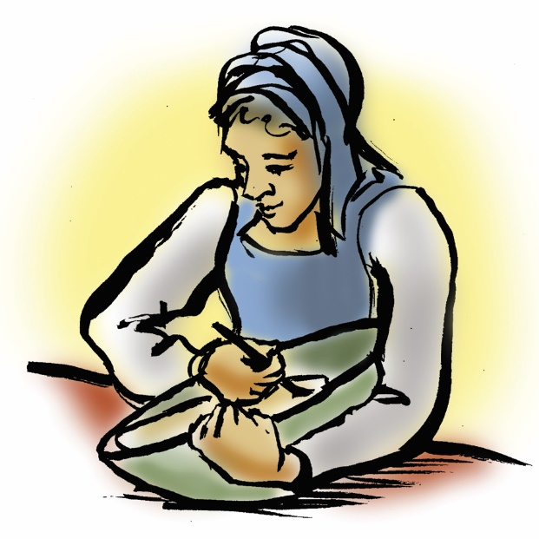
THE GATHERING
The congregation’s parts are in bold type.

PRELUDE

WORDS OF WELCOME AND ANNOUNCEMENTS

CONFESSION AND FORGIVENESS
All may make the sign of the cross, the sign that is marked at baptism, as the presiding minister begins.

Blessed be the holy Trinity, one God, whose compassion endures forever.
Amen.

Let us confess our sin to God.
Silence is kept for reflection.

Compassionate God,

we confess to you all our sins.
Our burden is heavy, and we cannot free ourselves.

In your mercy, call us back to you.
Your yoke is easy and your burden is light.
Restore us to dwell in your peace.
In Christ’s name we pray.
Amen.

Jesus says, “Come to me, all you who are weary
and are carrying heavy burdens, and I will give you rest.”
In the name of God, Father, ☩ Son, and Holy Spirit,
your sins are forgiven.
Rest in God’s love.
Amen.

GATHERING HYMN: LBW#174 For All the Saints (vs.1-4)

1 For all the saints who from their labors rest,
all who by faith before the world confessed,
your name, O Jesus, be forever blest.
Alleluia! Alleluia!

2 You were their rock, their fortress, and their might;
you, Lord, their captain in the well-fought fight;
you, in the darkness drear, their one true light.
Alleluia! Alleluia!

3 Oh, may your soldiers, faithful, true, and bold,
fight as the saints who nobly fought of old
and win with them the victor’s crown of gold.
Alleluia! Alleluia!

4 Oh, blest communion, fellowship divine,
we feebly struggle, they in glory shine;
yet all are one within your great design.
Alleluia! Alleluia!

Text: William W. How, 1823-1897, alt

GREETING

The grace of our Lord Jesus Christ,
the love of God, and the communion of the Holy Spirit be with you all.
And also with you.



HYMN OF PRAISE: WOV #789 Now the Feast and Celebration
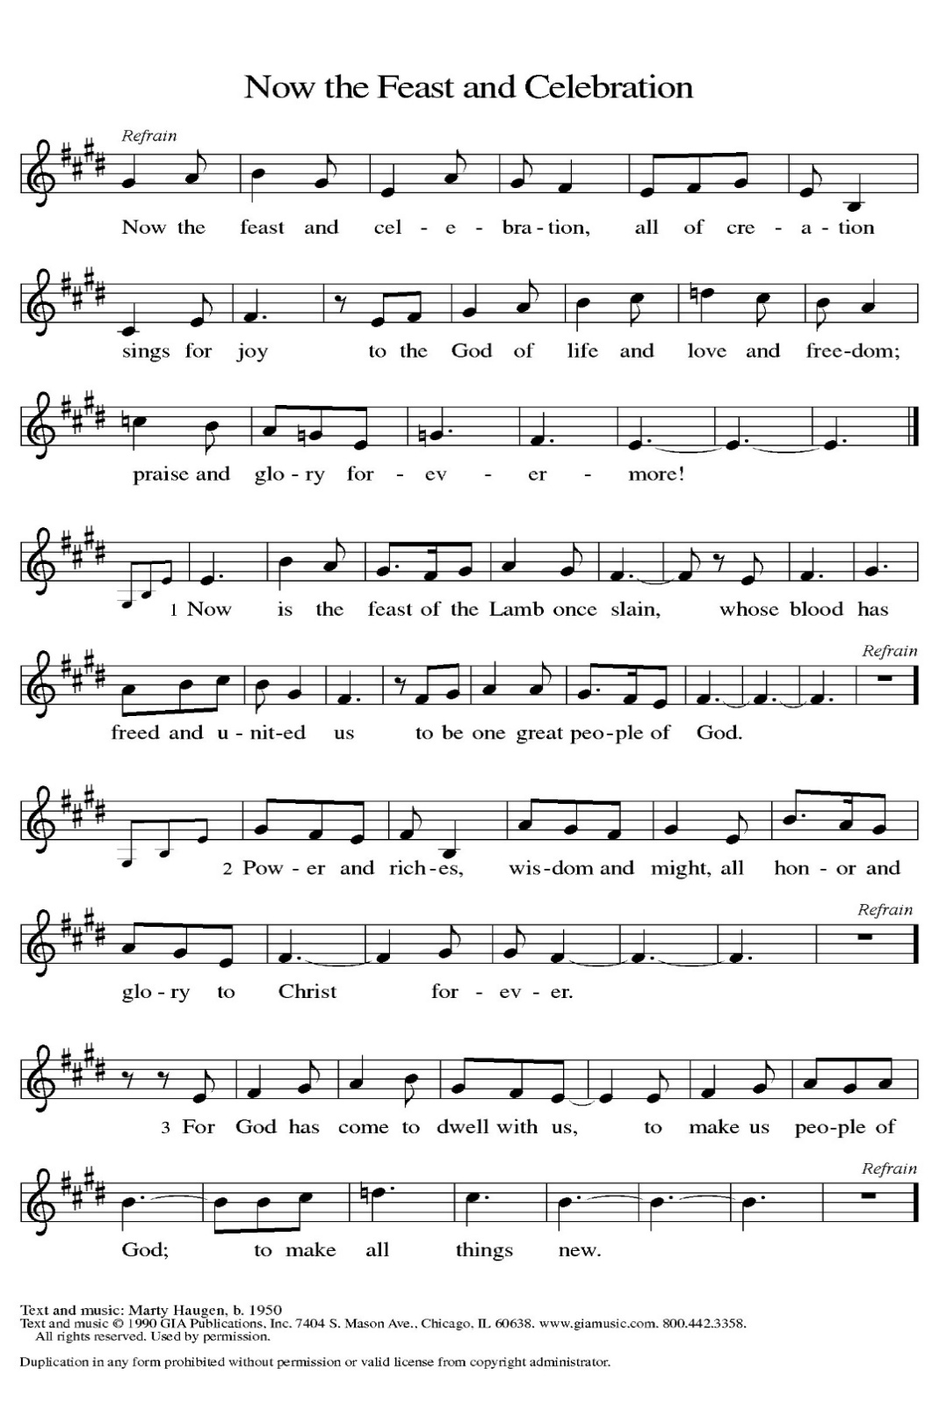
PRAYER OF THE DAY
Beloved and sovereign God, through the death and resurrection of your Son you bring us into your kingdom of justice and mercy. By your Spirit, give us your wisdom, that we may treasure the life that comes from Jesus Christ, our Savior and Lord.
Amen.

WORD

FIRST READING: Genesis 29:15-28

¹⁵ Laban said to Jacob, “Because you are my kinsman, should you therefore serve me for nothing? Tell me, what shall your wages be?” ¹⁶ Now Laban had two daughters; the name of the elder was Leah, and the name of the younger was Rachel. ¹⁷ Leah’s eyes were weak, but Rachel was graceful and beautiful. ¹⁸ Jacob loved Rachel, so he said, “I will serve you seven years for your younger daughter Rachel.” ¹⁹ Laban said, “It is better that I give her to you than that I should give her to any other man; stay with me.” ²⁰ So Jacob served seven years for Rachel, and they seemed to him but a few days because of his love for her.
²¹ Then Jacob said to Laban, “Give me my wife that I may go in to her, for my time is completed.” ²² So Laban gathered together all the people of the place and made a feast. ²³ But in the evening he took his daughter Leah and brought her to Jacob, and he went in to her. ²⁴ (Laban gave his maid Zilpah to his daughter Leah to be her maid.) ²⁵ When morning came, it was Leah! And Jacob said to Laban, “What is this you have done to me? Did I not serve with you for Rachel? Why then have you deceived me?” ²⁶ Laban said, “This is not done in our country—giving the younger before the firstborn. ²⁷ Complete the week of this one, and we will give you the other also in return for serving me another seven years.” ²⁸ Jacob did so and completed her week; then Laban gave him his daughter Rachel as a wife.

Word of God. Word of life. Thanks be to God.

Psalm: Psalm 119:129-136
¹²⁹ Your decrees are wonderful; therefore I obey them with all my heart.
¹³⁰ When your word is opened it gives light; it gives understanding to the simple.
¹³¹ I open my mouth and pant because I long for your commandments.
¹³² Turn to me and be gracious to me, as you always do to those who love your name.
¹³³ Order my footsteps in your word; let no iniquity have dominion over me.
¹³⁴ Rescue me from those who oppress me, and I will keep your commandments.
¹³⁵ Let your face shine upon your servant and teach me your statutes.
¹³⁶ My eyes shed streams of tears, because people do not keep your teaching.

Second Reading: Romans 8:26-39
These words celebrate the depth of God’s actions for us. Through Christ’s death for us and the activity of the Spirit praying for us, we are fused to God’s love poured out in Jesus Christ. Nothing, not even death itself, is able to separate us from such incredible divine love.
²⁶ The Spirit helps us in our weakness, for we do not know how to pray as we ought, but that very Spirit intercedes with groanings too deep for words. ²⁷ And God, who searches hearts, knows what is the mind of the Spirit, because the Spirit intercedes for the saints according to the will of God.
²⁸ We know that all things work together for good for those who love God, who are called according to his purpose. ²⁹ For those whom he foreknew he also predestined to be conformed to the image of his Son, in order that he might be the firstborn within a large family. ³⁰ And those whom he predestined he also called, and those whom he called he also justified, and those whom he justified he also glorified.
³¹ What then are we to say about these things? If God is for us, who is against us? ³² He who did not withhold his own Son but gave him up for all of us, how will he not with him also give us everything else? ³³ Who will bring any charge against God’s elect? It is God who justifies. ³⁴ Who is to condemn? It is Christ who died, or rather, who was raised, who is also at the right hand of God, who also intercedes for us. ³⁵ Who will separate us from the love of Christ? Will affliction or distress or persecution or famine or nakedness or peril or sword? ³⁶ As it is written, “For your sake we are being killed all day long; we are accounted as sheep to be slaughtered.” ³⁷ No, in all these things we are more than victorious through him who loved us. ³⁸ For I am convinced that neither death, nor life, nor angels, nor rulers, nor things present, nor things to come, nor powers, ³⁹ nor height, nor depth, nor anything else in all creation will be able to separate us from the love of God in Christ Jesus our Lord.
Word of God. Word of life. Thanks be to God.

GOSPEL ACCLAMATION
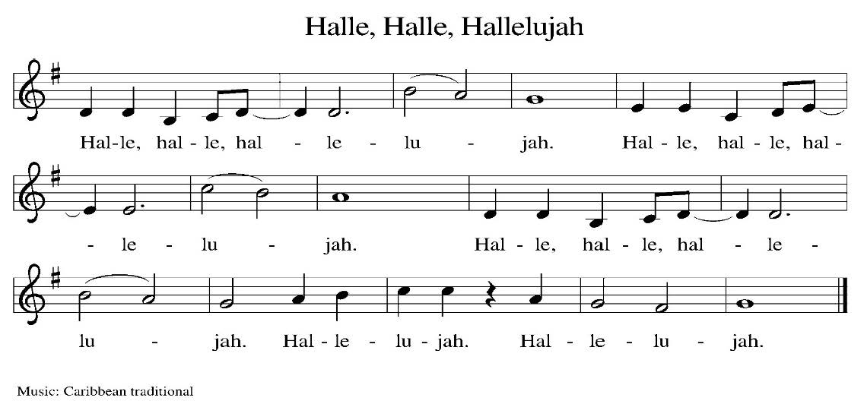

Gospel: Matthew 13:31-33, 44-52
Glory to you, O Lord.
³¹ [Jesus] put before [the crowds] another parable: “The kingdom of heaven is like a mustard seed that someone took and sowed in his field;³² it is the smallest of all the seeds, but when it has grown it is the greatest of shrubs and becomes a tree, so that the birds of the air come and make nests in its branches.”
³³ He told them another parable: “The kingdom of heaven is like yeast that a woman took and mixed in with three measures of flour until all of it was leavened.”
⁴⁴ “The kingdom of heaven is like treasure hidden in a field, which a man found and reburied; then in his joy he goes and sells all that he has and buys that field.
⁴⁵ “Again, the kingdom of heaven is like a merchant in search of fine pearls; ⁴⁶ on finding one pearl of great value, he went and sold all that he had and bought it.
⁴⁷ “Again, the kingdom of heaven is like a net that was thrown into the sea and caught fish of every kind; ⁴⁸ when it was full, they drew it ashore, sat down, and put the good into baskets but threw out the bad. ⁴⁹ So it will be at the end of the age. The angels will come out and separate the evil from the righteous ⁵⁰ and throw them into the furnace of fire, where there will be weeping and gnashing of teeth.
⁵¹ “Have you understood all this?” They answered, “Yes.” ⁵² And he said to them, “Therefore every scribe who has become a disciple in the kingdom of heaven is like the master of a household who brings out of his treasure what is new and what is old.”
The gospel of the Lord. Praise to you, O Christ.

SERMON

HYMN OF THE DAY: LBW#272 Abide with Me (vs.1-4) Text: Henry F. Lyte, 1793-1847

1 Abide with me, fast falls the eventide.
The darkness deepens; Lord, with me abide.
When other helpers fail and comforts flee,
help of the helpless, oh, abide with me.

2 I need thy presence ev’ry passing hour;
what but thy grace can foil the tempter’s pow’r?
Who like thyself my guide and stay can be?
Through cloud and sunshine, oh, abide with me.

3 Swift to its close ebbs out life’s little day;
earth’s joys grow dim, its glories pass away;
change and decay in all around I see;
O thou who changest not, abide with me.

4 I fear no foe, with thee at hand to bless;
ills have no weight, and tears no bitterness.
Where is death’s sting? Where, grave, thy victory?
I triumph still, if thou abide with me!

APOSTLES’ CREED
I believe in God, the Father almighty, creator of heaven and earth.
I believe in Jesus Christ, God’s only Son, our Lord, who was conceived by the Holy Spirit, born
of the virgin Mary, suffered under Pontius Pilate, was crucified, died, and was buried; he descended into hell. On the third day he rose again; he ascended into heaven, he is seated at the right hand of the Father, and he will come to judge the living and the dead.
I believe in the Holy Spirit, the holy catholic church, the communion of saints, the forgiveness of sins, the resurrection of the body, and the life everlasting. Amen.

THE PRAYERS
Trusting in God’s steadfast love for all God has made, let us pray for the church, the world, and all of creation.
A brief silence.
God our wisdom and our song, we pray for bishops, candidacy committees, those preparing for seminary, those awaiting call as deacons or pastors, and all who seek to lead your disciples in any way. God of grace,
hear our prayer.
God our breath and our heartbeat, help us to recognize signs of your presence among us. Protect and support diverse ecosystems, from national parks to family farms, from ranches to wild places. God of grace,
hear our prayer.
God our peace and our guide, help civic leaders hear all their peoples’ stories with compassion and curiosity, and remind us of your love from which we can never be separated. God of grace,
hear our prayer.
God our intercessor and our lawgiver, dismantle the barriers to care and recognition of all who live with chronic illness, mobility struggles, pain, and uncertainty. God of grace,
hear our prayer.
God our redeemer, may we trust your love above and beyond all else that distracts, annoys, frightens, exhausts, or divides us. God of grace,
hear our prayer.
Here other prayers may be offered.
God who seeks, finds, and saves, for our community’s part in the ongoing gift of creation, and for the riches of faith and hope which came before, we give you thanks. God of grace,
hear our prayer.
Grateful for your abundant provision and trusting in your goodness, we cast all our cares upon you, through the abundant grace of Christ Jesus.
Amen.

PEACE
The peace of the Lord be with you always.
And also with you

OFFERTORY SENTENCE
As we come to this time of offering, we invite you to give as you feel led, and we thank you for your generosity and faithful support of the work God is doing through our church.

OFFERTORY HYMN: WOV#705 As the Grains of Wheat
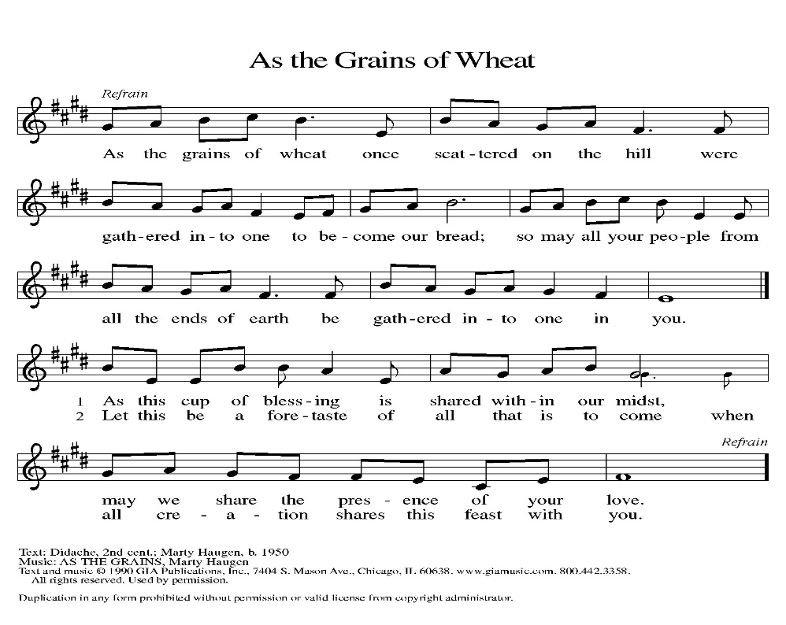
OFFERTORY PRAYER
Loving God, we offer at your table the gifts of our hearts. Help us take heart in you and share freely of your love, so that all creation can taste your abundance. We ask this in the name of Jesus, through the Spirit abiding with us now and forever. Amen.

COMMUNION
THE GREAT THANKSGIVING
The Lord be with you.
And also with you.
Lift up your hearts.
We lift them to the Lord.
Let us give thanks to the Lord our God.
It is right to give our thanks and praise.

THE PROPER PREFACE: It is indeed right and salutary.

SANCTUS (S-153, Service 4)
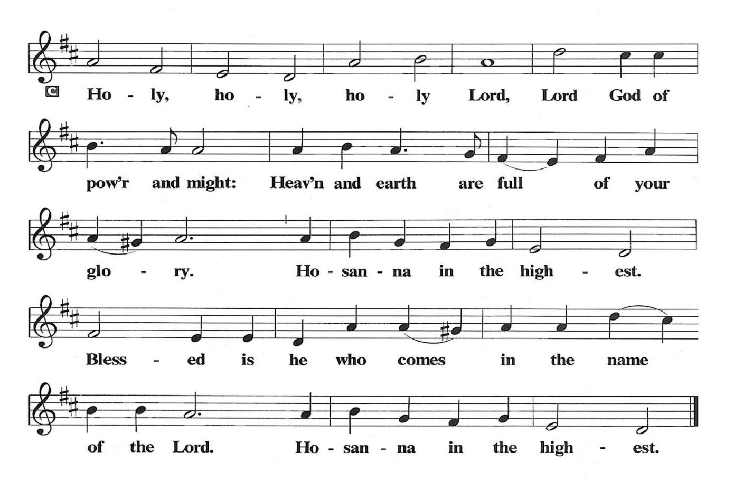
PRAYER OF INSTITUTION

LORD’S PRAYER
Gathered into one by the Holy Spirit, let us pray as Jesus taught us.

Our Father, who art in heaven, hallowed be thy name, thy kingdom come, thy will be done, on earth as it is in heaven. Give us this day our daily bread; and forgive us our trespasses, as we forgive those who trespass against us; and lead us not into temptation, but deliver us from evil. For thine is the kingdom, and the power, and the glory, forever and ever. Amen.

OR

Our Father in heaven, hallowed be your name, your kingdom come, your will be done, on earth as in heaven. Give us today our daily bread. Forgive us our sins as we forgive those who sin against us. Save us from the time of trial, and deliver us from evil. For the kingdom, the power, and the glory are yours now and forever. Amen

INVITATION TO COMMUNION
Heaven has come near. Come, share in the feast!

COMMUNION ANTHEM (S-154, Service 4)
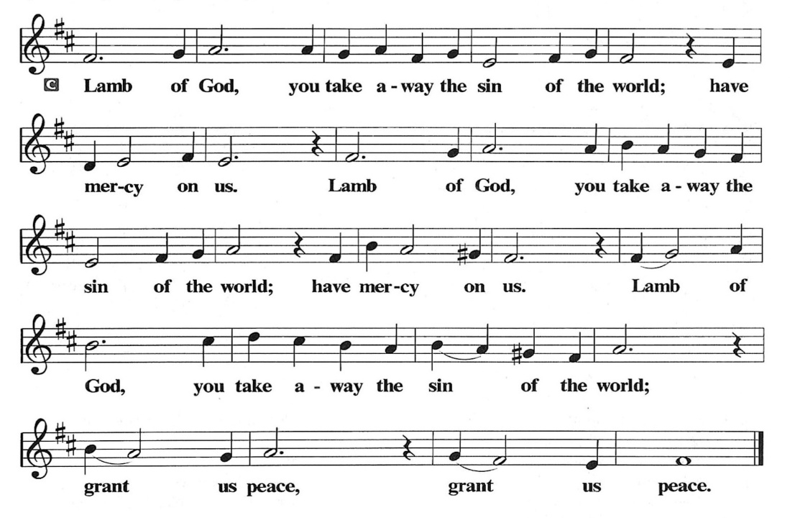

POST COMMUNION PRAYER
Compassionate God, through the gifts of bread and wine our hearts are filled with the abundance of your love. Strengthen us that we, through this holy meal, may share your love freely, as you have shared with us. We ask this in the name of Jesus, through the Spirit nourishing us now and forever.
Amen.

BLESSING
Creator, Redeemer, Sustainer, ☩ one God, bless, heal, and hold you today and always. Amen.

SENDING HYMN: WOV#721 Go, My Children wit My Blessing

1 “Go, my children, with my blessing, never alone.
Waking, sleeping, I am with you, you are my own.
In my love’s baptismal river
I have made you mine forever.
Go, my children, with my blessing, you are my own.

2 “Go, my children, sins forgiven, at peace and pure.
Here you learned how much I love you, what I can cure.
Here you heard my dear Son’s story,
here you touched him, saw his glory.
Go, my children, sins forgiven, at peace and pure.

3 “Go, my children, fed and nourished, closer to me.
Grow in love and love by serving, joyful and free.
Here my Spirit’s power filled you,
here his tender comfort stilled you.
Go, my children, fed and nourished, joyful and free.

4 “I the Lord will bless and keep you, and give you peace.
I the Lord will smile upon you, and give you peace.
I the Lord will be your Father,
Savior, Comforter and Brother.
Go, my children, I will keep you, and give you peace.”
DISMISSAL
Heaven has come near. Go, share the good news!
Thanks be to God.

POSTLUDE

PRAYER LIST
(Please call the office to add/or update the Prayer List)
Marty Cosgriff, Charlotte Berndt, God’s guidance and wisdom for Cameron, healing for Helene Rabe, Fred W. Taylor, Madeline McEntyre, Scott Tyler, Jim Lynch, Shirley Lustig, Michele Hansen, Lisa Weathers, Matthew Allison, Antonio Jamir and family, Joann and Tye Peyton, Linda Fairless, Shamari Johnson Moore, Suzy and John Henry, Gudrun Schamoni, God’s protection for Rhea, David Forsyth, Phil Arthur, Ruth Wolf with cancer, Peter Dow, Francis and Rueben, Anne with cancer, protection for Audrey Frangiamore, Susan Rados, Jack L Taylor for mobility and strength, healing and God’s guidance for Bill Kay, Fred Schweiger, Tim M. for God’s guidance, for relief and healing, Tyrone Steele.

ANNOUNCEMENTS

Join us August 2 when we will bless our high school graduates, Anais and Jonathan during the worship service with a special fellowship hour in their honor after worship

Relay For Life: Special Thank You to Karen Wirth for all she did for Immanuel and Relay For Life on Saturday, July 18. It is an important way to fight cancer memorializing those who have died and honor those living with cancer. See information below on an additional fundraiser for Relay for Life.

Favorite Hymns for Summer: For the rest of this summer, we will be using favorite hymns chosen by our congregation. Fill out ballot below to list your favorite hymns.

Fellowship Hour: We love spending time together after worship, please join us in Parish Hall and feel free to bring something yummy to share!
Council monthly meeting: The Council meets 3rd Wednesday of every month. The next meeting is June 17, 2026 at 7PM via Zoom. Congregation members are welcome at the meetings,
Next Dine and Connect, July 27, 2026: This is an interfaith and community run program to feed the houseless and food insecure in Alameda. Volunteers are need for all facets of the meal. Let the office know if you’d like to help.
Immanuel Website: You can find our weekly worship bulletin, worship live streaming link, church calendar, events announcements and much more online. Please visit:
Donate to Immanuel Online: It is important that our offerings continue to support our ministry. You can tithe to Immanuel several different ways including PayPal via the church website, through the mail: 1910 Santa Clara Avenue, Alameda, CA 94501, or through the church mail slot located to the right of the metal gate on Santa Clara Ave. Thank you!
Pastor Availability & Contact Info: Rev. Crystal Larsen Stewart’s office hours are Fridays. She can be reached by phone and email to schedule time for pastoral care and appointments. Cell: 510-693-1974. Email: pastor@immanuel-alameda.org
Church Office: Hours vary and are available by appointment. Please call the office at 510-523-0659 and leave a message for pastor or volunteers. We are in need of more volunteers for tasks like the Sunday bulletin, organizing and checking voicemail; please call if you can help.
Recycling: Pure Recycling is available by volunteer Walter McQuesten-510-521-1356. Collects: Plastic: CRV, empty, crushed, bagged, no lids (put lids in own recycle); Aluminum: empty, crushed/flattened and separated; Glass bottles: clean and boxed. It is good to recycle.

FAVORITE HYMN LIST
In response to numerous hymn requests, please use this form to write down your favorite hymns. These hymns will serve as the basis for the hymn selections to be sung at the 10am worship service during the summer months.
Please fill in either the number or first line of text of your favorite hymns from either the Evangelical Lutheran Book of Worship (ELW), Lutheran Book of Worship (LBW), or With One Voice (WOV). Use the back of the ballot if there is not enough space on the front. Obviously, we won’t be able to get to all of the hymns, but use this opportunity to let us know what hymns are especially meaningful to you. Please make your selections as soon as possible and return it to the Music Director, or place it in the collection plate, or just turn into the church office for early tabulation.
Hymn #________ First Line: ___________________________
Hymn #________ First Line: ___________________________
Hymn #________ First Line: ___________________________
Hymn #________ First Line: ___________________________
Hymn #________ First Line: ___________________________

Join Relay For Life for a Fundraiser Tuesday, August 4th


