IMMANUEL LUTHERAN CHURCH
Fourth Sunday Easter
May 3, 2026

Worship in person or online Sunday at 10 AM
See our website for the link: www.immanuel-alameda.org
For those online wanting to participate in communion, please have bread & wine/or juice available.

Rev. Crystal Larsen Stewart · pastor@immanuel-alameda.org
Church: 1420 Lafayette Street Alameda, CA 94501; Office: 1910 Santa Clara Ave.
(510) 523-0659 · office@immanuel-alameda.org
THE GATHERING
The congregation’s parts are in bold type.
PRELUDE

WORDS OF WELCOME AND ANNOUNCEMENTS

Thanksgiving for Baptism
All may make the sign of the cross, the sign that is marked at baptism, as the presiding minister begins.

Alleluia! Christ is risen.
Christ is risen, indeed. Alleluia!

In the name of ☩ the One
who was, who is, and who is to come.
Amen.

Baptized into Christ’s death and resurrection,
and called to live the baptized life,
let us give thanks for the gifts of baptism.

Water may be poured into the font as the presiding minister continues.
Merciful God,
you are the one who was, who is, and who is to come.
You lead us beside still waters.
We thank you for the waters of creation:
morning dew, gentle rain, roaring waves.
We thank you for the waters that nourish us.
Blessed are you.
You guide us to springs of the water of life.
Jesus Christ, you are the faithful witness
who accompanies us on our journeys.
We give you thanks for your life-giving death and resurrection.
We praise you for joining us in joy and sorrow.
Blessed are you.
You guide us to springs of the water of life.
Holy Spirit, you anoint our head with oil and our cup overflows.
Break down barriers that divide us.
Fill us with the breath of peace.
Blessed are you.
You guide us to springs of the water of life.
Holy One, we thank you for the gifts and grace of baptism,
and for making us a new creation.
We join with saints and angels, giving you honor and praise,
now and forever.
Amen.

GATHERING HYMN: WOV#747 Christ Is Made the Sure Foundation

1 Christ is made the sure foundation,
Christ, our head and cornerstone,
chosen of the Lord and precious,
binding all the church in one;
holy Zion’s help forever
and our confidence alone.

2 To this temple, where we call you,
come, O Lord of hosts, and stay;
come with all your lovingkindness,
hear your people as they pray;
and your fullest benediction
shed within these walls today.
3 Grant, we pray, to all your faithful
all the gifts they ask to gain;
what they gain from you, forever
with the blessed to retain;
and hereafter in your glory
evermore with you to reign.

4 Praise and honor to the Father,
praise and honor to the Son,
praise and honor to the Spirit,
ever three and ever one:
one in might and one in glory
while unending ages run!

Text: Latin hymn, c. 7th cent.; tr. John M. Neale, 1818-1866, alt.

GREETING
The grace of our Lord Jesus Christ, the love of God, and the communion of the Holy Spirit be with you all.
And also with you.

HYMN OF PRAISE: WOV #789
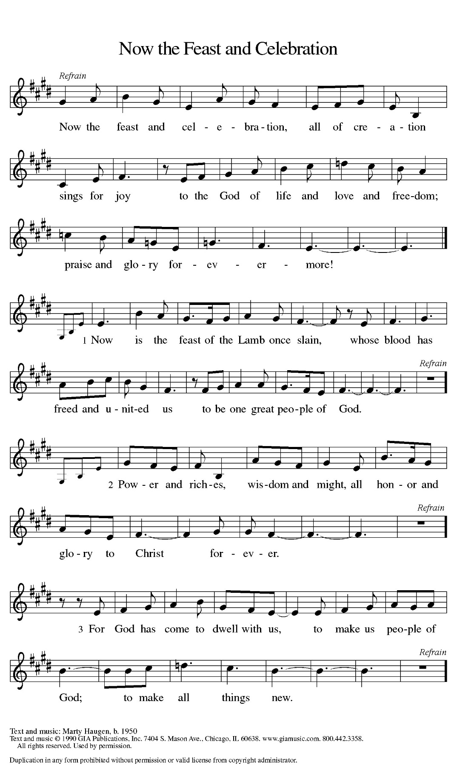
PRAYER OF THE DAY
Almighty God, your Son Jesus Christ is the way, the truth, and the life. Give us grace to love one another, to follow in the way of his commandments, and to share his risen life with all the world, for he lives and reigns with you and the Holy Spirit, one God, now and forever.
Amen.

THE WORD

First Reading: Acts 7:55-60
Stephen was one of the seven men chosen by the apostles to serve tables so that the apostles could be free to serve the word (Acts 6:1-6). Stephen does more than distribute food, however. For his preaching of God’s word, he becomes the first martyr of the faith.
⁵⁵ Filled with the Holy Spirit, [Stephen] gazed into heaven and saw the glory of God and Jesus standing at the right hand of God. ⁵⁶ “Look,” he said, “I see the heavens opened and the Son of Man standing at the right hand of God!” ⁵⁷ But they covered their ears, and with a loud shout all rushed together against him. ⁵⁸ Then they dragged him out of the city and began to stone him, and the witnesses laid their coats at the feet of a young man named Saul. ⁵⁹ While they were stoning Stephen, he prayed, “Lord Jesus, receive my spirit.” ⁶⁰ Then he knelt down and cried out in a loud voice, “Lord, do not hold this sin against them.” When he had said this, he died.
Word of God. Word of life. Thanks be to God.

Psalm: Psalm 31:1-5, 15-16
¹ In you, O Lord, have I taken refuge; let me never be put to shame; deliver me in your righteousness.
² Incline your ear to me; make haste to deliver me.
³ Be my strong rock, a castle to keep me safe, for you are my crag and my stronghold; for the sake of your name, lead me and guide me.
⁴ Take me out of the net that they have secretly set for me, for you are my tower of strength.
⁵ Into your hands I commend my spirit, for you have redeemed me, O Lord, God of truth.
¹⁵ My times are in your hand; rescue me from the hand of my enemies, and from those who persecute me.
¹⁶ Let your face shine upon your servant; save me in your steadfast love.”

Second Reading: 1 Peter 2:2-10
Christ is the cornerstone of God’s saving work and the foundation of our lives. We are God’s chosen, holy people who continuously celebrate and declare the mercy of God we experience through Jesus Christ.
² Like newborn infants, long for the pure, spiritual milk, so that by it you may grow into salvation—³ if indeed you have tasted that the Lord is good.
⁴ Come to him, a living stone, though rejected by mortals yet chosen and precious in God’s sight, and ⁵ like living stones let yourselves be built into a spiritual house, to be a holy priesthood, to offer spiritual sacrifices acceptable to God through Jesus Christ. ⁶ For it stands in scripture: “See, I am laying in Zion a stone, a cornerstone chosen and precious, and whoever believes in him will not be put to shame.” This honor, then, is for you who believe, but for those who do not believe, “The stone that the builders rejected has become the very head of the corner,” ⁸ and “A stone that makes them stumble and a rock that makes them fall.” They stumble because they disobey the word, as they were destined to do.
⁹ But you are a chosen people, a royal priesthood, a holy nation, God’s own people, in order that you may proclaim the excellence of him who called you out of darkness into his marvelous light. ¹⁰ Once you were not a people, but now you are God’s people; once you had not received mercy, but now you have received mercy.
Word of God. Word of life. Thanks be to God.

GOSPEL ACCLAMATION
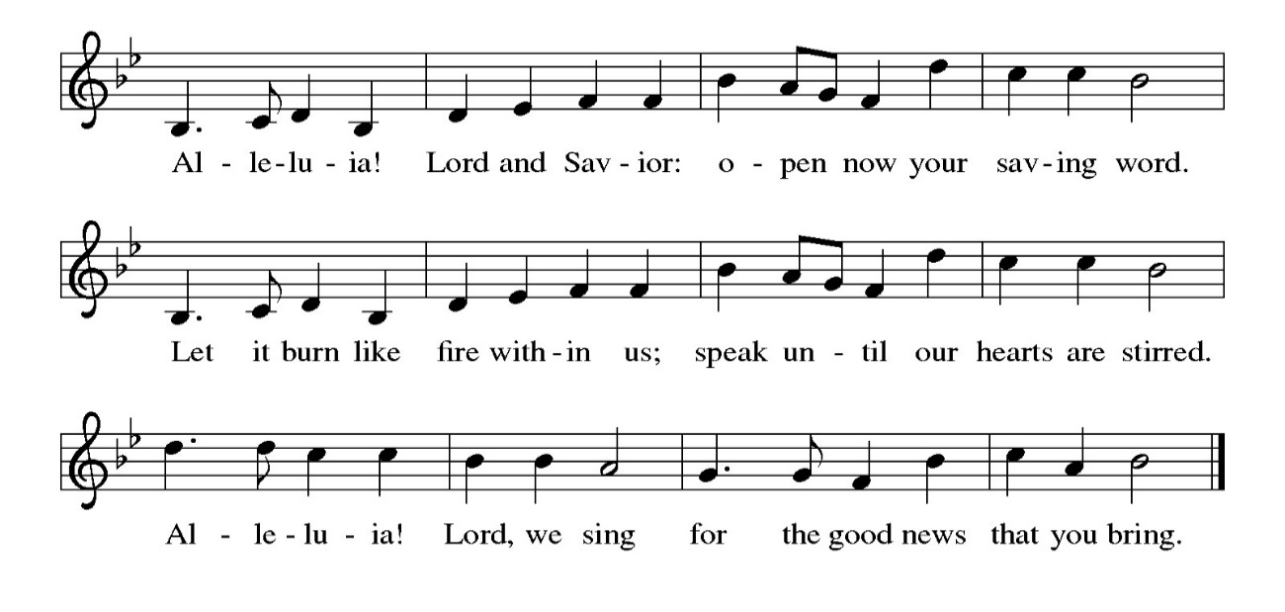
Gospel: John 14:1-14
Glory to you, O Lord.
On the night that he is to be arrested, Jesus shares final words with his disciples. As the one through whom God is known, he promises to go before them and act on their behalf.
[Jesus said to the disciples:] ¹ “Do not let your hearts be troubled. Believe in God; believe also in me. ² In my Father’s house there are many dwelling places. If it were not so, would I have told you that I go to prepare a place for you? ³ And if I go and prepare a place for you, I will come again and will take you to myself, so that where I am, there you may be also. ⁴ And you know the way to the place where I am going.” ⁵ Thomas said to him, “Lord, we do not know where you are going. How can we know the way?” ⁶ Jesus said to him, “I am the way and the truth and the life. No one comes to the Father except through me. ⁷ If you know me, you will know my Father also. From now on you do know him and have seen him.”
⁸ Philip said to him, “Lord, show us the Father, and we will be satisfied.” ⁹ Jesus said to him, “Have I been with you all this time, Philip, and you still do not know me? Whoever has seen me has seen the Father. How can you say, ‘Show us the Father’? ¹⁰ Do you not believe that I am in the Father and the Father is in me? The words that I say to you I do not speak on my own, but the Father who dwells in me does his works. ¹¹ Believe me that I am in the Father and the Father is in me, but if you do not, then believe because of the works themselves. ¹² Very truly, I tell you, the one who believes in me will also do the works that I do and, in fact, will do greater works than these, because I am going to the Father. ¹³ I will do whatever you ask in my name, so that the Father may be glorified in the Son. ¹⁴ If in my name you ask me for anything, I will do it.”
The gospel of the Lord. Praise to you, O Christ.

SERMON

HYMN OF THE DAY: LBW#148 Now the Green Blade Rises

1 Now the green blade rises from the buried grain, wheat that in dark earth many days has lain;
love lives again, that with the dead has been; love is come again like wheat arising green.

2 In the grave they laid him, love by hatred slain, thinking that he would never wake again;
laid in the earth like grain that sleeps unseen; love is come again like wheat arising green.

3 Forth he came at Easter, like the risen grain, he that for three days in the grave had lain;
raised from the dead, my living Lord is seen; love is come again like wheat arising green.
4 When our hearts are wintry, grieving, or in pain, your touch can call us back to life again,
fields of our hearts that dead and bare have been; love is come again like wheat arising green.
Text: John MacLeod Campbell Crum, 1872-1958. Text from Oxford Book of Carols © Oxford University Press 1928. All rights reserved

NICENE CREED

We believe in one God, the Father, the Almighty, maker of heaven and earth, of all that is, seen and unseen.
We believe in one Lord, Jesus Christ, the only Son of God, eternally begotten of the Father,
God from God, Light from Light, true God from true God, begotten, not made, of one Being with the Father; through him all things were made. For us and for our salvation he came down from heaven, was incarnate of the Holy Spirit and the virgin Mary and became truly human. For our sake he was crucified under Pontius Pilate; he suffered death and was buried. On the third day he rose again in accordance with the scriptures; he ascended into heaven and is seated at the right hand of the Father. He will come again in glory to judge the living and the dead, and his kingdom will have no end.
We believe in the Holy Spirit, the Lord, the giver of life, who proceeds from the Father and the Son,* who with the Father and the Son is worshiped and glorified, who has spoken through the prophets.
We believe in one holy catholic and apostolic church. We acknowledge one baptism for the forgiveness of sins. We look for the resurrection of the dead, and the life of the world to come. Amen.

THE PRAYERS
Trusting in the power of Christ’s resurrection to heal and redeem our broken world, let us pray for the needs of all creation.
A brief silence.
God of glory, you have built your church on Christ the cornerstone. Inspire lay leaders, deacons, pastors, and bishops to proclaim forgiveness and your steadfast love to all whom they encounter. Merciful God,
receive our prayer.
God of majesty, you bring forth plants and animals, skies and seas, mountains and valleys. Protect all you have made from the ravages of pollution and climate disaster. Merciful God,
receive our prayer.
God of mercy, you intend governments and social service agencies to be instruments of peace and justice. Guide political leaders and organizations to be agents of compassion, and raise up advocates for those who seek refuge and assistance. Merciful God,
receive our prayer.
God of well-being, you soothe those in distress, console all who grieve, provide for any in need, and comfort those who are sick especially those on our prayer list. Instill caregivers with a sense of purpose to be your healing hands in this world. Merciful God,
receive our prayer.
God of community, you call us together as your people for mutual support and to witness to your love in the world. Make your presence known among those unable to attend worship today. Merciful God,
receive our prayer.
Here other prayers may be offered.
God of eternal life, you have prepared dwelling places for your people, so that we are never separated from you. We give you thanks for the faithful departed who witnessed to your mighty acts in word and deed. Merciful God,
receive our prayer.
God of resurrection power, use us and these prayers to proclaim the good news of new life to all the world, through Jesus Christ, our risen Savior.
Amen.

PEACE
The peace of the Lord be with you always.
And also with you

OFFERTORY SENTENCE
As we come to this time of offering, we invite you to give as you feel led, and we thank you for your generosity and faithful support of the work God is doing through our church.

OFFERTORY HYMN: #564 Praise God, from Whom All Blessings Flow (inclusive language)
Praise God, from whom all blessings flow;
Praise God, all creatures here below;
Praise God, above, ye heav’nly host;
Creator, Christ, and Holy Ghost. Amen.

OFFERTORY PRAYER
Merciful God, accept the fruits of our labor, gathered to give you glory. You have set a table before us, a glimpse of that great day when we will hunger and thirst no more.
May You prepare us now to be nourished, so that goodness and mercy may follow us and bless the world you love. In the name of Jesus,
Amen.

COMMUNION
THE GREAT THANKSGIVING
The Lord be with you.
And also with you.
Lift up your hearts.
We lift them to the Lord.
Let us give thanks to the Lord our God.
It is right to give our thanks and praise.

THE PROPER PREFACE: It is indeed right and salutary…

SANCTUS
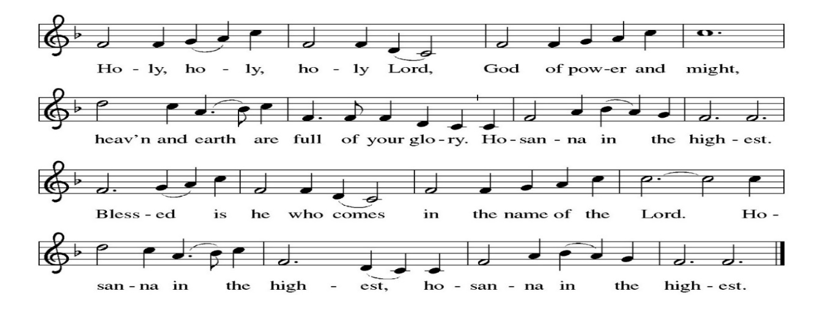
PRAYER OF INSTITUTION

LORD’S PRAYER
Gathered into one by the Holy Spirit, let us pray as Jesus taught us.
Our Father, who art in heaven, hallowed be thy name, thy kingdom come, thy will be done, on earth as it is in heaven. Give us this day our daily bread; and forgive us our trespasses, as we forgive those who trespass against us; and lead us not into temptation, but deliver us from evil. For thine is the kingdom, and the power, and the glory, forever and ever. Amen.

OR

Our Father in heaven, hallowed be your name, your kingdom come, your will be done, on earth as in heaven. Give us today our daily bread. Forgive us our sins as we forgive those who sin against us. Save us from the time of trial, and deliver us from evil. For the kingdom, the power, and the glory are yours now and forever. Amen

INVITATION TO COMMUNION
Come to the table of new life. Receive the risen Lord.

COMMUNION ANTHEM
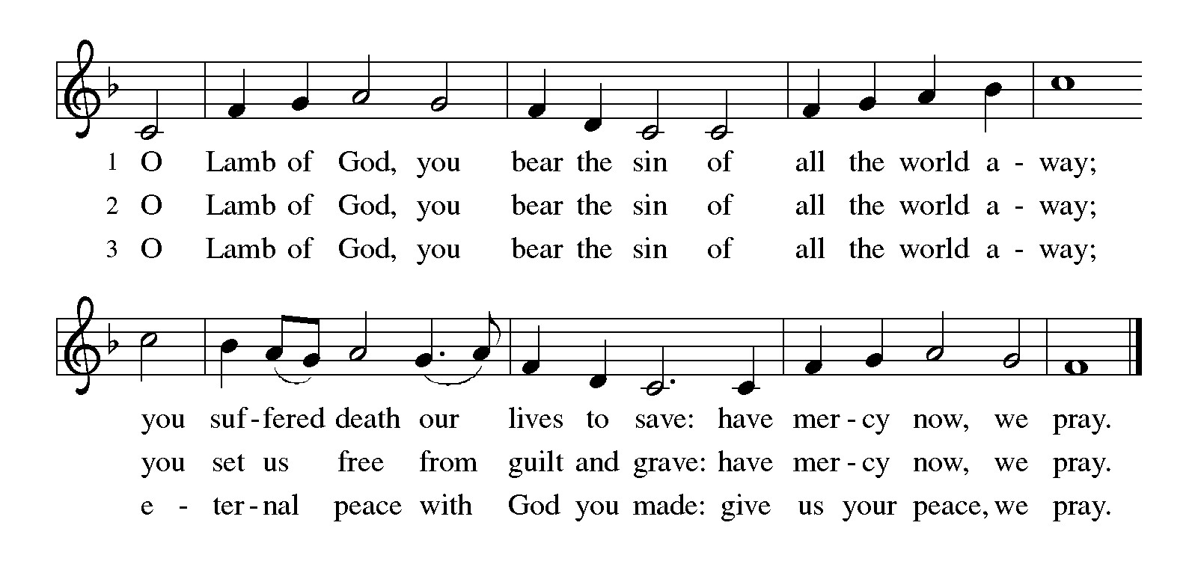
POST COMMUNION PRAYER
Holy One, through this meal you have made your home among us and are making all things new. Send us now to speak peace to anxious hearts, to love our enemies, and to bring your healing to the nations. In the name of Jesus,
Amen.

BLESSING
God Almighty, who is the beginning and the end, Jesus Christ, the firstborn of the dead, and the Spirit, our advocate and peace, ☩ bless you now and forever.
Amen.

SENDING HYMN: WOV#674 Alleluia! Jesus Is Risen!

1 Alleluia! Jesus is risen! Trumpets resounding in glorious light!
Splendor, the Lamb, heaven forever! Oh, what a miracle God has in sight!

Refrain: Jesus is risen and we shall arise. Give God the glory! Alleluia!

2 Walking the way, Christ in the center telling the story to open our eyes;
breaking our bread, giving us glory: Jesus our blessing, our constant surprise. Refrain

3 Jesus the vine, we are the branches; life in the Spirit the fruit of the tree;
heaven to earth, Christ to the people, gift of the future now flowing to me. Refrain

4 Weeping, be gone; sorrow, be silent :death put asunder, and Easter is bright.
Cherubim sing: O grave, be open! Clothe us in wonder, adorn us in light. Refrain

5 City of God, Easter forever, golden Jerusalem, Jesus the Lamb,
river of life, saints and archangels, sing with creation to God the I AM! Refrain

Text: Herbert F. Brokering, b. 1926. Text © 1995 Augsburg Fortress.
DISMISSAL
Go in peace. Praise the Lord. Alleluia!
Thanks be to God. Alleluia!

POSTLUDE
PRAYER LIST
(Please call the office to add/or update the Prayer List)

Marty Cosgriff, Charlotte Berndt, God’s guidance and wisdom for Cameron, healing for Helene Rabe, Fred W. Taylor, Madeline McEntyre, Scott Tyler, Jim Lynch, Shirley Lustig, Barbara who is in hospice, Michele Hansen, Lisa Weathers, Matthew Allison, Antonio Jamir and family, Joann and Tye Peyton, Linda Fairless, Shamari Johnson Moore, Suzy and John Henry, Gudrun Schamoni, God’s protection for Rhea, David Forsyth, Phil Arthur, Ruth Wolf with cancer, Peter Dow, Francis and Rueben, Anne with cancer, protection for Audrey Frangiamore, Susan Rados, Jack L Taylor for mobility and strength healing, healing and God’s guidance for Bill Kay, Fred Schweiger.

ANNOUNCEMENTS

PlanetCPR.org will meet the 2nd & 4th Saturdays of each month from 10am-1pm in the Parish Hall, They have offered ILC members a 20% discount on their CPR classes using promo code ILC20.
Fellowship Hour: We love spending time together after worship, please join us in Parish Hall and feel free to bring something yummy to share!
Council monthly meeting: The Council meets 3rd Wednesday of every month. The next meeting is May 20, 2026 at 7PM via Zoom. Congregation members are welcome at the meetings,
Next Dine and Connect, April 27: This is an interfaith and community run program to feed the houseless and food insecure in Alameda. Volunteers are need for all facets of the meal. See Terry O’Connor if you’d like to help.
Immanuel Website: You can find our weekly worship bulletin, worship live streaming link, church calendar, events announcements and much more online. Please visit:
Donate to Immanuel Online: It is important that our offerings continue to support our ministry. You can tithe to Immanuel several different ways including PayPal via the church website, through the mail: 1910 Santa Clara Avenue, Alameda, CA 94501, or through the church mail slot located to the right of the metal gate on Santa Clara Ave. Thank you!
Pastor Availability & Contact Info: Rev. Crystal Larsen Stewart’s office hours are Fridays. She can be reached by phone and email to schedule time for pastoral care and appointments. Cell: 510-693-1974. Email: pastor@immanuel-alameda.org
Church Office: Hours vary and are available by appointment. Please call the office at 510-523-0659 and leave a message for pastor or volunteers. We are in need of more volunteers for tasks like the Sunday bulletin, organizing and checking voicemail; please call if you can help.
Recycling: Pure Recycling is available by volunteer Walter McQuesten-510-521-1356. Collects: Plastic: CRV, empty, crushed, bagged, no lids (put lids in own recycle); Aluminum: empty, crushed/flattened and separated; Glass bottles: clean and boxed. It is good to recycle.

