Wear red for Pentecost

IMMANUEL LUTHERAN CHURCH
Day of Pentecost
May 24, 2026

Worship in person or online Sunday at 10 AM
See our website for the link: www.immanuel-alameda.org
For those online wanting to participate in communion, please have bread & wine/or juice available.

Rev. Crystal Larsen Stewart · pastor@immanuel-alameda.org
Church: 1420 Lafayette Street Alameda, CA 94501; Office: 1910 Santa Clara Ave.
(510) 523-0659 · office@immanuel-alameda.org

THE GATHERING
The congregation’s parts are in bold type.
PRELUDE

WORDS OF WELCOME AND ANNOUNCEMENTS

Thanksgiving for Baptism
All may make the sign of the cross, the sign that is marked at baptism, as the presiding minister begins.

Alleluia! Christ is risen.
Christ is risen, indeed. Alleluia!

In the name of ☩ the One
who was, who is, and who is to come.
Amen.

Baptized into Christ’s death and resurrection,
and called to live the baptized life,
let us give thanks for the gifts of baptism.

Water may be poured into the font as the presiding minister continues.
Merciful God,
you are the one who was, \
who is, and who is to come.
You lead us beside still waters.
We thank you for the waters of creation:
morning dew, gentle rain, roaring waves.
We thank you for the waters that nourish us.
Blessed are you.
You guide us to springs of the water of life.
Jesus Christ, you are the faithful witness
who accompanies us on our journeys.
We give you thanks for your life-giving death and resurrection.
We praise you for joining us in joy and sorrow.
Blessed are you.
You guide us to springs of the water of life.
Holy Spirit, you anoint our head with oil and our cup overflows.
Break down barriers that divide us.
Fill us with the breath of peace.
Blessed are you.
You guide us to springs of the water of life.
Holy One, we thank you for the gifts and grace of baptism,
and for making us a new creation.
We join with saints and angels, giving you honor and praise,
now and forever.
Amen.

GATHERING HYMN: WOV#688 O Holy Spirit, Root of life

1 O Holy Spirit, root of life, creator, cleanser of all things:
anoint our wounds, awaken us with lustrous movement of your wings.

2 Eternal Vigor, Saving One, you free us by your living Word,
becoming flesh to wear our pain, and all creation is restored.

3 O holy Wisdom, soaring power, encompass us with wings unfurled,
and carry us, encircling all above, below, and through the world.
Text: Jean Janzen, b. 1933, based on Hildegard of Bingen, 1078-1179. © 1991 Jean Janzen, admin. Augsburg Fortress

GREETING
The grace of our Lord Jesus Christ, the love of God, and the communion of the Holy Spirit be with you all.
And also with you.

HYMN OF PRAISE: WOV #789
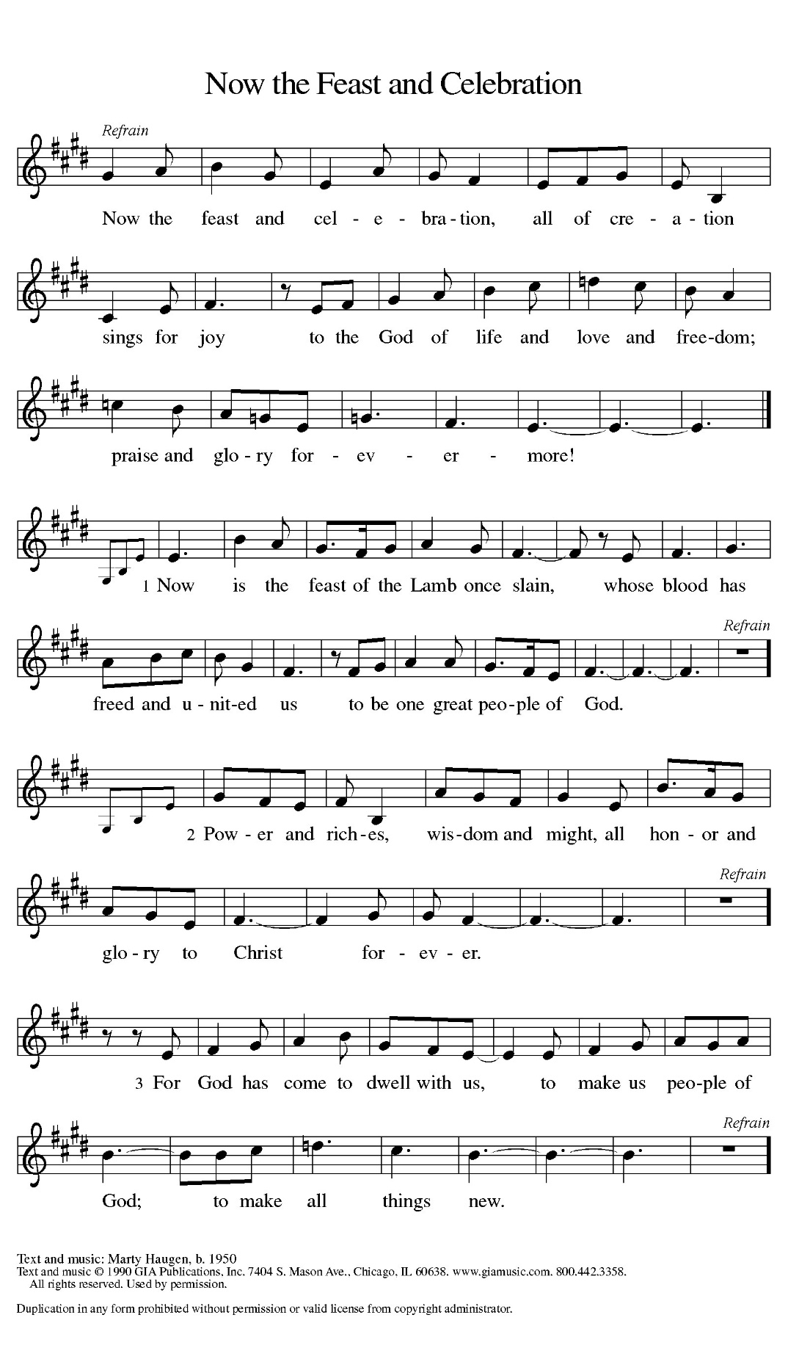
PRAYER OF THE DAY
O God, on this day you open the hearts of your faithful people by sending into us your Holy Spirit. Direct us by the light of that Spirit, that we may have a right judgment in all things and rejoice at all times in your peace, through Jesus Christ, your Son and our Lord, who lives and reigns with you and the Holy Spirit, one God, now and forever.
Amen.

THE WORD
FIRST READING: Acts 2:1-21
Pentecost was a Jewish harvest festival that marked the fiftieth day after Passover. Luke portrays the Holy Spirit being poured out upon the disciples before the gathered and astonished people assembled in Jerusalem for the festival. Filled with the Spirit, the disciples were able to witness to the power of Christ’s resurrection.
¹ When the day of Pentecost had come, [the apostles] were all together in one place. ² And suddenly from heaven there came a sound like the rush of a violent wind, and it filled the entire house where they were sitting. ³ Divided tongues, as of fire, appeared among them, and a tongue rested on each of them. ⁴ All of them were filled with the Holy Spirit and began to speak in other languages, as the Spirit gave them ability.
⁵ Now there were devout Jews from every people under heaven living in Jerusalem. ⁶ And at this sound the crowd gathered and was bewildered, because each one heard them speaking in the native language of each. ⁷ Amazed and astonished, they asked, “Are not all these who are speaking Galileans? ⁸ And how is it that we hear, each of us, in our own native language? ⁹ Parthians, Medes, Elamites, and residents of Mesopotamia, Judea and Cappadocia, Pontus and Asia, ¹⁰ Phrygia and Pamphylia, Egypt and the parts of Libya belonging to Cyrene, and visitors from Rome, both Jews and proselytes, ¹¹ Cretans and Arabs—in our own languages we hear them speaking about God’s deeds of power.” ¹² All were amazed and perplexed, saying to one another, “What does this mean?” ¹³ But others sneered and said, “They are filled with new wine.”
¹⁴ But Peter, standing with the eleven, raised his voice and addressed them, “Fellow Jews and all who live in Jerusalem, let this be known to you, and listen to what I say. ¹⁵ Indeed, these are not drunk, as you suppose, for it is only nine o’clock in the morning. ¹⁶ No, this is what was spoken through the prophet Joel:
¹⁷ ‘In the last days it will be, God declares,
that I will pour out my Spirit upon all flesh,
and your sons and your daughters shall prophesy,
and your young men shall see visions,
and your old men shall dream dreams.
¹⁸ Even upon my slaves, both men and women,
in those days I will pour out my Spirit,
and they shall prophesy.
¹⁹ And I will show portents in the heaven above
and signs on the earth below,
blood, and fire, and smoky mist.
²⁰ The sun shall be turned to darkness
and the moon to blood,
before the coming of the Lord’s great and glorious day.
²¹ Then everyone who calls on the name of the Lord shall be saved.’
Word of God, word of life. Thanks be to God.

PSALM: Psalm 104:30-35
³⁰ You send forth your Spirit, and they are created; and so you renew the face of the earth.
³¹ May the glory of the Lord endure forever; O Lord, rejoice in all your works.
³² You look at the earth and it trembles; you touch the mountains and they smoke.
³³ I will sing to the Lord as long as I live; I will praise my God while I have my being.
³⁴ May these words of mine please God. I will rejoice in the Lord.
^{35b} Bless the Lord, O my soul. Hallelujah!

GOSPEL ACCLAMATION
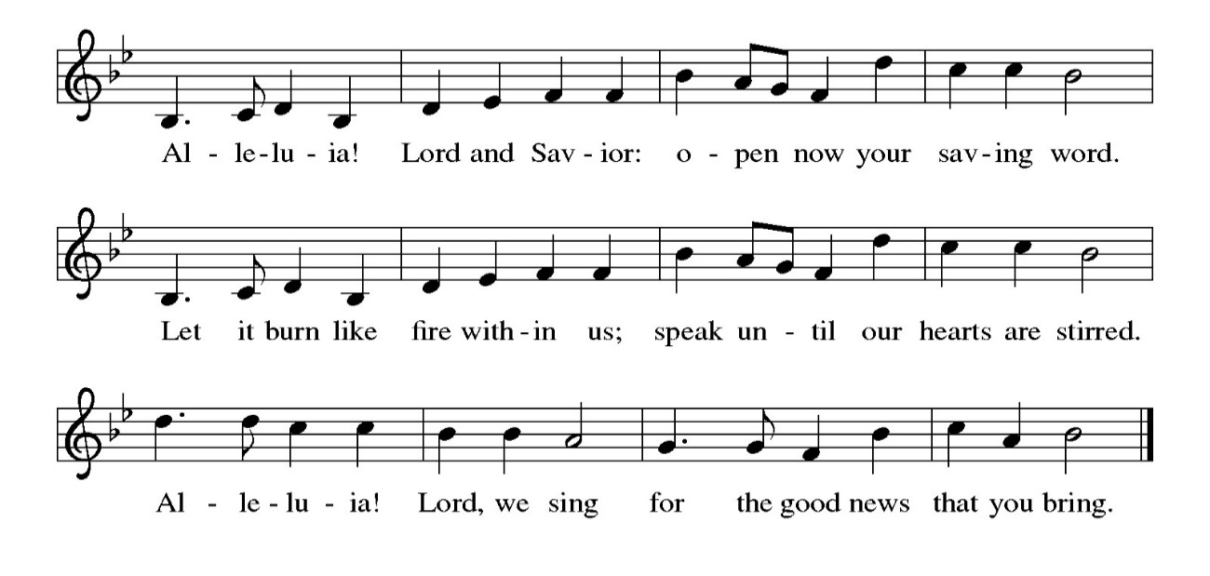
GOSPEL: John 20:19-23
Glory to you, O Lord.
The risen Jesus appears to his disciples, offering them a benediction, a commission, and the gift of the Holy Spirit.
¹⁹ When it was evening on that day, the first day of the week, and the doors were locked where the disciples were, for fear of the Jews, Jesus came and stood among them and said, “Peace be with you.” ²⁰ After he said this, he showed them his hands and his side. Then the disciples rejoiced when they saw the Lord. ²¹ Jesus said to them again, “Peace be with you. As the Father has sent me, so I send you.” ²² When he had said this, he breathed on them and said to them, “Receive the Holy Spirit. ²³ If you forgive the sins of any, they are forgiven them; if you retain the sins of any, they are retained.”
The gospel of the Lord. Praise to you, O Christ.

SERMON

HYMN OF THE DAY: WOV#648 Spirit, Sprit of Gentleness
Refrain: Spirit, Spirit of gentleness, blow through the wilderness calling and free;
Spirit, Spirit of restlessness, stir me from placidness, wind, wind on the sea.

1 You moved on the waters, you called to the deep,
then you coaxed up the mountains from the valleys of sleep;
and over the eons you called to each thing:
"Awake from your slumbers and rise on your wings." Refrain

2 You swept through the desert, you stung with the sand,
and you goaded your people with a law and a land;
and when they were blinded with idols and lies,
then you spoke through your prophets to open their eyes. Refrain

3 You sang in a stable, you cried from a hill,
then you whispered in silence when the whole world was still;
and down in the city you called once again,
when you blew through your people on the rush of the wind. Refrain

4 You call from tomorrow, you break ancient schemes.
From the bondage of sorrow all the captives dream dreams;
our women see visions, our men clear their eyes.
With bold new decisions your people arise. Refrain
Text: James K. Manley, b. 1940. Text © 1978 James K. Manley, admin. Augsburg Fortress.
APOSTLES’ CREED
I believe in God, the Father almighty, creator of heaven and earth.

I believe in Jesus Christ, God’s only Son, our Lord, who was conceived by the Holy Spirit, born of the virgin Mary, suffered under Pontius Pilate, was crucified, died, and was buried; he descended into hell. On the third day he rose again; he ascended into heaven, he is seated at the right hand of the Father, and he will come to judge the living and the dead.

I believe in the Holy Spirit, the holy catholic church, the communion of saints, the forgiveness of sins, the resurrection of the body, and the life everlasting. Amen.

THE PRAYERS
Trusting in the power of Christ’s resurrection to heal and redeem our broken world, let us pray for the needs of all creation.
A brief silence.
O God, you send the Holy Spirit to gather your church into one. Inspire all ministers of the gospel to speak prophetic and hope-filled words to all whom they encounter. Bless the work of interreligious dialogue. Merciful God,
receive our prayer.
You send the Holy Spirit to renew the face of the earth. Protect all living things, bring forth clean water and abundant food, and grant us wonder as we contemplate all you have made. Merciful God,
receive our prayer.
You send the Holy Spirit to break down the barriers of communication among nations. Bestow peace in war-torn areas, guide all in government and society to work for justice, and guard those serving in the armed forces, especially this weekend as we remember those who died in service to their country. Merciful God,
receive our prayer.
You send the Holy Spirit to accompany those who feel abandoned. Provide food for those who hunger and drink for those who thirst, soothe those who are anxious or bereaved, comfort those who are sick or suffering, and answer all who call upon your name (especially). Merciful God,
receive our prayer.
You send the Holy Spirit through the gift of baptism. Bless both those preparing for or affirming their baptism. May they be encouraged by this community of faith as they live out their baptismal promises. Merciful God,
receive our prayer.
Here other prayers may be offered.
You send the Holy Spirit to console us in our grief. We give you thanks for our ancestors in the faith whose witness to your mighty works continues to inspire our lives. Merciful God,
receive our prayer.
God of resurrection power, use us and these prayers to proclaim the good news of new life to all the world, through Jesus Christ, our risen Savior.
Amen.

PEACE
The peace of the Lord be with you always.
And also with you

OFFERTORY SENTENCE
As we come to this time of offering, we invite you to give as you feel led, and we thank you for your generosity and faithful support of the work God is doing through our church.

OFFERTORY HYMN: #564 Praise God, from Whom All Blessings Flow (inclusive language)
Praise God, from whom all blessings flow;
Praise God, all creatures here below;
Praise God, above, ye heav’nly host;
Creator, Christ, and Holy Ghost. Amen.

OFFERTORY PRAYER
Merciful God, accept the fruits of our labor, gathered to give you glory. You have set a table before us, a glimpse of that great day when we will hunger and thirst no more.
May You prepare us now to be nourished, so that goodness and mercy may follow us and bless the world you love. In the name of Jesus,
Amen.

COMMUNION
THE GREAT THANKSGIVING
The Lord be with you.
And also with you.
Lift up your hearts.
We lift them to the Lord.
Let us give thanks to the Lord our God.
It is right to give our thanks and praise.

THE PROPER PREFACE: It is indeed right and salutary…

SANCTUS
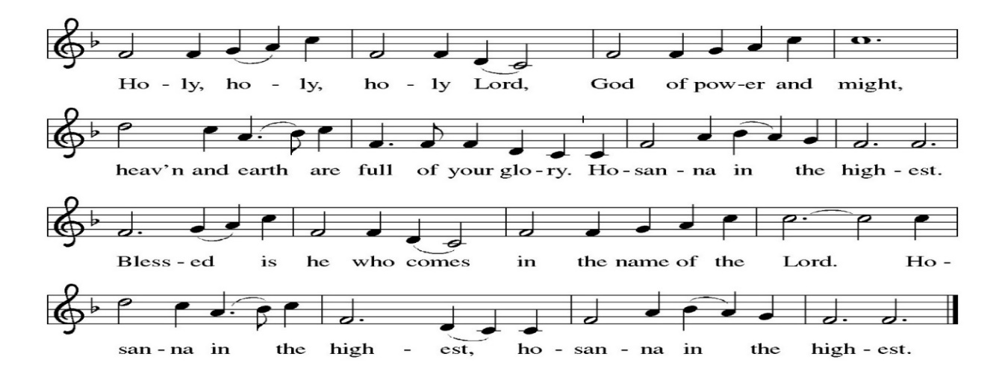
PRAYER OF INSTITUTION

LORD’S PRAYER
Gathered into one by the Holy Spirit, let us pray as Jesus taught us.
Our Father, who art in heaven, hallowed be thy name, thy kingdom come, thy will be done, on earth as it is in heaven. Give us this day our daily bread; and forgive us our trespasses, as we forgive those who trespass against us; and lead us not into temptation, but deliver us from evil. For thine is the kingdom, and the power, and the glory, forever and ever. Amen.

OR

Our Father in heaven, hallowed be your name, your kingdom come, your will be done, on earth as in heaven. Give us today our daily bread. Forgive us our sins as we forgive those who sin against us. Save us from the time of trial, and deliver us from evil. For the kingdom, the power, and the glory are yours now and forever. Amen

INVITATION TO COMMUNION
Come to the table of new life. Receive the risen Lord.

COMMUNION ANTHEM
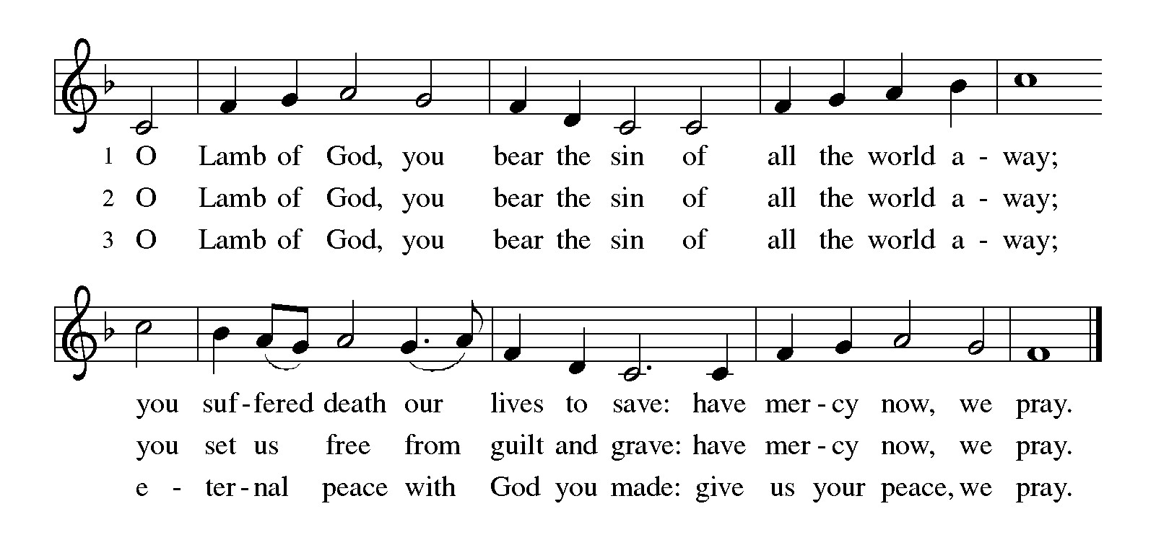
POST COMMUNION PRAYER
Holy One, through this meal you have made your home among us and are making all things new. Send us now to speak peace to anxious hearts, to love our enemies, and to bring your healing to the nations. In the name of Jesus,
Amen.

BLESSING
God Almighty, who is the beginning and the end, Jesus Christ, the firstborn of the dead, and the Spirit, our advocate and peace, ☩ bless you now and forever.
Amen.

SENDING HYMN LBW#523 Holy Spirit Ever Dwelling

1 Holy Spirit, ever dwelling in the holiest realms of light;
Holy Spirit, ever brooding o'er a world of gloom and night;
Holy Spirit, ever raising those of earth to thrones on high;
living, life-imparting Spirit, you we praise and magnify.

2 Holy Spirit, ever living as the church's very life;
Holy Spirit, ever striving through us in a ceaseless strife;
Holy Spirit, ever forming in the church the mind of Christ:
you we praise with endless worship for your gifts and fruits unpriced.

3 Holy Spirit, ever working through the church's ministry;
quick'ning, strength'ning, and absolving, setting captive sinners free;
Holy Spirit, ever binding age to age and soul to soul
in communion never ending, you we worship and extol.
Text: Timothy Rees, 1874-1939, alt.

DISMISSAL
Go in peace. Praise the Lord. Alleluia!
Thanks be to God. Alleluia!

POSTLUDE
PRAYER LIST
(Please call the office to add/or update the Prayer List)

Marty Cosgriff, Charlotte Berndt, God’s guidance and wisdom for Cameron, healing for Helene Rabe, Fred W. Taylor, Madeline McEntyre, Scott Tyler, Jim Lynch, Shirley Lustig, Barbara who is in hospice, Michele Hansen, Lisa Weathers, Matthew Allison, Antonio Jamir and family, Joann and Tye Peyton, Linda Fairless, Shamari Johnson Moore, Suzy and John Henry, Gudrun Schamoni, God’s protection for Rhea, David Forsyth, Phil Arthur, Ruth Wolf with cancer, Peter Dow, Francis and Rueben, Anne with cancer, protection for Audrey Frangiamore, Susan Rados, Jack L Taylor for mobility and strength, healing and God’s guidance for Bill Kay, Fred Schweiger.

ANNOUNCEMENTS

Fellowship Hour: We love spending time together after worship, please join us in Parish Hall and feel free to bring something yummy to share!
Council monthly meeting: The Council meets 3rd Wednesday of every month. The next meeting is June 17, 2026 at 7PM via Zoom. Congregation members are welcome at the meetings,
Next Dine and Connect, Tomorrow, May 25: This is an interfaith and community run program to feed the houseless and food insecure in Alameda. Volunteers are need for all facets of the meal especially since Terry O’Connor is on vacation. Contact Judy Blank if you’d like to help.
Immanuel Website: You can find our weekly worship bulletin, worship live streaming link, church calendar, events announcements and much more online. Please visit:
Donate to Immanuel Online: It is important that our offerings continue to support our ministry. You can tithe to Immanuel several different ways including PayPal via the church website, through the mail: 1910 Santa Clara Avenue, Alameda, CA 94501, or through the church mail slot located to the right of the metal gate on Santa Clara Ave. Thank you!
Pastor Availability & Contact Info: Rev. Crystal Larsen Stewart’s office hours are Fridays. She can be reached by phone and email to schedule time for pastoral care and appointments. Cell: 510-693-1974. Email: pastor@immanuel-alameda.org
Church Office: Hours vary and are available by appointment. Please call the office at 510-523-0659 and leave a message for pastor or volunteers. We are in need of more volunteers for tasks like the Sunday bulletin, organizing and checking voicemail; please call if you can help.
Recycling: Pure Recycling is available by volunteer Walter McQuesten-510-521-1356. Collects: Plastic: CRV, empty, crushed, bagged, no lids (put lids in own recycle); Aluminum: empty, crushed/flattened and separated; Glass bottles: clean and boxed. It is good to recycle.

