IMMANUEL LUTHERAN CHURCH
Secomd Sunday Easter
April 12, 2026

Worship in person or online Sunday at 10 AM
See our website for the link: www.immanuel-alameda.org
For those online wanting to participate in communion, please have bread & wine/or juice available.

Rev. Crystal Larsen Stewart · pastor@immanuel-alameda.org
Church: 1420 Lafayette Street Alameda, CA 94501; Office: 1910 Santa Clara Ave.
(510) 523-0659 · office@immanuel-alameda.org
THE GATHERING
The congregation’s parts are in bold type.

PRELUDE

WORDS OF WELCOME AND ANNOUNCEMENTS

Thanksgiving for Baptism
All may make the sign of the cross, the sign that is marked at baptism, as the presiding minister begins.

Alleluia! Christ is risen.
Christ is risen, indeed. Alleluia!

In the name of ☩ the One
who was, who is, and who is to come.
Amen.

Baptized into Christ’s death and resurrection,
and called to live the baptized life,
let us give thanks for the gifts of baptism.

Water may be poured into the font as the presiding minister continues.
Merciful God,
you are the one who was, who is, and who is to come.
You lead us beside still waters.
We thank you for the waters of creation:
morning dew, gentle rain, roaring waves.
We thank you for the waters that nourish us.
Blessed are you.
You guide us to springs of the water of life.
Jesus Christ, you are the faithful witness
who accompanies us on our journeys.
We give you thanks for your life-giving death and resurrection.
We praise you for joining us in joy and sorrow.
Blessed are you.
You guide us to springs of the water of life.
Holy Spirit, you anoint our head with oil and our cup overflows.
Break down barriers that divide us.
Fill us with the breath of peace.
Blessed are you.
You guide us to springs of the water of life.
Holy One, we thank you for the gifts and grace of baptism,
and for making us a new creation.
We join with saints and angels, giving you honor and praise,
now and forever.
Amen.

GATHERING HYMN: LBW #143 Now All the Vault of Heaven Resounds

1 Now all the vault of heav’n resounds
in praise of love that still abounds:
“Christ has triumphed! He is living!”
Sing, choirs of angels, loud and clear!
Repeat their song of glory here:
Christ has triumphed! Christ has triumphed!”
Alleluia, alleluia, alleluia!

2 Eternal is the gift he brings,
therefore our heart with rapture sings:
“Christ has triumphed! He is living!”
Now still he comes to give us life
and by his presence stills all strife.
Christ has triumphed! He is living!
Alleluia, alleluia, alleluia!
3 Oh, fill us, Lord, with dauntless love;
set heart and will on things above
that we conquer through your triumph;
grant grace sufficient for life’s day
that by our lives we truly say:
Christ has triumphed! He is living!
Alleluia, alleluia, alleluia!

4 Adoring praises now we bring
and with the heav’nly blessed sing:
“Christ has triumphed! Alleluia!”
Be to the Father, and our Lord,
to Spirit blest, most holy God,
all the glory, never ending!
Alleluia, alleluia, alleluia!

Text: Paul Z. Strodach, 1876-1947, alt. © 1958 Service Book and Hymnal, admin. Augsburg Fortress
GREETING
The grace of our Lord Jesus Christ, the love of God, and the communion of the Holy Spirit be with you all.
And also with you.

HYMN OF PRAISE: WOV #789
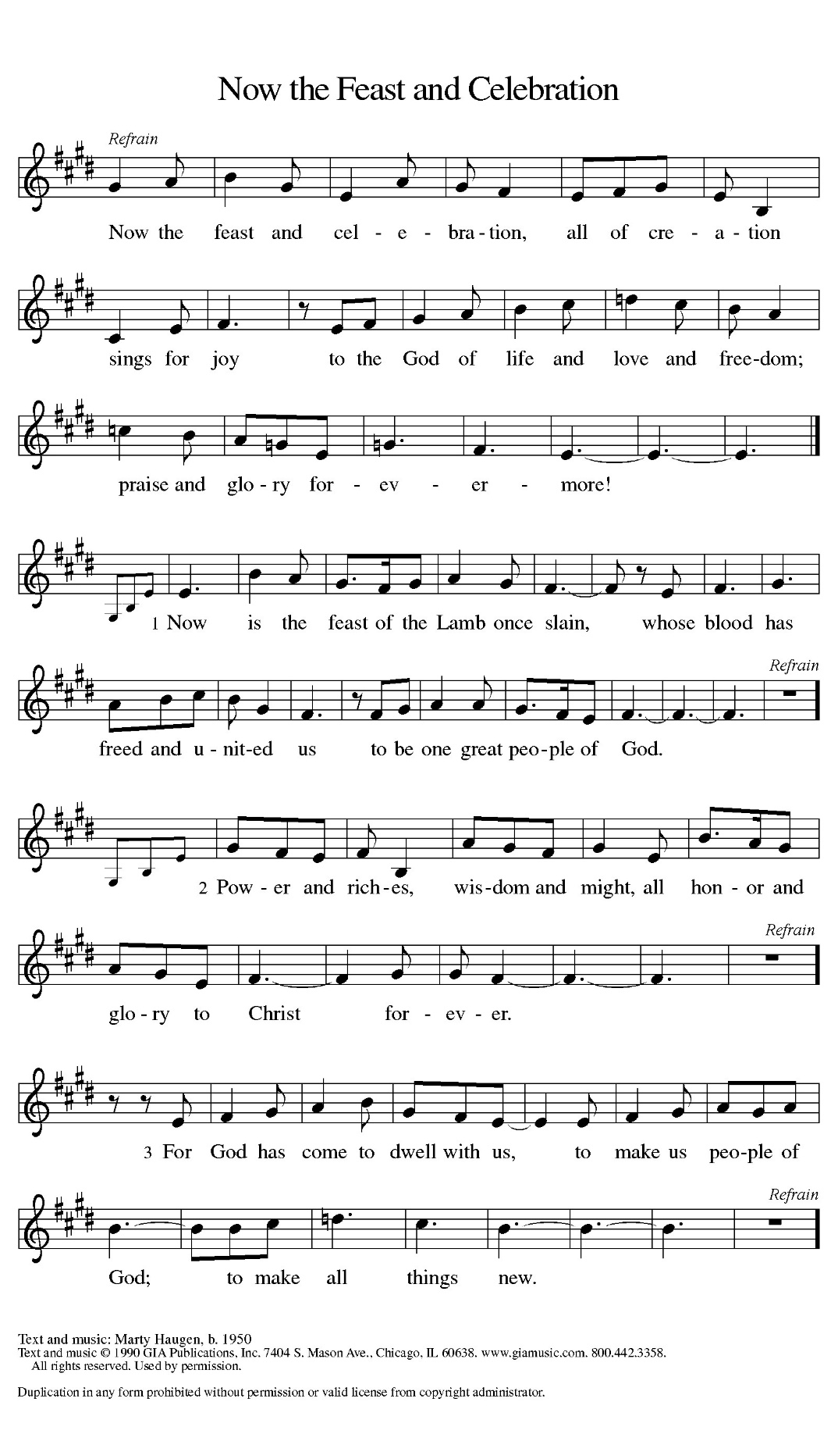
PRAYER OF THE DAY
Almighty and eternal God, the strength of those who believe and the hope of those who doubt, may we, who have not seen, have faith in you and receive the fullness of Christ’s blessing, who lives and reigns with you and the Holy Spirit, one God, now and forever.. Amen.
THE WORD

FIRST READING: 1 Peter 1:3-9
This epistle was written to encourage Christians experiencing hardships and suffering because of their faith in Christ. The letter opens by blessing God for the living hope we have through Christ’s resurrection even amid difficult circumstances and surroundings.
³ Blessed be the God and Father of our Lord Jesus Christ! By his great mercy he has given us a new birth into a living hope through the resurrection of Jesus Christ from the dead ⁴ and into an inheritance that is imperishable, undefiled, and unfading, kept in heaven for you, ⁵ who are being protected by the power of God through faith for a salvation ready to be revealed in the last time. ⁶ In this you rejoice, even if now for a little while you have had to suffer various trials, ⁷ so that the genuineness of your faith—being more precious than gold that, though perishable, is tested by fire—may be found to result in praise and glory and honor when Jesus Christ is revealed. ⁸ Although you have not seen him, you love him, and even though you do not see him now, you believe in him and rejoice with an indescribable and glorious joy, ⁹ for you are receiving the outcome of your faith, the salvation of your souls.
Word of God. Word of life. Thanks be to God.

PSALM: Psalm 16 (read responsively)
¹ Protect me, O God, for I take refuge in you; I have said to the Lord, “You are my Lord, my good above all other.”
² All my delight is in the godly that are in the land, upon those who are noble among the people.
³ But those who run after other gods shall have their troubles multiplied.
⁴ I will not pour out drink offerings to such gods, never take their names upon my lips.
⁵ O Lord, you are my portion and my cup; it is you who uphold my lot.
⁶ My boundaries enclose a pleasant land; indeed, I have a rich inheritance.
⁷ I will bless the Lord who gives me counsel; my heart teaches me night after night.
⁸ I have set the Lord always before me; because God is at my right hand, I shall not be shaken.
⁹ My heart, therefore, is glad, and my spirit rejoices; my body also shall rest in hope.
¹⁰ For you will not abandon me to the grave, nor let your holy one |ee the pit.
¹¹ You will show me the path of life; in your presence there is fullness of joy, and in your right hand are pleasures forevermore

GOSPEL ACCLAMATION
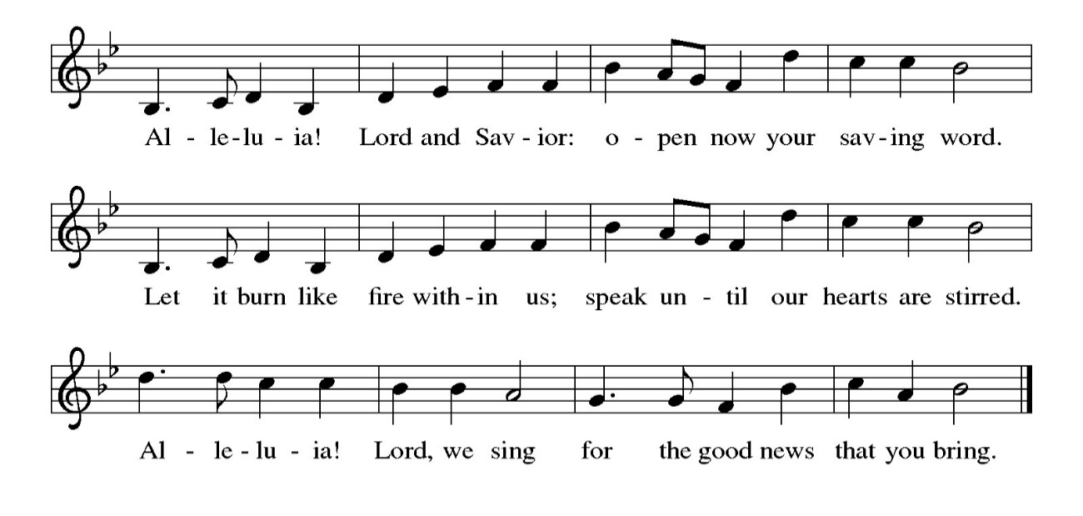
GOSPEL: John 20:19-31
Glory to you, O Lord.
¹⁹ When it was evening on that day, the first day of the week, and the doors were locked where the disciples were, for fear of the Jews, Jesus came and stood among them and said, “Peace be with you.” ²⁰ After he said this, he showed them his hands and his side. Then the disciples rejoiced when they saw the Lord. ²¹ Jesus said to them again, “Peace be with you. As the Father has sent me, so I send you.” ²² When he had said this, he breathed on them and said to them, “Receive the Holy Spirit. ²³ If you forgive the sins of any, they are forgiven them; if you retain the sins of any, they are retained.”
²⁴ But Thomas (who was called the Twin), one of the twelve, was not with them when Jesus came. ²⁵ So the other disciples told him, “We have seen the Lord.” But he said to them, “Unless I see the mark of the nails in his hands and put my finger in the mark of the nails and my hand in his side, I will not believe.”
²⁶ A week later his disciples were again in the house, and Thomas was with them. Although the doors were shut, Jesus came and stood among them and said, “Peace be with you.” ²⁷ Then he said to Thomas, “Put your finger here and see my hands. Reach out your hand and put it in my side. Do not doubt but believe.” ²⁸ Thomas answered him, “My Lord and my God!” ²⁹ Jesus said to him, “Have you believed because you have seen me? Blessed are those who have not seen and yet have come to believe.”
³⁰ Now Jesus did many other signs in the presence of his disciples that are not written in this book. ³¹ But these are written so that you may continue to believe that Jesus is the Messiah, the Son of God, and that through believing you may have life in his name.
The gospel of the Lord. Praise to you, O Christ.
SERMON

HYMN OF THE DAY: LBW #139 O Sons and Daughters of the King (vs.1, 5-8)

Alleluia, alleluia, alleluia!

1 O sons and daughters of the King, whom heav’nly hosts in glory sing,
today the grave has lost its sting! Alleluia!

5 When Thomas first the tidings heard, that they had seen the risen Lord,
he doubted the disciples’ word. Alleluia!

6 “My pierced side, O Thomas, see, and look upon my hands, my feet;
not faithless, but believing be.” Alleluia!

7 No longer Thomas then denied; he saw the feet, the hands, the side;
“You are my Lord and God!” he cried. Alleluia!

8 How blest are they who have not seen, and yet whose faith has constant been,
for they eternal life shall win. Alleluia!
Alleluia, Alleluia, Alleluia!
Text: attr. Jean Tisserand, d. 1494; tr. John M. Neale, 1818-1866, alt.
NICENE CREED
We believe in one God, the Father, the Almighty,
maker of heaven and earth,
of all that is, seen and unseen.
We believe in one Lord, Jesus Christ, the only Son of God,
eternally begotten of the Father,
God from God, Light from Light,
true God from true God,
begotten, not made,
of one Being with the Father;
through him all things were made.
For us and for our salvation
he came down from heaven,
was incarnate of the Holy Spirit and the virgin Mary
and became truly human.
For our sake he was crucified under Pontius Pilate;
he suffered death and was buried.
On the third day he rose again
in accordance with the scriptures;
he ascended into heaven
and is seated at the right hand of the Father.
He will come again in glory to judge the living and the dead,
and his kingdom will have no end.
We believe in the Holy Spirit, the Lord, the giver of life,
who proceeds from the Father and the Son,*
who with the Father and the Son is worshiped and glorified,
who has spoken through the prophets.
We believe in one holy catholic and apostolic church.
We acknowledge one baptism for the forgiveness of sins.
We look for the resurrection of the dead,
and the life of the world to come. Amen.

THE PRAYERS
Trusting in the power of Christ’s resurrection to heal and redeem our broken world, let us pray for the needs of all creation.
A brief silence.
Almighty God, you give life to the dead and call into existence things that do not exist. Breathe your Spirit upon us, that our faith may be renewed day by day. Merciful God,
receive our prayer.
Maker of heaven and earth, your mercies are new every morning. Open us to the wonders of creation, from the beauty of flowers to the complexity of subatomic particles. Merciful God,
receive our prayer.
God of peace, in every place where conflict rages, sow seeds of calm and openness to reconciliation. Strengthen the resolve of leaders and citizens to work for peace in their nations. Merciful God,
receive our prayer.
Healing God, come alongside all who are doubting, fearful, or suffering in any way. Reveal to them your presence and assure them of the inheritance you have prepared for them. Merciful God,
receive our prayer.
Giver of joy, let this assembly be a place of genuine love and mutual affection. Deepen our care for one another and help us to embody your forgiving and sacrificial love. Merciful God,
receive our prayer.
Here other prayers may be offered .Eternal One, we give thanks for saints who were faithful unto death and have joined the church triumphant. Inspire us by their witness and bring us with them into your glorious presence. Merciful God,
receive our prayer.
God of resurrection power, use us and these prayers to proclaim the good news of new life to all the world, through Jesus Christ, our risen Savior.
Amen.

PEACE
The peace of the Lord be with you always.
And also with you

OFFERTORY SENTENCE
As we come to this time of offering, we invite you to give as you feel led, and we thank you for your generosity and faithful support of the work God is doing through our church.

OFFERTORY HYMN: #564 Praise God, from Whom All Blessings Flow (inclusive language)
Praise God, from whom all blessings flow;
Praise God, all creatures here below;
Praise God, above, ye heav’nly host;
Creator, Christ, and Holy Ghost. Amen.

OFFERTORY PRAYER
Merciful God, accept the fruits of our labor, gathered to give you glory. You have set a table before us, a glimpse of that great day when we will hunger and thirst no more.
May You prepare us now to be nourished, so that goodness and mercy may follow us and bless the world you love. In the name of Jesus,
Amen.

COMMUNION
THE GREAT THANKSGIVING
The Lord be with you.
And also with you.
Lift up your hearts.
We lift them to the Lord.
Let us give thanks to the Lord our God.
It is right to give our thanks and praise.

THE PROPER PREFACE: It is indeed right and salutary…

SANCTUS
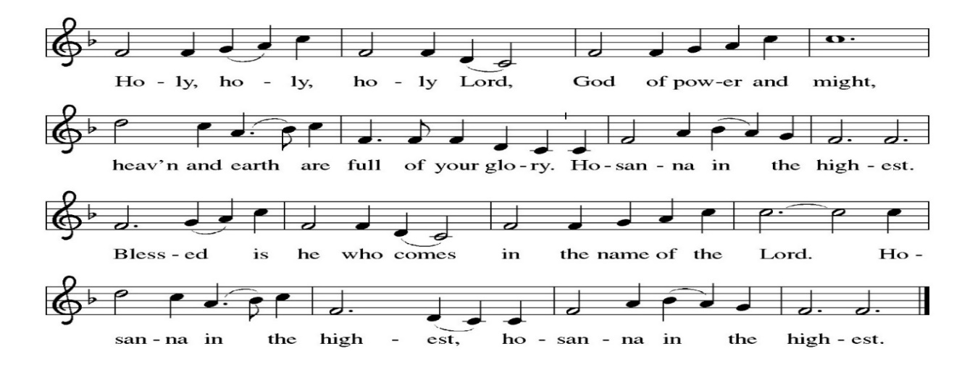
PRAYER OF INSTITUTION

LORD’S PRAYER
Gathered into one by the Holy Spirit, let us pray as Jesus taught us.
Our Father, who art in heaven, hallowed be thy name, thy kingdom come, thy will be done, on earth as it is in heaven. Give us this day our daily bread; and forgive us our trespasses, as we forgive those who trespass against us; and lead us not into temptation, but deliver us from evil. For thine is the kingdom, and the power, and the glory, forever and ever. Amen.

OR

Our Father in heaven, hallowed be your name, your kingdom come, your will be done, on earth as in heaven. Give us today our daily bread. Forgive us our sins as we forgive those who sin against us. Save us from the time of trial, and deliver us from evil. For the kingdom, the power, and the glory are yours now and forever. Amen

INVITATION TO COMMUNION
Come to the table of new life. Receive the risen Lord.

COMMUNION ANTHEM
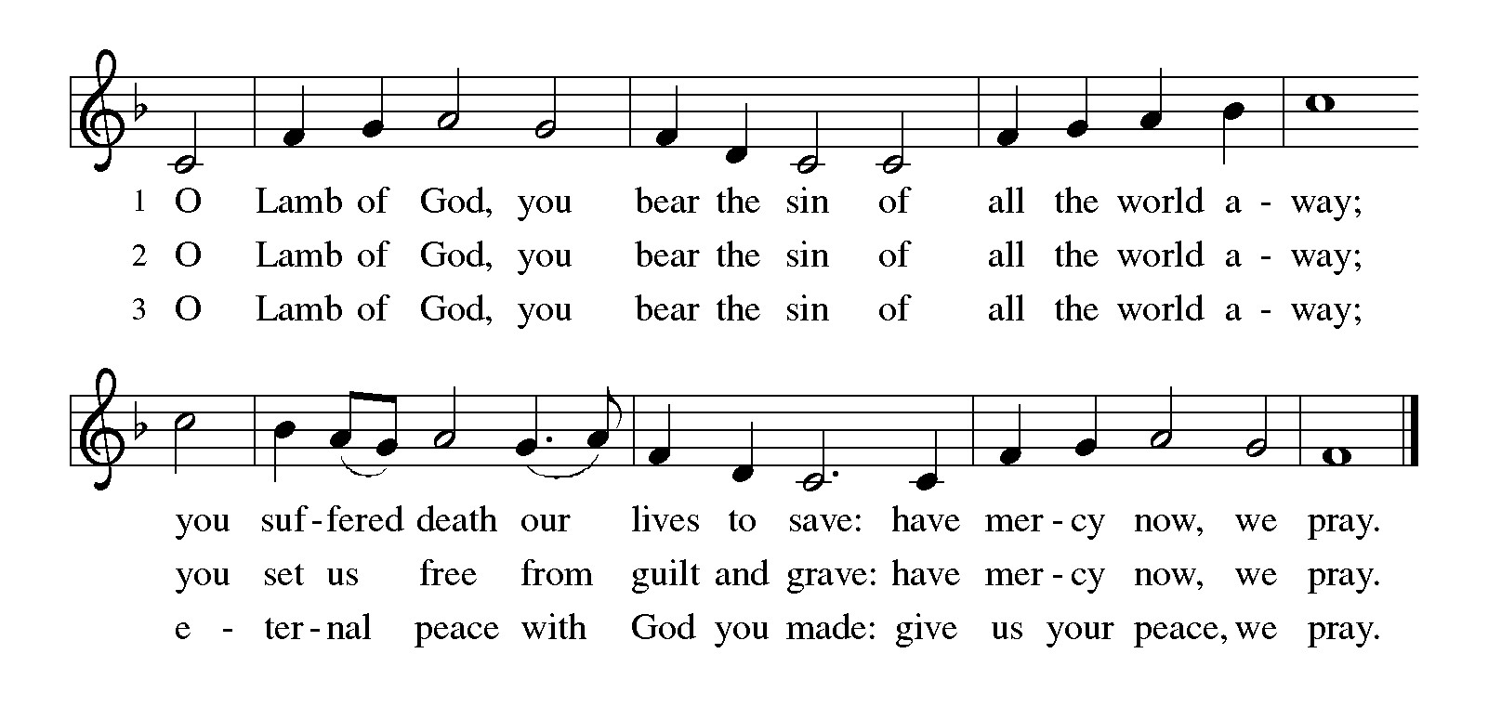
POST COMMUNION PRAYER
Holy One, through this meal you have made your home among us and are making all things new. Send us now to speak peace to anxious hearts, to love our enemies, and to bring your healing to the nations. In the name of Jesus,
Amen.

BLESSING
God Almighty, who is the beginning and the end, Jesus Christ, the firstborn of the dead, and the Spirit, our advocate and peace, ☩ bless you now and forever.
Amen.

SENDING HYMN: WOV#612 Halle, Halle, Hallelujah

Halle, halle, hallelujah.
Halle, halle, hallelujah.
Halle, halle, hallelujah.
Hallelujah. Hallelujah.

DISMISSAL
Go in peace. Praise the Lord. Alleluia!
Thanks be to God. Alleluia!

POSTLUDE
 EASTER FLOWERS IN MEMORY OR HONOR OF

Gary and Judy Blank: Harry and Lahala Blank, Norman and Anne Colbath
Ruth and Peter Dow: Family and friends who have passed away
Linda Fairless: Family and friends who have passed away.
Gudrun Schamoni: Henry Schamoni
Karen Wirth: Marian Pedroarena, Kristin Wirth, Gerry Wirth

PRAYER LIST
(Please call the office to add/or update the Prayer List)

Marty Cosgriff, Charlotte Berndt, God’s protection for David Powell, God’s guidance and wisdom for Cameron, healing for Helene Rabe, Fred W. Taylor, Madeline McEntyre, Scott Tyler, Jim Lynch, Shirley Lustig, Barbara who is in hospice, Michele Hansen, Lisa Weathers, Matthew Allison, Antonio Jamir and family, Joann and Tye Peyton, Linda Fairless, Shamari Johnson Moore, Suzy and John Henry, Gudrun Schamoni, God’s protection for Rhea, David Forsyth, Phil Arthur, Ruth Wolf with cancer, Peter Dow, Francis and Rueben, Anne with cancer, protection for Audrey Frangiamore, Susan Rados, Jack L Taylor for mobility and strength healing, healing and God’s guidance for Bill Kay, Fred Schweiger.

ANNOUNCEMENTS

Spring Boutique, Saturday, April 25, 2026 10AM-2PM: Come shop at our Fun & Festive event! Our local artists, artisans & crafters showcase unique & beautiful wares! Glorious array of finely handcrafted items and goodies for the whole family!
PlanetCPR.org will meet the 2nd & 4th Saturdays of each month from 10am-1pm in the Parish Hall, They have offered ILC members a 20% discount on their CPR classes using promo code ILC20.
Fellowship Hour: We love spending time together after worship, please join us in Parish Hall and feel free to bring something yummy to share!
Council monthly meeting: The Council meets 3rd Wednesday of every month. The next meeting is April 15, 2026 at 7PM via Zoom. Congregation members are welcome at the meetings,
Next Dine and Connect, April 27: This is an interfaith and community run program to feed the houseless and food insecure in Alameda. Volunteers are need for all facets of the meal. See Terry O’Connor if you’d like to help.
Immanuel Website: You can find our weekly worship bulletin, worship live streaming link, church calendar, events announcements and much more online. Please visit:
Donate to Immanuel Online: It is important that our offerings continue to support our ministry. You can tithe to Immanuel several different ways including PayPal via the church website, through the mail: 1910 Santa Clara Avenue, Alameda, CA 94501, or through the church mail slot located to the right of the metal gate on Santa Clara Ave. Thank you!
Pastor Availability & Contact Info: Rev. Crystal Larsen Stewart’s office hours have changed from Thursdays to Fridays. She can be reached by phone and email to schedule time for pastoral care and appointments. Cell: 510-693-1974. Email: pastor@immanuel-alameda.org
Church Office: Hours vary and are available by appointment. Please call the office at 510-523-0659 and leave a message for pastor or volunteers. We are in need of more volunteers for tasks like the Sunday bulletin, organizing and checking voicemail; please call if you can help.
Recycling: Pure Recycling is available by volunteer Walter McQuesten-510-521-1356. Collects: Plastic: CRV, empty, crushed, bagged, no lids (put lids in own recycle); Aluminum: empty, crushed/flattened and separated; Glass bottles: clean and boxed. It is good to recycle!

