IMMANUEL LUTHERAN CHURCH
THIRD SUNDAY IN LENT
March 8, 2026

Worship in person or online Sunday at 10 AM
See our website for the link: www.immanuel-alameda.org
For those online wanting to participate in communion, please have bread & wine/or juice available.

Rev. Crystal Larsen Stewart · pastor@immanuel-alameda.org
Church: 1420 Lafayette Street Alameda, CA 94501; Office: 1910 Santa Clara Ave.
(510) 523-0659 · office@immanuel-alameda.org

THE GATHERING
The congregation’s parts are in bold type.

PRELUDE

WORDS OF WELCOME AND ANNOUNCEMENTS

GATHERING HYMN: LBW#104 In the Cross of Christ I Glory

1 In the cross of Christ I glory,
tow'ring o'er the wrecks of time.
All the light of sacred story
gathers round its head sublime.

2 When the woes of life o'ertake me,
hopes deceive, and fears annoy,
never shall the cross forsake me;
lo, it glows with peace and joy.
Text: John Bowring, 1792-1872
3 When the sun of bliss is beaming
light and love upon my way,
from the cross the radiance streaming
adds more luster to the day.

4 Bane and blessing, pain and pleasure,
by the cross are sanctified;
peace is there that knows no measure,
joys that through all time abide.

CONFESSION AND FORGIVENESS
Almighty God, to whom all hearts are open, all desires known, and from whom no secrets are hid: Cleanse the thoughts of our hearts by the inspiration of your Holy Spirit, that we may perfectly love you and worthily magnify your holy name, through Jesus Christ our Lord. Amen

If we say we have no sin, we deceive ourselves, and the truth is not in us. But if we confess our sins, God who is faithful and just will forgive our sins and cleanse us from all unrighteousness.

Most merciful God,
we confess that we are captive to sin and cannot free ourselves. We have sinned against you in thought, word, and deed, by what we have done and by what we have left undone. We have not loved you with our whole heart; we have not loved our neighbors as ourselves. For the sake of your Son, Jesus Christ, have mercy on us. Forgive us, renew us, and lead us, so that we may delight in your will and walk in your ways, to the glory of your holy name. Amen

Almighty God, in his mercy, has given his Son to die for us and, for his sake, forgives us all our sins. As a called and ordained minister of the Church of Christ, and by his authority, I therefore declare to you the entire forgiveness of all your sins, in the name of the Father, and of the ☩ Son, and of the Holy Spirit.
Amen.

GREETING
The grace of our Lord Jesus Christ, the love of God, and the communion of the Holy Spirit with you all.
And also with you.

KYRIE
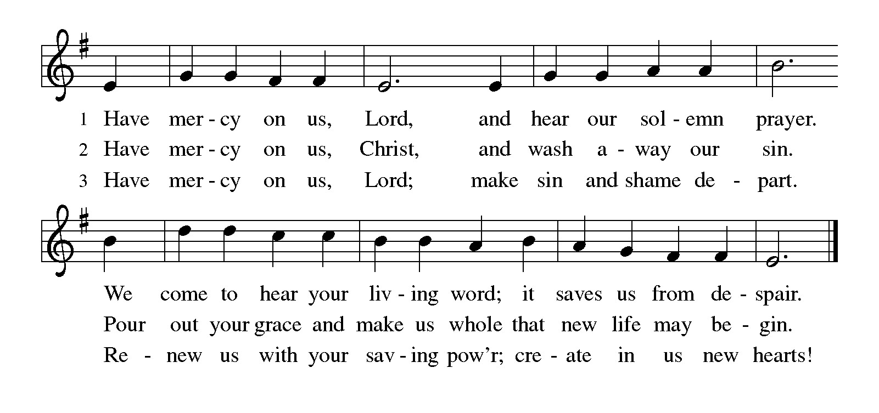
PRAYER OF THE DAY
Merciful God, the fountain of living water, you quench our thirst and wash away our sin. Give us this water always. Bring us to drink from the well that flows with the beauty of your truth through Jesus Christ, our Savior and Lord, who lives and reigns with you and the Holy Spirit, one God, now and forever. Amen.

THE WORD

First Reading: Exodus 17:1-7
Because the thirsty Israelites quarreled with Moses and put God to the test, Moses cried out in desperation to God. God commanded Moses to strike the rock to provide water for the people. The doubt-filled question—“Is the Lord among us or not?”—received a very positive answer.
¹ From the wilderness of Sin the whole congregation of the Israelites journeyed by stages, as the Lord commanded. They camped at Rephidim, but there was no water for the people to drink. ² The people quarreled with Moses and said, “Give us water to drink.” Moses said to them, “Why do you quarrel with me? Why do you test the Lord?” ³ But the people thirsted there for water, and the people complained against Moses and said, “Why did you bring us out of Egypt, to kill us and our children and livestock with thirst?” ⁴ So Moses cried out to the Lord, “What shall I do for this people? They are almost ready to stone me.” ⁵ The Lord said to Moses, “Go on ahead of the people and take some of the elders of Israel with you; take in your hand the staff with which you struck the Nile and go. ⁶ I will be standing there in front of you on the rock at Horeb. Strike the rock, and water will come out of it, so that the people may drink.” Moses did so, in the sight of the elders of Israel. ⁷ He called the place Massah and Meribah, because the Israelites quarreled and tested the Lord, saying, “Is the Lord among us or not?”
Word of God. Word of life. Thanks be to God.

Psalm: Psalm 95
¹ Come, let us sing | to the Lord;
let us shout for joy to the rock of | our salvation.
² Let us come before God’s presence | with thanksgiving
and raise a loud shout to the | Lord with psalms.
³ For you, Lord, | are a great God,
and a great ruler a- | bove all gods.
⁴ In your hand are the caverns | of the earth;
the heights of the hills are | also yours.
⁵ The sea is yours, | for you made it,
and your hands have molded | the dry land.
⁶ Come, let us worship | and bow down,
let us kneel before the | Lord our maker.
⁷ For the Lord is our God, and we are the people of God’s pasture and the sheep | of God’s hand.
Oh, that today you would | hear God’s voice!
⁸ “Harden | not your hearts,
as at Meribah, as on that day at Massah | in the desert.
⁹ There your ancestors | tested me,
they put me to the test, though they had | seen my works.
¹⁰ Forty years I loathed that gener- | ation, saying,
‘The heart of this people goes astray; they do not | know my ways.’
¹¹ Indeed I swore | in my anger,
‘They shall never come | to my rest.’ ”

Second Reading: Romans 5:1-11
Though we often hear that God helps those who help themselves, here Paul tells us that through Jesus’ death God helps utterly helpless sinners. Since we who had been enemies are reconciled to God in the cross, we now live in hope for our final salvation.
¹ Since we are justified by faith, we have peace with God through our Lord Jesus Christ, ² through whom we have obtained access to this grace in which we stand, and we boast in our hope of sharing the glory of God. ³ And not only that, but we also boast in our afflictions, knowing that affliction produces endurance, ⁴ and endurance produces character, and character produces hope, ⁵ and hope does not put us to shame, because God’s love has been poured into our hearts through the Holy Spirit that has been given to us.
⁶ For while we were still weak, at the right time Christ died for the ungodly. ⁷ Indeed, rarely will anyone die for a righteous person—though perhaps for a good person someone might actually dare to die. ⁸ But God proves his love for us in that while we still were sinners Christ died for us. ⁹ Much more surely, therefore, since we have now been justified by his blood, will we be saved through him from the wrath of God. ¹⁰ For if while we were enemies we were reconciled to God through the death of his Son, much more surely, having been reconciled, will we be saved by his life. ¹¹ But more than that, we even boast in God through our Lord Jesus Christ, through whom we have now received reconciliation.
Word of God. Word of life. Thanks be to God.

GOSPEL ACCLAMATION:
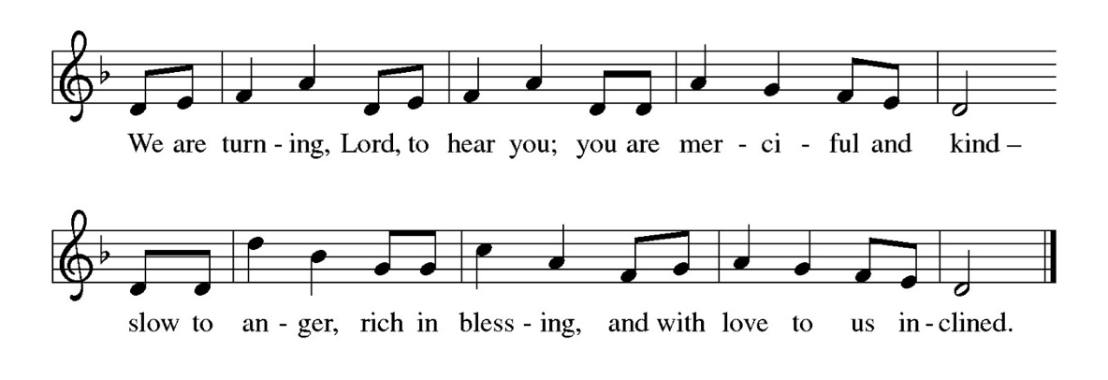
Gospel: John 4:5-42
Glory to you, O Lord.
⁵ [Jesus] came to a Samaritan city called Sychar, near the plot of ground that Jacob had given to his son Joseph.⁶ Jacob’s well was there, and Jesus, tired out by his journey, was sitting by the well. It was about noon.
⁷ A Samaritan woman came to draw water, and Jesus said to her, “Give me a drink.” ⁸ (His disciples had gone to the city to buy food.) ⁹ The Samaritan woman said to him, “How is it that you, a Jew, ask a drink of me, a woman of Samaria?” (Jews do not share things in common with Samaritans.) ¹⁰ Jesus answered her, “If you knew the gift of God and who it is that is saying to you, ‘Give me a drink,’ you would have asked him, and he would have given you living water.” ¹¹ The woman said to him, “Sir, you have no bucket, and the well is deep. Where do you get that living water? ¹² Are you greater than our ancestor Jacob, who gave us the well and with his sons and his flocks drank from it?” ¹³ Jesus said to her, “Everyone who drinks of this water will be thirsty again, ¹⁴ but those who drink of the water that I will give them will never be thirsty. The water that I will give will become in them a spring of water gushing up to eternal life.” ¹⁵ The woman said to him, “Sir, give me this water, so that I may never be thirsty or have to keep coming here to draw water.”
¹⁶ Jesus said to her, “Go, call your husband, and come back.” ¹⁷ The woman answered him, “I have no husband.” Jesus said to her, “You are right in saying, ‘I have no husband,’ ¹⁸ for you have had five husbands, and the one you have now is not your husband. What you have said is true!” ¹⁹ The woman said to him, “Sir, I see that you are a prophet. ²⁰ Our ancestors worshiped on this mountain, but you say that the place where people must worship is in Jerusalem.” ²¹ Jesus said to her, “Woman, believe me, the hour is coming when you will worship the Father neither on this mountain nor in Jerusalem. ²² You worship what you do not know; we worship what we know, for salvation is from the Jews. ²³ But the hour is coming and is now here when the true worshipers will worship the Father in spirit and truth, for the Father seeks such as these to worship him. ²⁴ God is spirit, and those who worship him must worship in spirit and truth.” ²⁵ The woman said to him, “I know that Messiah is coming” (who is called Christ). “When he comes, he will proclaim all things to us.” ²⁶ Jesus said to her, “I am he, the one who is speaking to you.”
²⁷ Just then his disciples came. They were astonished that he was speaking with a woman, but no one said, “What do you want?” or, “Why are you speaking with her?” ²⁸ Then the woman left her water jar and went back to the city. She said to the people, ²⁹ “Come and see a man who told me everything I have ever done! He cannot be the Messiah, can he?” ³⁰ They left the city and were on their way to him.
³¹ Meanwhile the disciples were urging him, “Rabbi, eat something.” ³² But he said to them, “I have food to eat that you do not know about.” ³³ So the disciples said to one another, “Surely no one has brought him something to eat?” ³⁴ Jesus said to them, “My food is to do the will of him who sent me and to complete his work. ³⁵ Do you not say, ‘Four months more, then comes the harvest’? But I tell you, look around you, and see how the fields are ripe for harvesting. ³⁶ The reaper is already receiving wages and is gathering fruit for eternal life, so that sower and reaper may rejoice together. ³⁷ For here the saying holds true, ‘One sows and another reaps.’ ³⁸ I sent you to reap that for which you did not labor. Others have labored, and you have entered into their labor.”
³⁹ Many Samaritans from that city believed in him because of the woman’s testimony, “He told me everything I have ever done.” ⁴⁰ So when the Samaritans came to him, they asked him to stay with them, and he stayed there two days. ⁴¹ And many more believed because of his word. ⁴² They said to the woman, “It is no longer because of what you said that we believe, for we have heard for ourselves, and we know that this is truly the Savior of the world.”
The gospel of the Lord. Praise to you, O Christ.
SERMON

HYMN OF THE DAY: WOV#656 By the Babylonian Rivers
1 By the Babylonian rivers
we sat down in grief and wept;
hung our harps upon a willow,
mourned for Zion when we slept.

2 There our captors in derision
did require of us a song;
so we sat with staring vision,
and the days were hard and long.
3 How shall we sing the Lord’s song
in a strange and bitter land?
Can our voices veil the sorrow?
Lord God, hold your holy band.

4 Let the cross be benediction
for those bound in tyranny;
by the pow’r of resurrection
loose them from captivity.

Text: Ewald Bash 1924-1994. © 1964 The American Lutheran Church, admin. Augsburg Fortress

APOSTLES’ CREED
I believe in God, the Father almighty, creator of heaven and earth.

I believe in Jesus Christ, God’s only Son, our Lord, who was conceived by the Holy Spirit, born of the virgin Mary, suffered under Pontius Pilate, was crucified, died, and was buried; he descended into hell. On the third day he rose again; he ascended into heaven, he is seated at the right hand of the Father, and he will come to judge the living and the dead.

I believe in the Holy Spirit, the holy catholic church, the communion of saints, the forgiveness of sins, the resurrection of the body, and the life everlasting. Amen.

THE PRAYERS
Reconciled by God’s mercy and sustained by God’s presence, let us pray for the world and its needs.
A brief silence.

O God, when suffering arises, preserve your church. Give to pastors, deacons, bishops, and all servants of your gospel the endurance that produces character and the hope that will never disappoint. Hear us, O God.
Your mercy is great.
When the waters run dry, sustain this earth. Send water to places languishing with drought, and bring relief to places damaged by floods. Hear us, O God.
Your mercy is great.
When quarrels ensue, soften our hearts. Quell hostilities between nations and peoples, and reconcile all humans across the lines of race, class, nationality, moral conviction, religion, and all else that divides or oppresses. Hear us, O God.
Your mercy is great.
When your people thirst, satisfy their needs. Send water and food to all who need nourishment. Grant welcome to all who are excluded. Show your mercy to any in need. Hear us, O God.
Your mercy is great.
When we gather to worship, send us your Spirit. Renew our hearts through the joyful noise we make and bless the work of our church musicians. Hear us, O God.
Your mercy is great.
Here other prayers may be offered.
O God, when death draws near, we rejoice in the promise of life with you. We remember all who have entered eternal rest, and we pray that you bring us the hope of sharing in your glory. Hear us, O God.
Your mercy is great.
Receive our prayers, O God, through Jesus Christ, our strength and salvation.
Amen.

PEACE
The peace of the Lord be with you always.
And also with you

OFFERTORY SENTENCE
We invite you to give as you are able, responding with gratitude to God’s abundant grace.

OFFERTORY HYMN
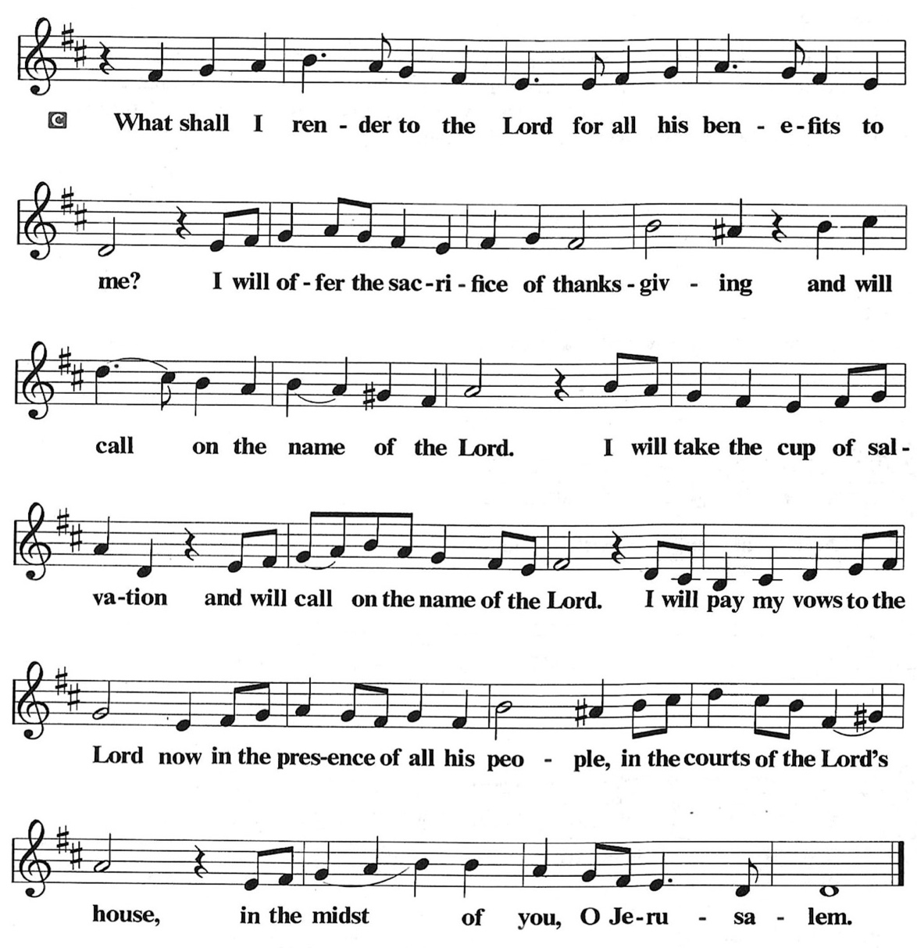

OFFERTORY PRAYER
O God, maker of heaven and earth, your steadfast love embraces all creation. You send rain and sunshine to nourish the earth and bring forth its bounty. As we are about to partake in these gifts of bread and wine,
we ask that you draw us into further understanding of the the death and life of your Son, who calls us to bear witness to his saving work. We ask this in Jesus’ name.
Amen.
COMMUNION
THE GREAT THANKSGIVING
The Lord be with you.
And also with you.
Lift up your hearts.
We lift them to the Lord.
Let us give thanks to the Lord our God.
It is right to give him thanks and praise.

THE PROPER PREFACE: It is indeed right and salutary…

SANCTUS
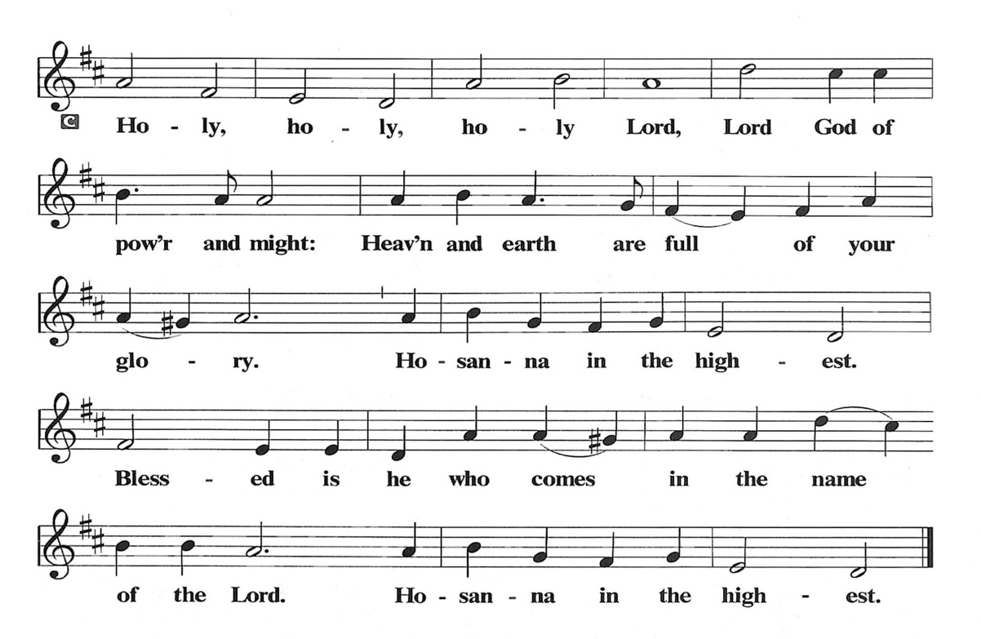
PRAYER OF INSTITUTION

LORD’S PRAYER
Gathered into one by the Holy Spirit, let us pray as Jesus taught us.

Our Father, who art in heaven, hallowed be thy name, thy kingdom come, thy will be done, on earth as it is in heaven. Give us this day our daily bread; and forgive us our trespasses, as we forgive those who trespass against us; and lead us not into temptation, but deliver us from evil. For thine is the kingdom, and the power, and the glory, forever and ever. Amen.

OR

Our Father in heaven, hallowed be your name, your kingdom come, your will be done, on earth as in heaven. Give us today our daily bread. Forgive us our sins as we forgive those who sin against us. Save us from the time of trial, and deliver us from evil. For the kingdom, the power, and the glory are yours now and forever. Amen

INVITATION TO COMMUNION
Come to the table. Feast on God’s goodness and mercy.

LAMB OF GOD
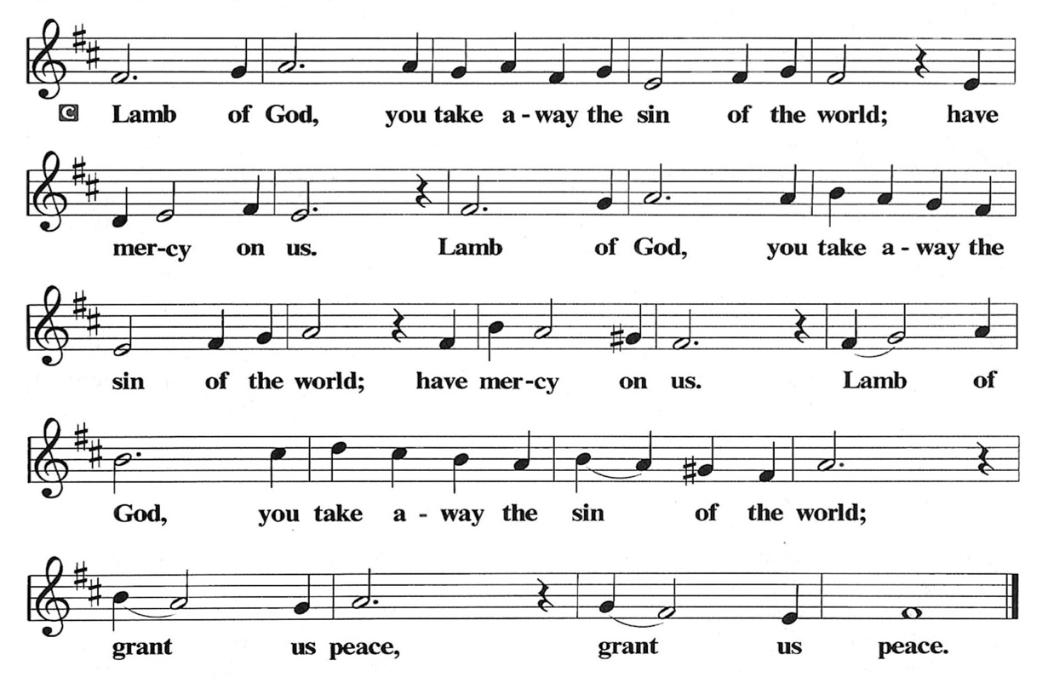
POST COMMUNION PRAYER
God of our salvation, we give you thanks for this meal that restores our souls, reconciles us to you, and strengthens us for the journey. Through the body and blood of your Son, may we become Christ’s body in the world, bearing witness to your love for all creation, through Jesus Christ, our Savior and Lord.
Amen.

BLESSING
Receive the blessing of the holy Trinity: God, who calls all things into existence, Jesus Christ, who redeems us, and the Holy Spirit, whose breath sustains creation, ☩ bless you now and always.
Amen.

SENDING HYMN: LBW #343 Guide Me Ever, Great Redeemer

1 Guide me ever, great Redeemer,
pilgrim through this barren land.
I am weak, but you are mighty;
hold me with your pow’rful hand.
Bread of heaven, bread of heaven,
feed me now and evermore,
feed me now and evermore.

2 Open now the crystal fountain
where the healing waters flow;
let the fire and cloudy pillar
lead me all my journey through.
Strong deliv’rer, strong deliv’rer,
shield me with your mighty arm,
shield me with your mighty arm.

3 When I tread the verge of Jordan,
bid my anxious fears subside;
death of death and hell’s destruction,
land me safe on Canaan’s side.
Songs and praises, songs and praises,
I will raise forevermore,
I will raise forevermore.
Text: William Williams, 1717-1791; tr. William Williams and Peter Williams, 1722-1796, alt.

DISMISSAL
Go in peace. Believe the good news. Thanks be to God.

POSTLUDE
PRAYER LIST
(Please call the office to add/or update the Prayer List)

Sue Patterson on hospice care, Ann Miller Taylor, Don and Barbara Wilson, Marty Cosgriff, Charlotte Berndt, God’s protection for David Powell, God’s guidance and wisdom for Cameron, healing for Helene Rabe, Fred W. Taylor, Madeline McEntyre, Scott Tyler, Jim Lynch, Shirley Lustig, Barbara who is in hospice, Michele Hansen, Lisa Weathers, Matthew Allison, Antonio Jamir and family, Joann and Tye Peyton, Linda Fairless, Shamari Johnson Moore, Christine Fairless, Suzy and John Henry, Gudrun Schamoni, God’s protection for Rhea, David Forsyth, Phil Arthur, Ruth Wolf with cancer, Peter Dow, Francis and Rueben, Anne with cancer, protection for Audrey Frangiamore, Susan Rados.

ANNOUNCEMENTS
Special Guest Presentation on March 22, 2026. See information below.
Fellowship Hour: We love spending time together after worship, please join us in Parish Hall and feel free to bring something yummy to share!
Council monthly meeting: The Council meets 3rd Wednesday of every month. The next meeting is March 18, 2026 at 7PM via Zoom. Congregation members are welcome at the meetings,
Next Dine and Connect: March 30: This is an interfaith and community run program to feed the houseless and food insecure in Alameda. Volunteers are need for all facets of the meal. See Terry O’Connor if you’d like to help.
Immanuel Website: You can find our weekly worship bulletin, worship live streaming link, church calendar, events announcements and much more online. Please visit:
Donate to Immanuel Online: It is important that our offerings continue to support our ministry. You can tithe to Immanuel several different ways including PayPal via the church website, through the mail: 1910 Santa Clara Avenue, Alameda, CA 94501, or through the church mail slot located to the right of the metal gate on Santa Clara Ave. Thank you!
Pastor Availability & Contact Info: Rev. Crystal Larsen Stewart’s office hours have changed from Thursdays to Fridays. She can be reached by phone and email to schedule time for pastoral care and appointments. Cell: 510-693-1974. Email: pastor@immanuel-alameda.org
Church Office: Hours vary and are available by appointment. Please call the office at 510-523-0659 and leave a message for pastor or volunteers. We are in need of more volunteers for tasks like the Sunday bulletin, organizing and checking voicemail; please call if you can help.
Recycling: Pure Recycling is available by volunteer Walter McQuesten-510-521-1356. Collects: Plastic: CRV, empty, crushed, bagged, no lids (put lids in own recycle); Aluminum: empty, crushed/flattened and separated; Glass bottles: clean and boxed. It is good to recycle!

*Liturgy materials used from Sundays and Seasons & A Sanctified Art.
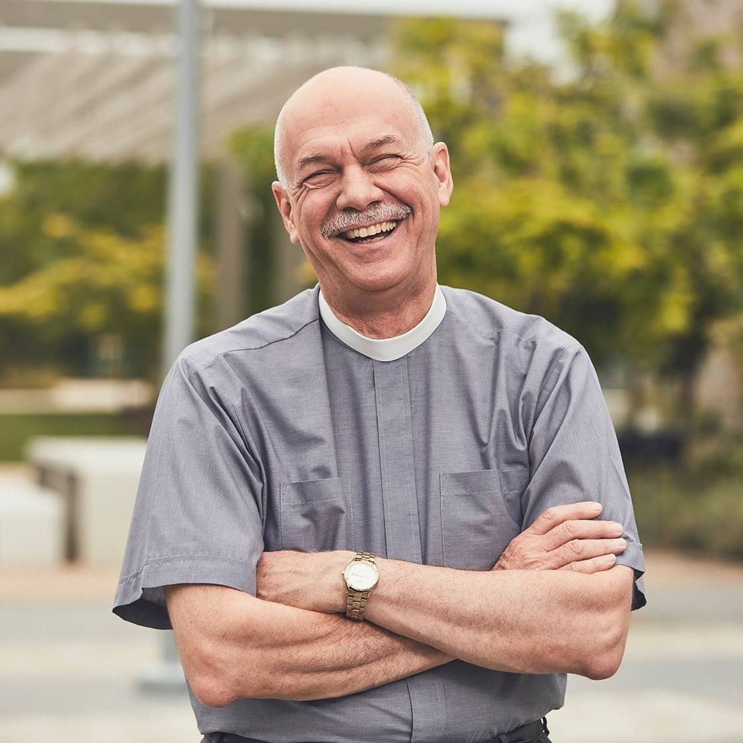
On March 22nd The Rev. Eric C. Shafer will preach at Immanuel. Rev. Eric is a pastor of the Evangelical Lutheran Church in America (ELCA), and is Global Refuge’s “Pastor-in-Residence.” Global Refuge is the new name for Lutheran Immigration and Refuge Service. He will share about what the special ministry of Global Refuge is.

In 2022, Rev. Eric, retired after more than eight years as Senior Pastor at Mt. Olive Lutheran Church in Santa Monica, California. There he helped open the Students4Students Shelter at Mt. Olive, the first shelter for homeless college students in the USA. His previous positions include Senior Vice President for Odyssey Networks in New York City and Director of Communication for the ELCA in Chicago. Shafer has taught in South Africa and Madagascar and made multiple trips to Jerusalem and the West Bank. He is
also the host of the YouTube program Hope Matters.

PLEASE NOTE:
On March 22, after Immanuel collects the regular offering, we will then collect a second special offering for Global Refuge. Please prayerfully consider bringing a special offering for this important ministry that day.

