Welcome Rev. Eric Shafer, Global Refuge’s “Pastor-in-Residence,” sharing this special ministry.

IMMANUEL LUTHERAN CHURCH
Fifth SUNDAY IN LENT
March 22, 2026

Worship in person or online Sunday at 10 AM
See our website for the link: www.immanuel-alameda.org
For those online wanting to participate in communion, please have bread & wine/or juice available.

Rev. Crystal Larsen Stewart · pastor@immanuel-alameda.org
Church: 1420 Lafayette Street Alameda, CA 94501; Office: 1910 Santa Clara Ave.
(510) 523-0659 · office@immanuel-alameda.org

THE GATHERING
The congregation’s parts are in bold type.

PRELUDE

WORDS OF WELCOME AND ANNOUNCEMENTS

GATHERING HYMN: LBW #479 My faith Looks Up to Thee Text: Ray Palmer, 1808-1887

1 My faith looks up to thee,
thou Lamb of Calvary,
Savior divine!
Now hear me while I pray,
take all my guilt away,
oh, let me from this day
be wholly thine!

2 May thy rich grace impart
strength to my fainting heart,
my zeal inspire;
as thou hast died for me,
oh, may my love to thee
pure, warm, and changeless be,
a living fire!

3 While life's dark maze I tread
and griefs around me spread,
be thou my guide;
bid darkness turn to day,
wipe sorrow's tears away,
nor let me ever stray
from thee aside.

4 When ends life's transient dream,
when death's cold, sullen stream
shall o'er me roll;
blest Savior, then, in love
fear and distrust remove;
oh, bear me safe above,
a ransomed soul!

.

CONFESSION AND FORGIVENESS
Almighty God, to whom all hearts are open, all desires known, and from whom no secrets are hid: Cleanse the thoughts of our hearts by the inspiration of your Holy Spirit, that we may perfectly love you and worthily magnify your holy name, through Jesus Christ our Lord. Amen

If we say we have no sin, we deceive ourselves, and the truth is not in us. But if we confess our sins, God who is faithful and just will forgive our sins and cleanse us from all unrighteousness.

Most merciful God,
we confess that we are captive to sin and cannot free ourselves. We have sinned against you in thought, word, and deed, by what we have done and by what we have left undone. We have not loved you with our whole heart; we have not loved our neighbors as ourselves. For the sake of your Son, Jesus Christ, have mercy on us. Forgive us, renew us, and lead us, so that we may delight in your will and walk in your ways, to the glory of your holy name. Amen

Almighty God, in his mercy, has given his Son to die for us and, for his sake, forgives us all our sins. As a called and ordained minister of the Church of Christ, and by his authority, I therefore declare to you the entire forgiveness of all your sins, in the name of the Father, and of the ☩ Son, and of the Holy Spirit.
Amen.

GREETING
The grace of our Lord Jesus Christ, the love of God, and the communion of the Holy Spirit with you all.
And also with you.

KYRIE
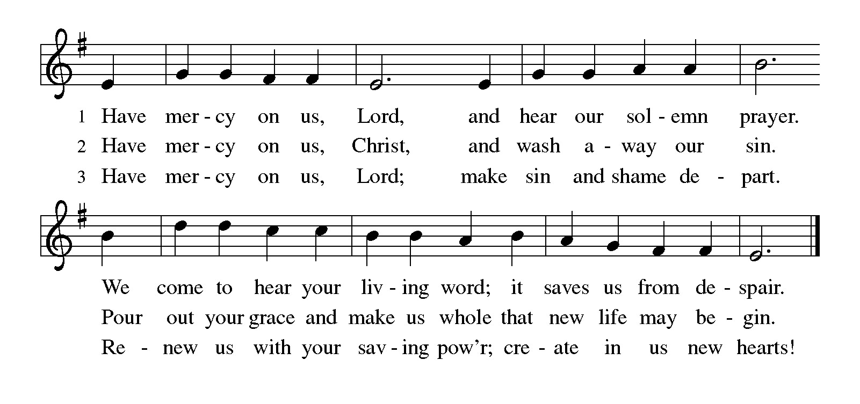
PRAYER OF THE DAY
Almighty God, your Son came into the world to free us all from sin and death. Breathe upon us the power of your Spirit, that we may be raised to new life in Christ and serve you in righteousness all our days, through Jesus Christ, our Savior and Lord, who lives and reigns with you and the Holy Spirit, one God, now and forever. Amen

THE WORD

First Reading: Ezekiel 37:1-14
Ezekiel’s vision of the valley of dry bones is a promise that Israel as a nation, though dead in exile, will live again in their land through God’s life-giving spirit. Three times Israel is assured that through this vision they will know that “I am the Lord.”
¹ The hand of the Lord came upon me, and he brought me out by the spirit of the Lord and set me down in the middle of a valley; it was full of bones. ² He led me all around them; there were very many lying in the valley, and they were very dry. ³ He said to me, “Mortal, can these bones live?” I answered, “O Lord God, you know.” ⁴ Then he said to me, “Prophesy to these bones and say to them: O dry bones, hear the word of the Lord. ⁵ Thus says the Lord God to these bones: I will cause breath to enter you, and you shall live. ⁶ I will lay sinews on you and will cause flesh to come upon you and cover you with skin and put breath in you, and you shall live, and you shall know that I am the Lord.”
⁷ So I prophesied as I had been commanded, and as I prophesied, suddenly there was a noise, a rattling, and the bones came together, bone to its bone. ⁸ I looked, and there were sinews on them, and flesh had come upon them, and skin had covered them, but there was no breath in them. ⁹ Then he said to me, “Prophesy to the breath, prophesy, mortal, and say to the breath: Thus says the Lord God: Come from the four winds, O breath, and breathe upon these slain, that they may live.” ¹⁰ I prophesied as he commanded me, and the breath came into them, and they lived and stood on their feet, a vast multitude.
¹¹ Then he said to me, “Mortal, these bones are the whole house of Israel. They say, ‘Our bones are dried up, and our hope is lost; we are cut off completely.’ ¹² Therefore prophesy and say to them: Thus says the Lord God: I am going to open your graves and bring you up from your graves, O my people, and I will bring you back to the land of Israel. ¹³ And you shall know that I am the Lord when I open your graves and bring you up from your graves, O my people. ¹⁴ I will put my spirit within you, and you shall live, and I will place you on your own soil; then you shall know that I, the Lord, have spoken and will act, says the Lord.”
Word of God. Word of life. Thanks be to God.

Psalm: Psalm 130
¹ Out | of the depths
I cry to | you, O Lord;
² O Lord, | hear my voice!
Let your ears be attentive to the voice of my | supplication.
³ If you were to keep watch | over sins,
O Lord, | who could stand?
⁴ Yet with you | is forgiveness,
in order that you | may be feared.
⁵ I wait for you, O Lord; | my soul waits;
in your word | is my hope.
⁶ My soul waits for the Lord more than those who keep watch | for the morning,
more than those who keep watch | for the morning.
⁷ O Israel, wait for the Lord, for with the Lord there is | steadfast love;
with the Lord there is plen- | teous redemption.
⁸ For the Lord shall | redeem Israel
from | all their sins.

Second Reading: Romans 8:6-11
For Paul, Christian spirituality entails living in the reality of the Holy Spirit. The driving force behind our actions and values is not our sinful desire for self-satisfaction but the very Spirit by which God raised Jesus from the dead and will also raise us from the dead.
⁶ To set the mind on the flesh is death, but to set the mind on the Spirit is life and peace. ⁷ For this reason the mind that is set on the flesh is hostile to God; it does not submit to God’s law—indeed, it cannot, ⁸ and those who are in the flesh cannot please God.
⁹ But you are not in the flesh; you are in the Spirit, since the Spirit of God dwells in you. Anyone who does not have the Spirit of Christ does not belong to him. ¹⁰ But if Christ is in you, then the body is dead because of sin, but the Spirit is life because of righteousness. ¹¹ If the Spirit of him who raised Jesus from the dead dwells in you, he who raised Christ Jesus from the dead will give life to your mortal bodies also through his Spirit that dwells in you.
Word of God. Word of life. Thanks be to God.

GOSPEL ACCLAMATION:
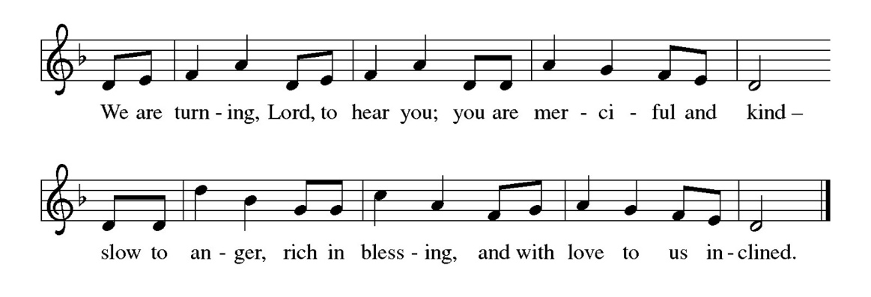
Gospel: Matthew 25:31-45
Glory to you, O Lord.
Matthew 25:31-45
³¹ “When the Son of Man comes in his glory and all the angels with him, then he will sit on the throne of his glory. ³² All the nations will be gathered before him, and he will separate people one from another as a shepherd separates the sheep from the goats,³³ and he will put the sheep at his right hand and the goats at the left. ³⁴ Then the king will say to those at his right hand, ‘Come, you who are blessed by my Father, inherit the kingdom prepared for you from the foundation of the world, ³⁵ for I was hungry and you gave me food, I was thirsty and you gave me something to drink, I was a stranger and you welcomed me, ³⁶ I was naked and you gave me clothing, I was sick and you took care of me, I was in prison and you visited me.’ ³⁷ Then the righteous will answer him, ‘Lord, when was it that we saw you hungry and gave you food or thirsty and gave you something to drink? ³⁸ And when was it that we saw you a stranger and welcomed you or naked and gave you clothing? ³⁹ And when was it that we saw you sick or in prison and visited you?’ ⁴⁰ And the king will answer them, ‘Truly I tell you, just as you did it to one of the least of these brothers and sisters of mine, you did it to me.’ ⁴¹ Then he will say to those at his left hand, ‘You who are accursed, depart from me into the eternal fire prepared for the devil and his angels,⁴² for I was hungry and you gave me no food, I was thirsty and you gave me nothing to drink, ⁴³ I was a stranger and you did not welcome me, naked and you did not give me clothing, sick and in prison and you did not visit me.’ ⁴⁴ Then they also will answer, ‘Lord, when was it that we saw you hungry or thirsty or a stranger or naked or sick or in prison and did not take care of you?’ ⁴⁵ Then he will answer them, ‘Truly I tell you, just as you did not do it to one of the least of these, you did not do it to me.’
The gospel of the Lord. Praise to you, O Christ.
SERMON

HYMN OF THE DAY: WOV #702 I Am the Bread of Life (vs.1-4)

1"I am the Bread of life. You who come to me shall not hunger,
and who believe in me shall not thirst. No one can come to me unless the Father beckons."

Refrain: "And I will raise you up, and I will raise you up, and I will raise you up on the last day."

2 "The bread that I will give is my flesh for the life of the world,
and if you eat of this bread, you shall live forever, you shall live forever." Refrain

3 "Unless you eat of the flesh of the Son of Man
and drink of his blood, and drink of his blood, you shall not have life within you." Refrain

4 "I am the resurrection, I am the life.
If you believe in me, even though you die, you shall live forever." Refrain
Text: Suzanne Toolan, RSM, b. 1927, based on John 6. Text © 1966, 1970, 1986, 1993 GIA Publications, Inc., 7404 S. Mason Ave., Chicago, IL 60638. www.giamusic.com. 800.442.3358. All rights reserved. Used by permission
APOSTLES’ CREED
I believe in God, the Father almighty, creator of heaven and earth.

I believe in Jesus Christ, God’s only Son, our Lord, who was conceived by the Holy Spirit, born of the virgin Mary, suffered under Pontius Pilate, was crucified, died, and was buried; he descended into hell. On the third day he rose again; he ascended into heaven, he is seated at the right hand of the Father, and he will come to judge the living and the dead.

I believe in the Holy Spirit, the holy catholic church, the communion of saints, the forgiveness of sins, the resurrection of the body, and the life everlasting. Amen.

THE PRAYERS
Reconciled by God’s mercy and sustained by God’s presence, let us pray for the world and its needs.
A brief silence.

We pray for the church. Grant life and peace to all who gather in your name. Breathe into us so that we may share your message of forgiveness, hope, and love. Hear us, O God.
Your mercy is great.
We pray for creation. Renew landscapes that have dried up, prosper the work of those who restore homes and habitats after natural disasters, and sustain places where biodiversity thrives. Hear us, O God.
Your mercy is great.
We pray for the nations. Unbind leaders trapped by fear to act boldly for justice, free all who live in places of war and violence, and guide refugees and asylum seekers to safety,, especially in the Persian Gulf region. Hear us, O God.
Your mercy is great.
We pray for all people in need. Take away the stone of poverty that weighs down so many. Console any who weep and heal all who are sick especially those on our prayer list. Hear us, O God.
Your mercy is great.
We pray for this assembly. Deepen our wonder at the mystery of your resurrection and life. Hear us, O God.
Your mercy is great.
Here other prayers may be offered.
We offer our thanksgiving for all people who have died in faith. Give us faith to trust in your power to redeem and save, and bring us up from our graves to life in you. Hear us, O God.
Your mercy is great.
Receive our prayers, O God, through Jesus Christ, our strength and salvation.
Amen.

PEACE
The peace of the Lord be with you always.
And also with you

OFFERTORY SENTENCE
We invite you to give as you are able, responding with gratitude to God’s abundant grace.

OFFERTORY HYMN
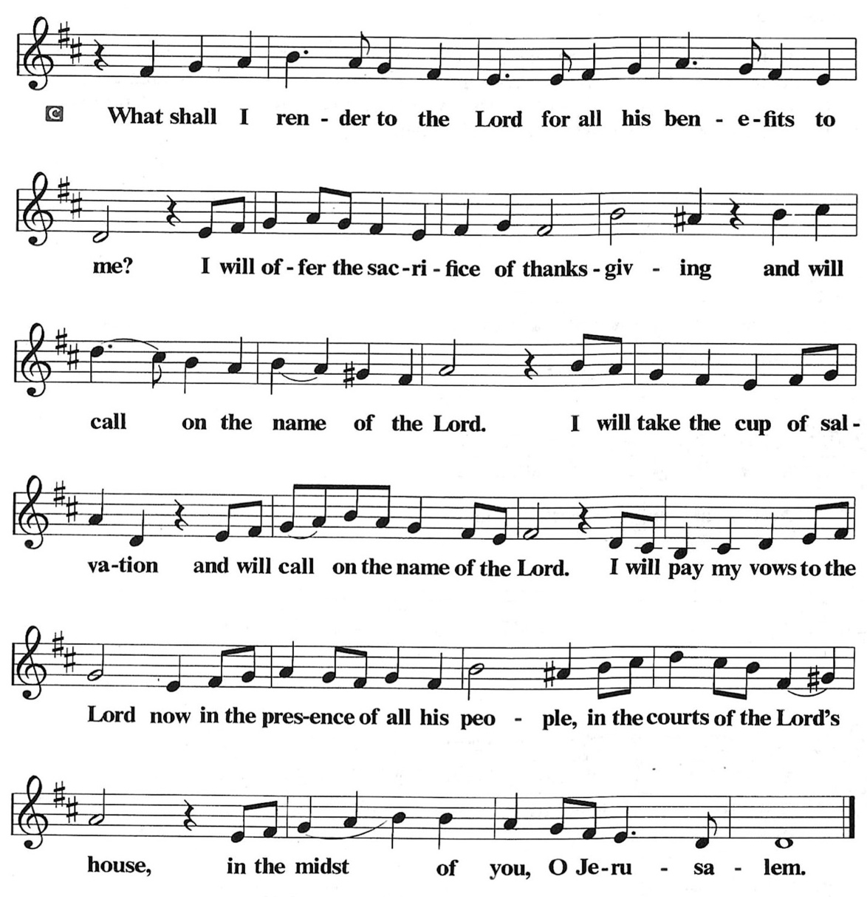

OFFERTORY PRAYER
O God, maker of heaven and earth, your steadfast love embraces all creation. You send rain and sunshine to nourish the earth and bring forth its bounty. As we are about to partake in these gifts of bread and wine,
we ask that you draw us into further understanding of the the death and life of your Son, who calls us to bear witness to his saving work. We ask this in Jesus’ name.
Amen.

COMMUNION
THE GREAT THANKSGIVING
The Lord be with you.
And also with you.
Lift up your hearts.
We lift them to the Lord.
Let us give thanks to the Lord our God.
It is right to give our thanks and praise.

THE PROPER PREFACE: It is indeed right and salutary…

SANCTUS
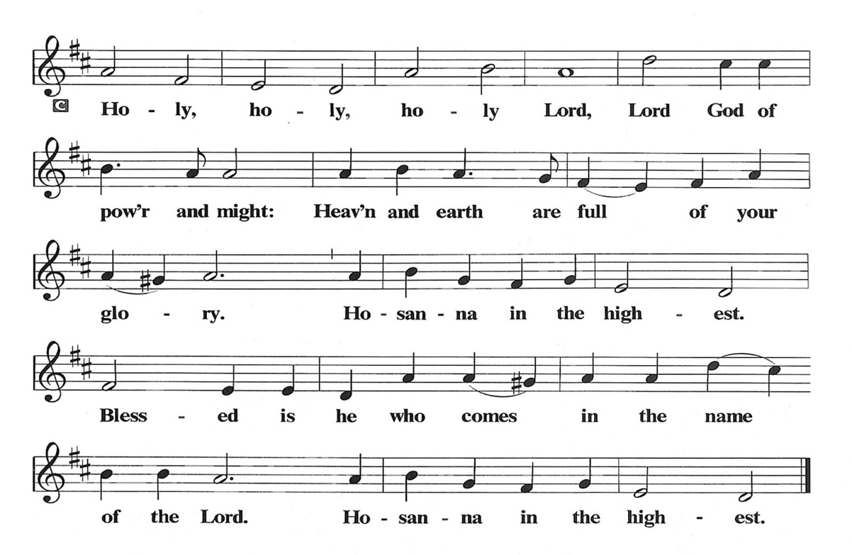
PRAYER OF INSTITUTION

LORD’S PRAYER
Gathered into one by the Holy Spirit, let us pray as Jesus taught us.

Our Father, who art in heaven, hallowed be thy name, thy kingdom come, thy will be done, on earth as it is in heaven. Give us this day our daily bread; and forgive us our trespasses, as we forgive those who trespass against us; and lead us not into temptation, but deliver us from evil. For thine is the kingdom, and the power, and the glory, forever and ever. Amen.

OR

Our Father in heaven, hallowed be your name, your kingdom come, your will be done, on earth as in heaven. Give us today our daily bread. Forgive us our sins as we forgive those who sin against us. Save us from the time of trial, and deliver us from evil. For the kingdom, the power, and the glory are yours now and forever. Amen

INVITATION TO COMMUNION
Come to the table. Feast on God’s goodness and mercy.

LAMB OF GOD
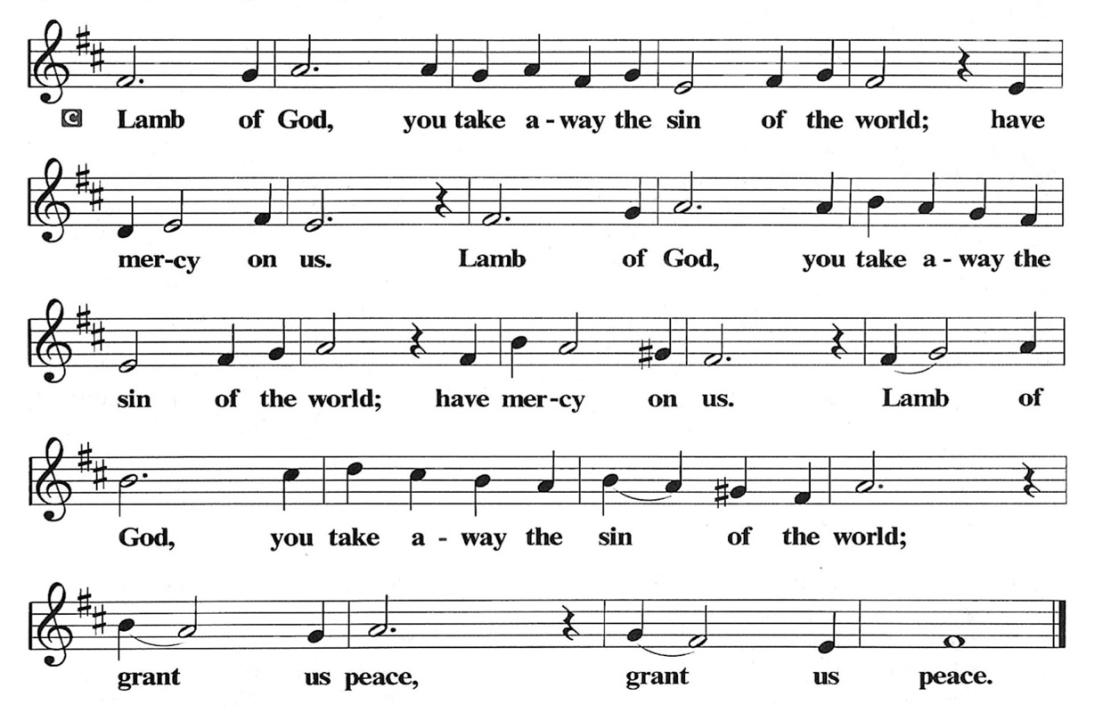
POST COMMUNION PRAYER
God of our salvation, we give you thanks for this meal that restores our souls, reconciles us to you, and strengthens us for the journey. Through the body and blood of your Son, may we become Christ’s body in the world, bearing witness to your love for all creation, through Jesus Christ, our Savior and Lord.
Amen.

BLESSING
Receive the blessing of the holy Trinity: God, who calls all things into existence, Jesus Christ, who redeems us, and the Holy Spirit, whose breath sustains creation, ☩ bless you now and always.
Amen.

SENDING HYMN: LBW #107 Beneath the Cross of Jesus Text: Elizabeth C. Clephane, 1830-1869

1 Beneath the cross of Jesus
I long to take my stand;
the shadow of a mighty rock
within a weary land,
a home within a wilderness,
a rest upon the way,
from the burning of the noontide heat
and burdens of the day.

2 Upon the cross of Jesus,
my eye at times can see
the very dying form of one
who suffered there for me.
And from my contrite heart, with tears,
two wonders I confess:
the wonder of his glorious love
and my unworthiness.

3 I take, O cross, your shadow
for my abiding place;
I ask no other sunshine than
the sunshine of his face;
content to let the world go by,
to know no gain nor loss,
my sinful self my only shame,
my glory all, the cross.

DISMISSAL
Go in peace. Believe the good news. Thanks be to God.

POSTLUDE
PRAYER LIST
(Please call the office to add/or update the Prayer List)

Marty Cosgriff, Charlotte Berndt, God’s protection for David Powell, God’s guidance and wisdom for Cameron, healing for Helene Rabe, Fred W. Taylor, Madeline McEntyre, Scott Tyler, Jim Lynch, Shirley Lustig, Barbara who is in hospice, Michele Hansen, Lisa Weathers, Matthew Allison, Antonio Jamir and family, Joann and Tye Peyton, Linda Fairless, Shamari Johnson Moore, Suzy and John Henry, Gudrun Schamoni, God’s protection for Rhea, David Forsyth, Phil Arthur, Ruth Wolf with cancer, Peter Dow, Francis and Rueben, Anne with cancer, protection for Audrey Frangiamore, Susan Rados, Jack L Taylor for mobility and strength healing.

ANNOUNCEMENTS
Holy Week Services: See information below
Spring Boutique, Saturday, April 25, 2026 10AM-2PM: Come shop at our Fun & Festive event! Our local artists, artisans & crafters showcase unique & beautiful wares! Glorious array of finely handcrafted items and goodies for the whole family!
Fellowship Hour: We love spending time together after worship, please join us in Parish Hall and feel free to bring something yummy to share!
Council monthly meeting: The Council meets 3rd Wednesday of every month. The next meeting is March 18, 2026 at 7PM via Zoom. Congregation members are welcome at the meetings,
Next Dine and Connect: March 30: This is an interfaith and community run program to feed the houseless and food insecure in Alameda. Volunteers are need for all facets of the meal. See Terry O’Connor if you’d like to help.
Immanuel Website: You can find our weekly worship bulletin, worship live streaming link, church calendar, events announcements and much more online. Please visit:
Donate to Immanuel Online: It is important that our offerings continue to support our ministry. You can tithe to Immanuel several different ways including PayPal via the church website, through the mail: 1910 Santa Clara Avenue, Alameda, CA 94501, or through the church mail slot located to the right of the metal gate on Santa Clara Ave. Thank you!
Pastor Availability & Contact Info: Rev. Crystal Larsen Stewart’s office hours have changed from Thursdays to Fridays. She can be reached by phone and email to schedule time for pastoral care and appointments. Cell: 510-693-1974. Email: pastor@immanuel-alameda.org
Church Office: Hours vary and are available by appointment. Please call the office at 510-523-0659 and leave a message for pastor or volunteers. We are in need of more volunteers for tasks like the Sunday bulletin, organizing and checking voicemail; please call if you can help.
Recycling: Pure Recycling is available by volunteer Walter McQuesten-510-521-1356. Collects: Plastic: CRV, empty, crushed, bagged, no lids (put lids in own recycle); Aluminum: empty, crushed/flattened and separated; Glass bottles: clean and boxed. It is good to recycle!
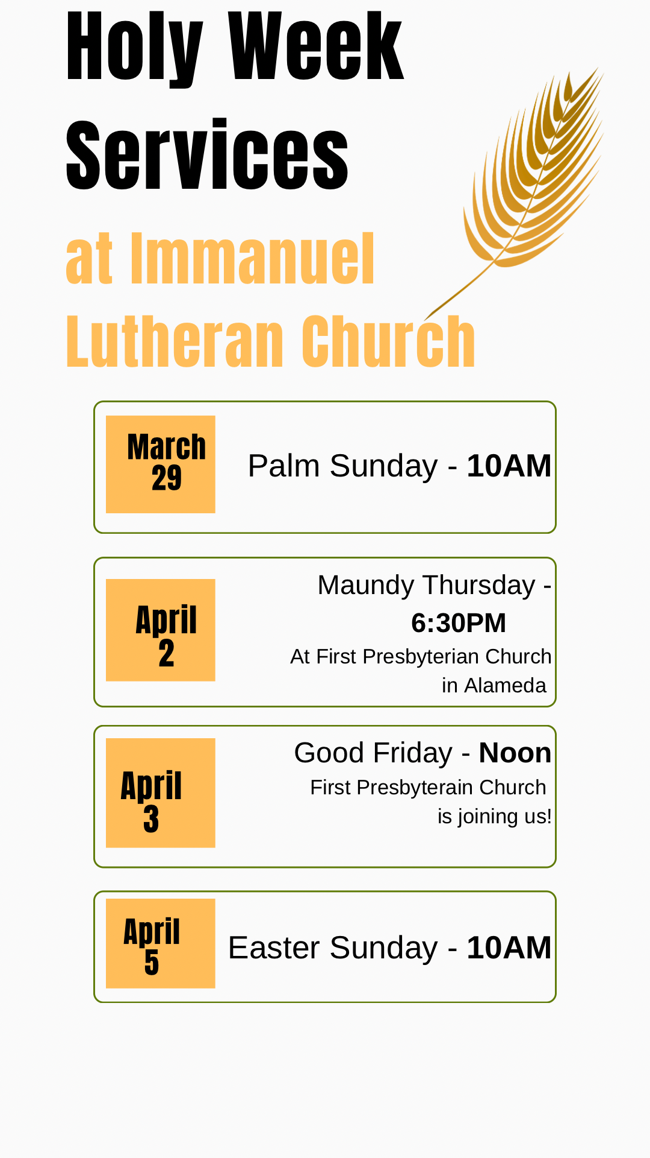

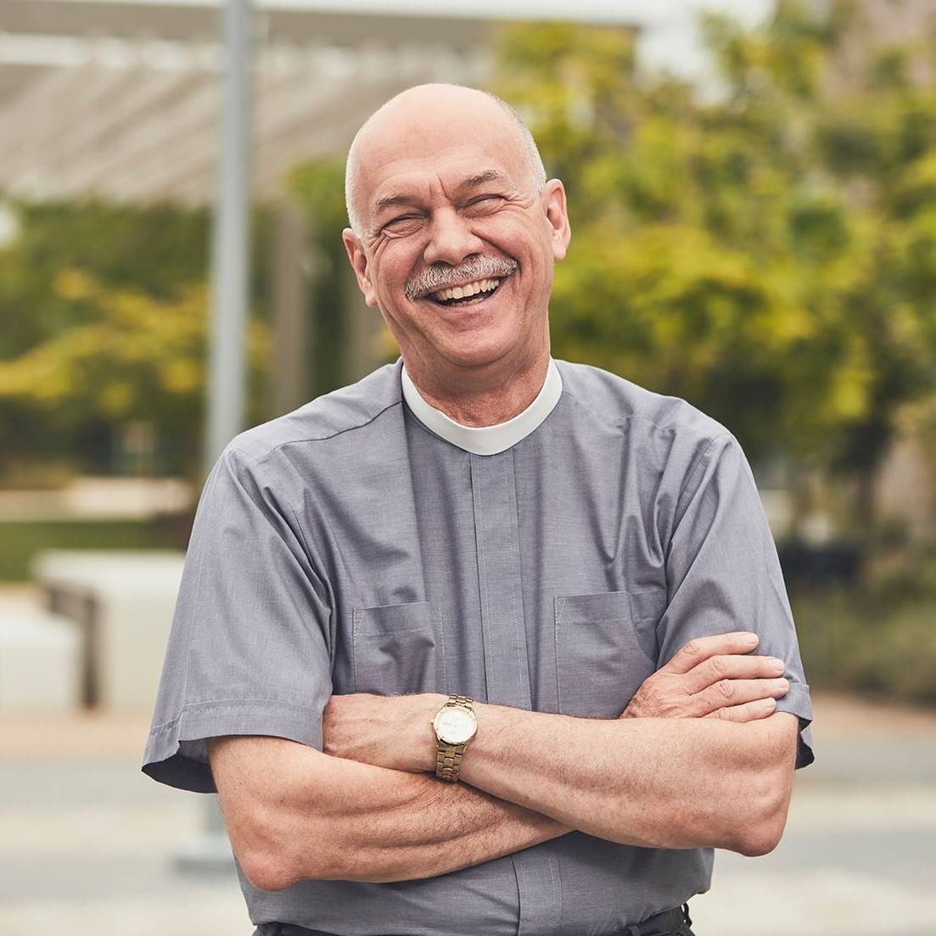
On March 22nd The Rev. Eric C. Shafer will preach at Immanuel. Rev. Eric is a pastor of the Evangelical Lutheran Church in America (ELCA), and is Global Refuge’s “Pastor-in-Residence.” Global Refuge is the new name for Lutheran Immigration and Refuge Service. He will share about what the special ministry of Global Refuge is.

In 2022, Rev. Eric, retired after more than eight years as Senior Pastor at Mt. Olive Lutheran Church in Santa Monica, California. There he helped open the Students4Students Shelter at Mt. Olive, the first shelter for homeless college students in the USA. His previous positions include Senior Vice President for Odyssey Networks in New York City and Director of Communication for the ELCA in Chicago. Shafer has taught in South Africa and Madagascar and made multiple trips to Jerusalem and the West Bank. He is
also the host of the YouTube program Hope Matters.

PLEASE NOTE:
On March 22, after Immanuel collects the regular offering, we will then collect a second special offering for Global Refuge. Please prayerfully consider bringing a special offering for this important ministry that day.

