IMMANUEL LUTHERAN CHURCH
SECOND SUNDAY IN LENT
March 1, 2026

Worship in person or online Sunday at 10 AM
See our website for the link: www.immanuel-alameda.org
For those online wanting to participate in communion, please have bread & wine/or juice available.

Rev. Crystal Larsen Stewart · pastor@immanuel-alameda.org
Church: 1420 Lafayette Street Alameda, CA 94501; Office: 1910 Santa Clara Ave.
(510) 523-0659 · office@immanuel-alameda.org


THE GATHERING
The congregation’s parts are in bold type.

PRELUDE

WORDS OF WELCOME AND ANNOUNCEMENTS

GATHERING HYMN: LBW#93 Jesus, Refuge of the Weary

1 Jesus, refuge of the weary,
blest redeemer, whom we love,
fountain in life’s desert dreary,
Savior from the world above:
often have your eyes, offended,
gazed upon the sinner’s fall;
yet upon the cross extended,
you have borne the pain of all.

2 Do we pass that cross unheeding,
breathing no repentant vow,
though we see you wounded, bleeding,
see your thorn-encircled brow?
Yet your sinless death has brought us
life eternal, peace, and rest;
only what your grace has taught us
calms the sinner’s deep distress.

3 Jesus, may our hearts be burning
with more fervent love for you;
may our eyes be ever turning
to behold your cross anew;
till in glory, parted never
from the blessed Savior’s side,
graven in our hearts forever,
dwell the cross, the Crucified.

Text: Girolamo Savonarola, 1452-1498; tr. Jane F. Wilde, 1826-1896, alt

CONFESSION AND FORGIVENESS
Almighty God, to whom all hearts are open, all desires known, and from whom no secrets are hid: Cleanse the thoughts of our hearts by the inspiration of your Holy Spirit, that we may perfectly love you and worthily magnify your holy name, through Jesus Christ our Lord. Amen

If we say we have no sin, we deceive ourselves, and the truth is not in us. But if we confess our sins, God who is faithful and just will forgive our sins and cleanse us from all unrighteousness.

Most merciful God,
we confess that we are captive to sin and cannot free ourselves. We have sinned against you in thought, word, and deed, by what we have done and by what we have left undone. We have not loved you with our whole heart; we have not loved our neighbors as ourselves. For the sake of your Son, Jesus Christ, have mercy on us. Forgive us, renew us, and lead us, so that we may delight in your will and walk in your ways, to the glory of your holy name. Amen

Almighty God, in his mercy, has given his Son to die for us and, for his sake, forgives us all our sins. As a called and ordained minister of the Church of Christ, and by his authority, I therefore declare to you the entire forgiveness of all your sins, in the name of the Father, and of the ☩ Son, and of the Holy Spirit.
Amen.

GREETING
The grace of our Lord Jesus Christ, the love of God, and the communion of the Holy Spirit with you all.
And also with you.

KYRIE
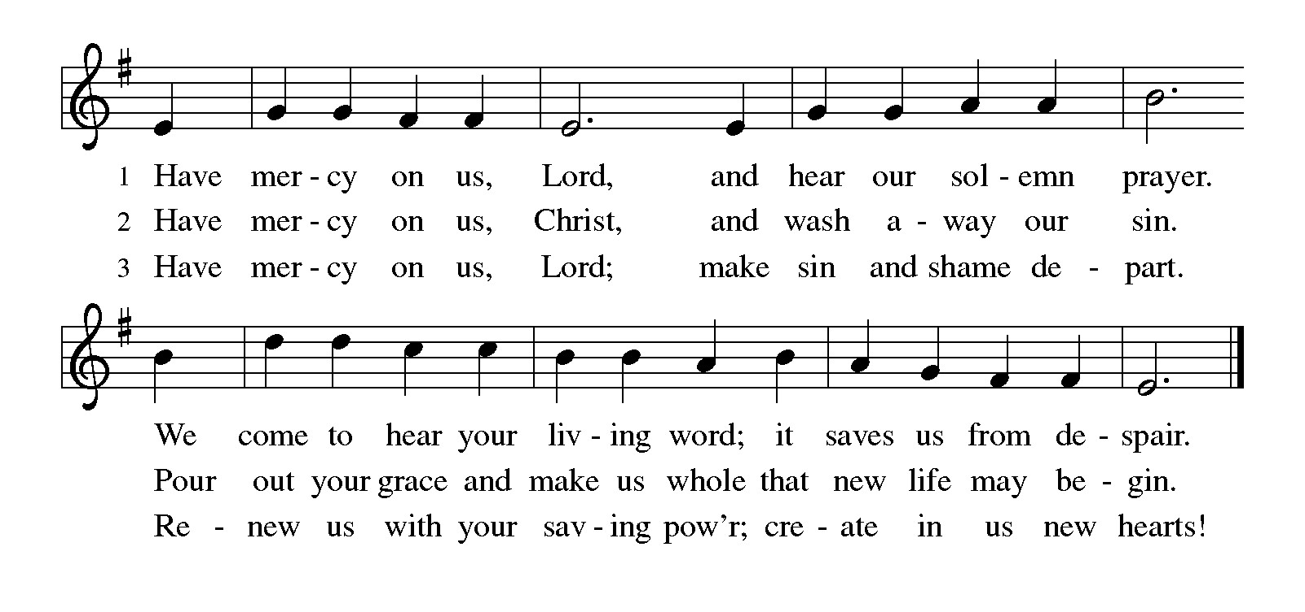
PRAYER OF THE DAY
O God, our leader and guide, in the waters of baptism you bring us to new birth to live as your children. Strengthen our faith in your promises, that by your Spirit we may lift up your life to all the world through your Son, Jesus Christ, our Savior and Lord, who lives and reigns with you and the Holy Spirit, one God, now and forever. Amen.

THE WORD

First Reading: Genesis 12:1-4a
God’s call of Abram and Sarai has a clear purpose—that through them all the families of the earth would gain a blessing. As they set out on their journey, they are accompanied by promises of land, nation, and a great reputation.
¹ The Lord said to Abram, “Go from your country and your kindred and your father’s house to the land that I will show you. ² I will make of you a great nation, and I will bless you and make your name great, so that you will be a blessing. ³ I will bless those who bless you, and the one who curses you I will curse, and in you all the families of the earth shall be blessed.”
^{4a} So Abram went, as the Lord had told him, and Lot went with him.
Word of God. Word of life. Thanks be to God.

Psalm: Psalm 121
¹ I lift up my eyes | to the hills;
from where is my | help to come?
² My help comes | from the Lord,
the maker of heav- | en and earth.
³ The Lord will not let your | foot be moved
nor will the one who watches over you | fall asleep.
⁴ Behold, the keep- | er of Israel
will neither slum- | ber nor sleep;
⁵ the Lord watches | over you;
the Lord is your shade at | your right hand;
⁶ the sun will not strike | you by day,
nor the | moon by night.
⁷ The Lord will preserve you | from all evil
and will | keep your life.
⁸ The Lord will watch over your going out and your | coming in,
from this time forth for- | evermore.

Second Reading: Romans 4:1-5, 13-17
In the person and example of Abraham we discover that a right relationship with God does not involve earning a reward from God but entails trusting God’s promises. Abraham is the forebear and model for both Jews and Gentiles, because we too trust that ours is a God who gives life to the dead.
¹ What then are we to say was gained by Abraham, our ancestor according to the flesh? ² For if Abraham was justified by works, he has something to boast about, but not before God. ³ For what does the scripture say? “Abraham believed God, and it was reckoned to him as righteousness.” ⁴ Now to one who works, wages are not reckoned as a gift but as something due. ⁵ But to one who does not work but trusts him who justifies the ungodly, such faith is reckoned as righteousness.
¹³ For the promise that he would inherit the world did not come to Abraham or to his descendants through the law but through the righteousness of faith. ¹⁴ For if it is the adherents of the law who are to be the heirs, faith is null and the promise is void. ¹⁵ For the law brings wrath, but where there is no law, neither is there transgression.
¹⁶ For this reason the promise depends on faith, in order that it may rest on grace, so that it may be guaranteed to all his descendants, not only to the adherents of the law but also to those who share the faith of Abraham (who is the father of all of us, ¹⁷ as it is written, “I have made you the father of many nations”), in the presence of the God in whom he believed, who gives life to the dead and calls into existence the things that do not exist.
Word of God. Word of life. Thanks be to God.

GOSPEL ACCLAMATION:
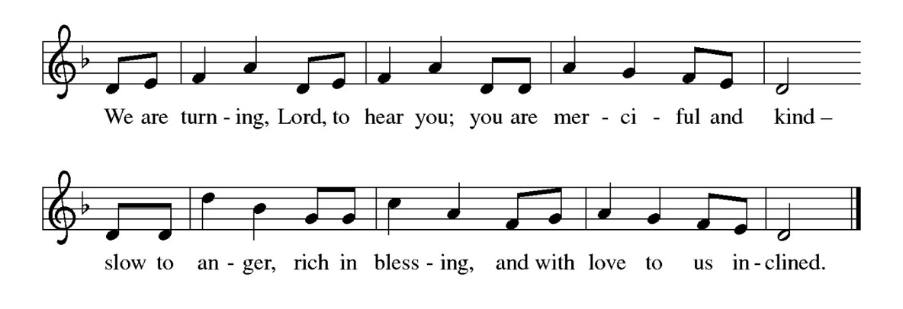
Gospel: John 3:1-17
Glory to you, O Lord.
A curious Pharisee visits Jesus by night to learn from the teacher his friends reject. Jesus speaks to him about life in the Spirit and the kingdom of God.
¹ Now there was a Pharisee named Nicodemus, a leader of the Jews. ² He came to Jesus by night and said to him, “Rabbi, we know that you are a teacher who has come from God, for no one can do these signs that you do unless God is with that person.” ³ Jesus answered him, “Very truly, I tell you, no one can see the kingdom of God without being born from above.” ⁴ Nicodemus said to him, “How can anyone be born after having grown old? Can one enter a second time into the mother’s womb and be born?” ⁵ Jesus answered, “Very truly, I tell you, no one can enter the kingdom of God without being born of water and Spirit. ⁶ What is born of the flesh is flesh, and what is born of the Spirit is spirit. ⁷ Do not be astonished that I said to you, ‘You must be born from above.’ ⁸ The wind blows where it chooses, and you hear the sound of it, but you do not know where it comes from or where it goes. So it is with everyone who is born of the Spirit.” ⁹ Nicodemus said to him, “How can these things be?” ¹⁰ Jesus answered him, “Are you the teacher of Israel, and yet you do not understand these things?
¹¹ “Very truly, I tell you, we speak of what we know and testify to what we have seen, yet you do not receive our testimony. ¹² If I have told you about earthly things and you do not believe, how can you believe if I tell you about heavenly things? ¹³ No one has ascended into heaven except the one who descended from heaven, the Son of Man. ¹⁴ And just as Moses lifted up the serpent in the wilderness, so must the Son of Man be lifted up, ¹⁵ that whoever believes in him may have eternal life.
¹⁶ “For God so loved the world that he gave his only Son, so that everyone who believes in him may not perish but may have eternal life.
¹⁷ “Indeed, God did not send the Son into the world to condemn the world but in order that the world might be saved through him.”
The gospel of the Lord. Praise to you, O Christ.
SERMON

HYMN OF THE DAY: WOV#769 Mothering God, You Gave Me Birth
Text: Jean Janzen, b. 1933; based on Julian of Norwich, c. 1342- c. 1413. Text © 1991 Jean Janzen, admin. Augsburg Fortress
1 Mothering God, you gave me birth
in the bright morning of this world.
Creator, source of ev'ry breath,
you are my rain, my wind, my sun.

2 Mothering Christ, you took my form,
offering me your food of light,

grain of life, and grape of love,
your very body for my peace.

3 Mothering Spirit, nurt'ring one,
in arms of patience hold me close,
so that in faith I root and grow
until I flow'r, until I know.

APOSTLES’ CREED
I believe in God, the Father almighty, creator of heaven and earth.

I believe in Jesus Christ, God’s only Son, our Lord, who was conceived by the Holy Spirit, born of the virgin Mary, suffered under Pontius Pilate, was crucified, died, and was buried; he descended into hell. On the third day he rose again; he ascended into heaven, he is seated at the right hand of the Father, and he will come to judge the living and the dead.

I believe in the Holy Spirit, the holy catholic church, the communion of saints, the forgiveness of sins, the resurrection of the body, and the life everlasting. Amen.

THE PRAYERS
Reconciled by God’s mercy and sustained by God’s presence, let us pray for the world and its needs.
A brief silence.

Faithful One, you renew us by grace. As you have inspired faith through the work of church artists and hymnwriters throughout the ages, give your church the means to praise your beauty today. Hear us, O God.
Your mercy is great.
Living One, you delight in this world. The sun and moon, the wind and the water declare your goodness. Preserve this earth, and protect conservationists, scientists, and all who labor in service to creation. Hear us, O God.
Your mercy is great.
Ruling One, you bless us to be a blessing. Open the hearts of all leaders to seek the flourishing of every person and lend your help to all who wait for justice, deliverance, and peace. Hear us, O God.
Your mercy is great.
Compassionate One, you send your Son to save. Declare your word of acceptance to any who feel condemned and lift up any brought low by hatred and exclusion. Tend to all who are struggling with illness or loss. Hear us, O God.
Your mercy is great.
Guiding One, you watch over our going out and coming in. Bless newcomers in this assembly and accompany those who have recently left this community to journey elsewhere. Hear us, O God.
Your mercy is great.
Here other prayers may be offered.
Eternal One, you neither slumber nor sleep. Be our keeper in life and in death. Thank you for our beloved who have died, and for your promise which saves this whole world by your love. Hear us, O God.
Your mercy is great.
Receive our prayers, O God, through Jesus Christ, our strength and salvation.
Amen.

PEACE
The peace of the Lord be with you always.
And also with you

OFFERTORY SENTENCE
We invite you to give as you are able, responding with gratitude to God’s abundant grace.

OFFERTORY HYMN
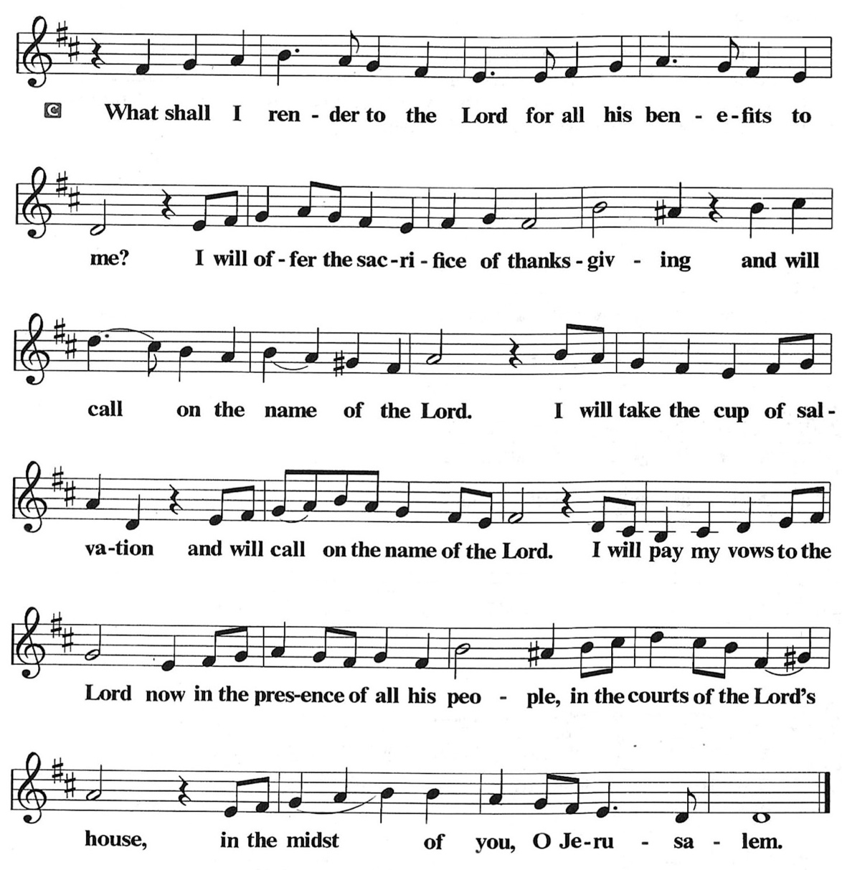

OFFERTORY PRAYER
O God, maker of heaven and earth, your steadfast love embraces all creation. You send rain and sunshine to nourish the earth and bring forth its bounty. As we are about to partake in these gifts of bread and wine,
we ask that you draw us into further understanding of the the death and life of your Son, who calls us to bear witness to his saving work. We ask this in Jesus’ name.
Amen.

COMMUNION
THE GREAT THANKSGIVING
The Lord be with you.
And also with you.
Lift up your hearts.
We lift them to the Lord.
Let us give thanks to the Lord our God.
It is right to give him thanks and praise.

THE PROPER PREFACE: It is indeed right and salutary…

SANCTUS
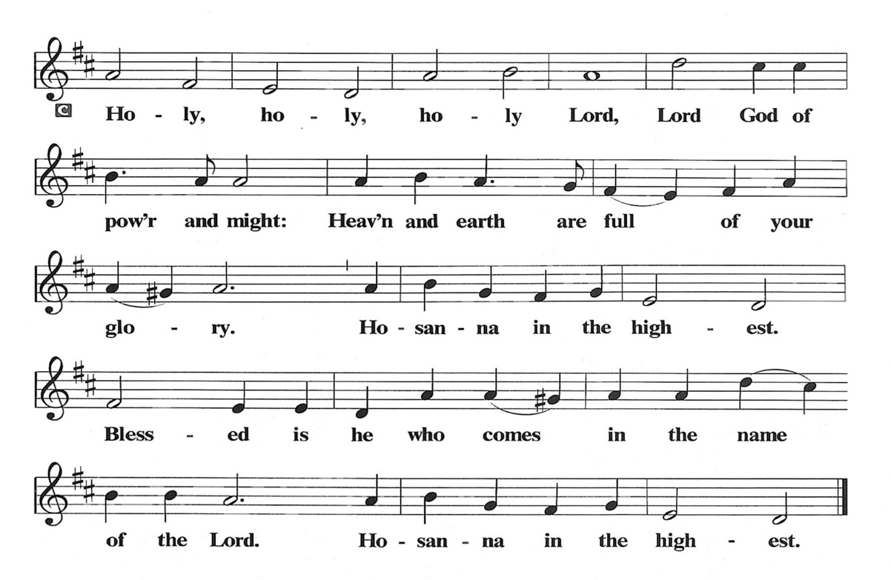
PRAYER OF INSTITUTION

LORD’S PRAYER
Gathered into one by the Holy Spirit, let us pray as Jesus taught us.

Our Father, who art in heaven, hallowed be thy name, thy kingdom come, thy will be done, on earth as it is in heaven. Give us this day our daily bread; and forgive us our trespasses, as we forgive those who trespass against us; and lead us not into temptation, but deliver us from evil. For thine is the kingdom, and the power, and the glory, forever and ever. Amen.

OR

Our Father in heaven, hallowed be your name, your kingdom come, your will be done, on earth as in heaven. Give us today our daily bread. Forgive us our sins as we forgive those who sin against us. Save us from the time of trial, and deliver us from evil. For the kingdom, the power, and the glory are yours now and forever. Amen

INVITATION TO COMMUNION
Come to the table. Feast on God’s goodness and mercy.

LAMB OF GOD
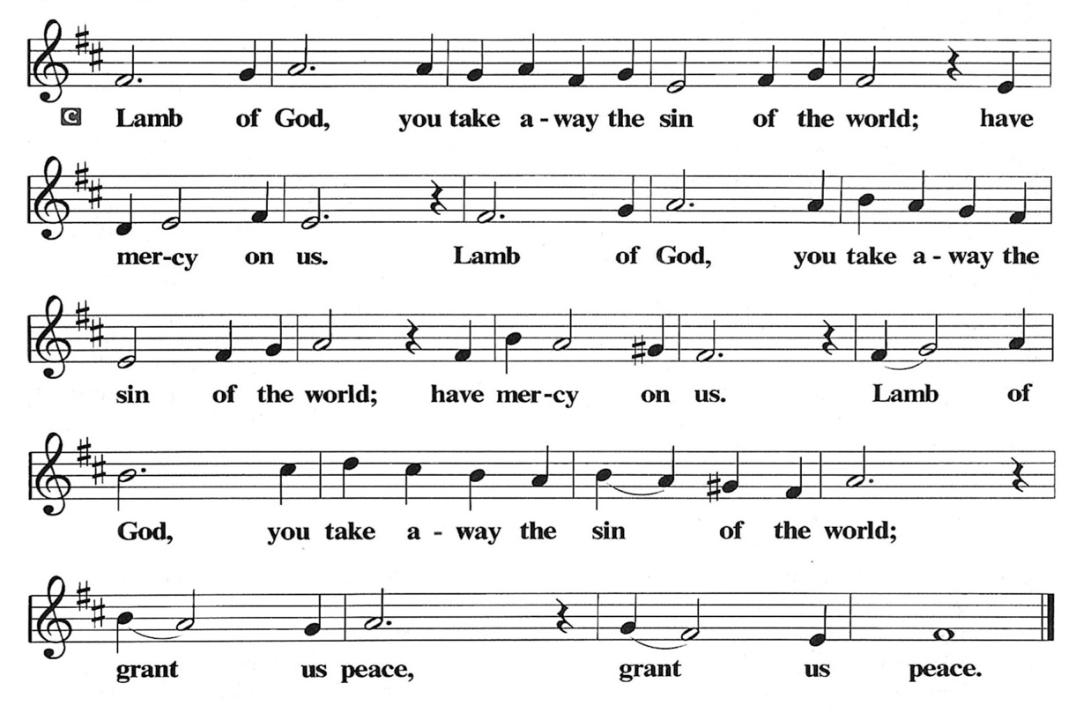
POST COMMUNION PRAYER
God of our salvation, we give you thanks for this meal that restores our souls, reconciles us to you, and strengthens us for the journey. Through the body and blood of your Son, may we become Christ’s body in the world, bearing witness to your love for all creation, through Jesus Christ, our Savior and Lord.
Amen.

BLESSING
Receive the blessing of the holy Trinity: God, who calls all things into existence, Jesus Christ, who redeems us, and the Holy Spirit, whose breath sustains creation, ☩ bless you now and always.
Amen.

SENDING HYMN: LBW #482 When I Survey the Wondrous Cross Text: Isaac Watts, 1674-1748

1 When I survey the wondrous cross
on which the prince of glory died,
my richest gain I count but loss
and pour contempt on all my pride.

2 Forbid it, Lord, that I should boast
save in the death of Christ, my God;
all the vain things that charm me most,
I sacrifice them to his blood.
3 See, from his head, his hands, his feet,
sorrow and love flow mingled down.
Did e’er such love and sorrow meet,
or thorns compose so rich a crown?

4 Were the whole realm of nature mine,
that were a tribute far too small;
love so amazing, so divine,
demands my soul, my life, my all!

DISMISSAL
Go in peace. Believe the good news. Thanks be to God.

POSTLUDE

PRAYER LIST
(Please call the office to add/or update the Prayer List)

Sue Patterson on hospice care, Ann Miller Taylor, Don and Barbara Wilson, Marty Cosgriff, Charlotte Berndt, God’s protection for David Powell, God’s guidance and wisdom for Cameron, healing for Helene Rabe, Fred W. Taylor, Madeline McEntyre, Scott Tyler, Jim Lynch, Shirley Lustig, Barbara who is in hospice, Michele Hansen, Lisa Weathers, Matthew Allison, Antonio Jamir and family, Joann and Tye Peyton, Linda Fairless, Shamari Johnson Moore, Christine Fairless, Suzy and John Henry, Gudrun Schamoni, God’s protection for Rhea, David Forsyth, Phil Arthur, Ruth Wolf with cancer, Peter Dow, Francis and Rueben, Anne with cancer, protection for Audrey Frangiamore, Susan Rados.

ANNOUNCEMENTS
Special Guest Presentation on March 22, 2026. See information below.
Fellowship Hour: We love spending time together after worship, please join us in Parish Hall and feel free to bring something yummy to share!
Council monthly meeting: The Council meets 3rd Wednesday of every month. The next meeting is March 18, 2026 at 7PM via Zoom. Congregation members are welcome at the meetings,
Next Dine and Connect Tomorrow: February 23, 2026. Volunteers are needed at 10am to prepare the meal, 2-3pm to set up and serve, and 5pm to help clean up. Next Dine and Connect: March 30: This is an interfaith and community run program to feed the houseless and food insecure in Alameda. Volunteers are need for all facets of the meal. See Terry O’Connor if you’d like to help.
Immanuel Website: You can find our weekly worship bulletin, worship live streaming link, church calendar, events announcements and much more online. Please visit:
Donate to Immanuel Online: It is important that our offerings continue to support our ministry. You can tithe to Immanuel several different ways including PayPal via the church website, through the mail: 1910 Santa Clara Avenue, Alameda, CA 94501, or through the church mail slot located to the right of the metal gate on Santa Clara Ave. Thank you!
Pastor Availability & Contact Info: Rev. Crystal Larsen Stewart’s office hours have changed from Thursdays to Fridays. She can be reached by phone and email to schedule time for pastoral care and appointments. Cell: 510-693-1974. Email: pastor@immanuel-alameda.org
Church Office: Hours vary and are available by appointment. Please call the office at 510-523-0659 and leave a message for pastor or volunteers. We are in need of more volunteers for tasks like the Sunday bulletin, organizing and checking voicemail; please call if you can help.
Recycling: Pure Recycling is available by volunteer Walter McQuesten-510-521-1356. Collects: Plastic: CRV, empty, crushed, bagged, no lids (put lids in own recycle); Aluminum: empty, crushed/flattened and separated; Glass bottles: clean and boxed. It is good to recycle!

*Liturgy materials used from Sundays and Seasons & A Sanctified Art.
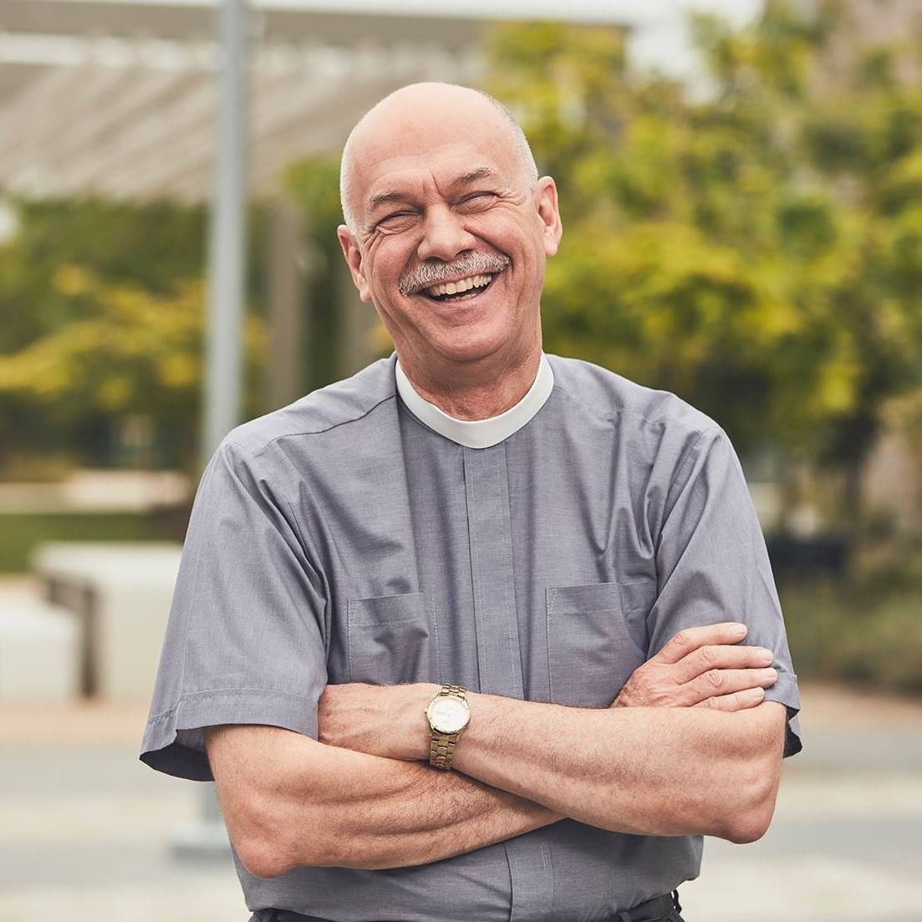
On March 22nd The Rev. Eric C. Shafer will preach at Immanuel. Rev. Eric is a pastor of the Evangelical Lutheran Church in America (ELCA), and is Global Refuge’s “Pastor-in-Residence.” Global Refuge is the new name for Lutheran Immigration and Refuge Service. He will share about what the special ministry of Global Refuge is.

In 2022, Rev. Eric, retired after more than eight years as Senior Pastor at Mt. Olive Lutheran Church in Santa Monica, California. There he helped open the Students4Students Shelter at Mt. Olive, the first shelter for homeless college students in the USA. His previous positions include Senior Vice President for Odyssey Networks in New York City and Director of Communication for the ELCA in Chicago. Shafer has taught in South Africa and Madagascar and made multiple trips to Jerusalem and the West Bank. He is
also the host of the YouTube program Hope Matters.

PLEASE NOTE:
On March 22, after Immanuel collects the regular offering, we will then collect a second special offering for Global Refuge. Please prayerfully consider bringing a special offering for this important ministry that day.

