IMMANUEL LUTHERAN CHURCH
Fifth Sunday after Epiphany, February 8, 2026
Worship in person or online Sunday at 10 AM
See our website for the link: www.immanuel-alameda.org
For those online wanting to participate in communion, please have bread & wine/or juice available.
Rev. Crystal Larsen Stewart · pastor@immanuel-alameda.org
Church: 1420 Lafayette Street Alameda, CA 94501; Office: 1910 Santa Clara Ave.
(510) 523-0659 · office@immanuel-alameda.org


THE GATHERING
The congregation’s spoken parts are in bold italic type.

PRELUDE

WORDS OF WELCOME AND ANNOUNCEMENTS

GATHERING HYMN: LBW #494 Jesus Calls Us; O’er the Tumult Text: Cecil F. Alexander, 1823-1895

1 Jesus calls us; o’er the tumult
of our life’s wild, restless sea,
day by day his clear voice sounding,
saying, “Christian, follow me.”

2 As of old St. Andrew heard it
by the Galilean lake,
turned from home and toil and kindred,
leaving all for his dear sake.

3 Jesus calls us from the worship
of the vain world’s golden store,
from each idol that would keep us,
saying, “Christian, love me more.”

4 In our joys and in our sorrows,
days of toil and hours of ease,
still he calls, in cares and pleasures,
“Christian, love me more than these.”

5 Jesus calls us! In your mercy,
Savior, make us hear your call,
give our hearts to your obedience,
serve and love you best of all.

CONFESSION AND FORGIVENESS
All may make the sign of the cross, the sign that is marked at baptism, as the presiding minister begins.

Blessed be the holy Trinity, ☩ one God,
the Creator of heaven and earth,
the Word who spoke life into being,
the Wind stirring the waters.
Amen.
Let us turn in confession to the one who knows us completely.

Silence is kept for reflection.

Mighty God, lover of justice,
you call us to life in community, but we have served our own interests at the expense of our neighbors.
We have sown deceit where honesty was needed.
We say the right words, but our hearts are far from you.
Turn us to seek your face.
Knit us together and give us the mind of Christ, that we may do justice, love mercy, and walk humbly with you, our God.
Amen.

The former things have passed away, and new things God now declares:
Like a spring of water that never fails, God covers you in the righteousness of Christ, and forgives your sin in ☩ Jesus’ name.
May the Spirit give you strength to live for others, and bless you with the gift of peace.
Amen.

GREETING
The grace of our Lord Jesus Christ, the love of God, and the communion of the Holy Spirit be with you all.
And also with you.

CANTICLE OF PRAISE
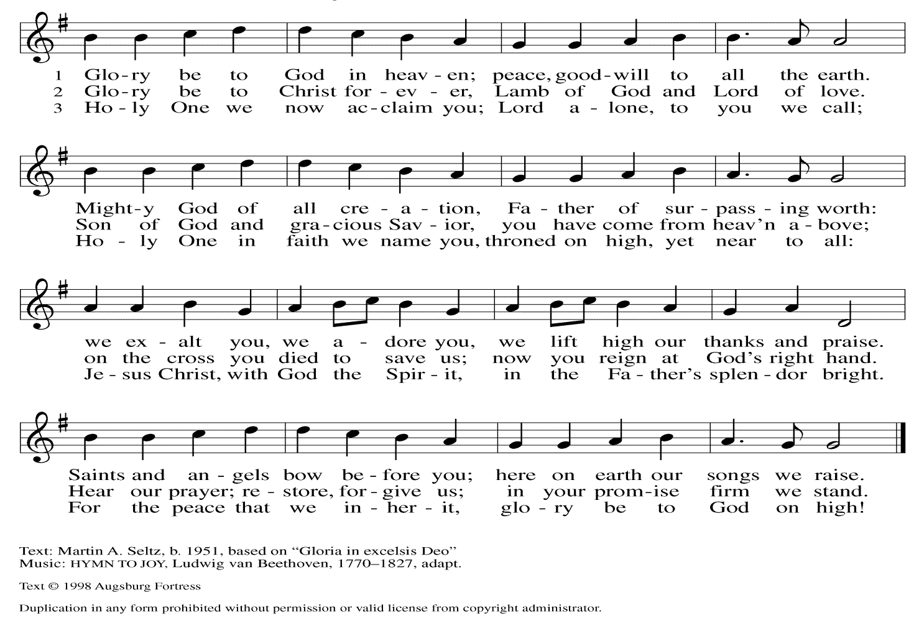

PRAYER OF THE DAY
Lord God, with endless mercy you receive the prayers of all who call upon you. By your Spirit show us the things we ought to do, and give us the grace and power to do them, through Jesus Christ, our Savior and Lord.
Amen.

THE WORD

First Reading: Isaiah 58:1-9a
Shortly after the return of Israel from exile in Babylon, the people were troubled by the ineffectiveness of their fasts. God reminds them that outward observance is no substitute for genuine fasting that results in acts of justice, such as feeding the hungry, sheltering the homeless, and clothing the naked.
¹ Shout out; do not hold back! Lift up your voice like a trumpet! Announce to my people their rebellion,
to the house of Jacob their sins.² Yet day after day they seek me and delight to know my ways, as if they were a nation that practiced righteousness and did not forsake the ordinance of their God; they ask of me righteous judgments; they want God on their side. ³ “Why do we fast, but you do not see? Why humble ourselves, but you do not notice?” Look, you serve your own interest on your fast day and oppress all your workers. ⁴ You fast only to quarrel and to fight and to strike with a wicked fist. Such fasting as you do today will not make your voice heard on high. ⁵ Is such the fast that I choose, a day to humble oneself?
Is it to bow down the head like a bulrush and to lie in sackcloth and ashes? Will you call this a fast, a day acceptable to the Lord?
⁶ Is not this the fast that I choose: to loose the bonds of injustice, to undo the straps of the yoke, to let the oppressed go free, and to break every yoke? Is it not to share your bread with the hungry and bring the homeless poor into your house; when you see the naked, to cover them and not to hide yourself from your own kin? ⁸ Then your light shall break forth like the dawn, and your healing shall spring up quickly; your vindicator shall go before you; the glory of the Lord shall be your rear guard. ^{9a} Then you shall call, and the Lord will answer; you shall cry for help, and he will say, “Here I am.”
Word of God. Word of life. Thanks be to God.

Psalm: Psalm 112:1-9
¹ Hallelujah! Happy are they who fear the Lord and have great delight in God’s commandments!
² Their descendants will be mighty in the land; the generation of the upright will be blessed.
³ Wealth and riches will be in their house, and their righteousness will last forever.
⁴ Light shines in the darkness for the upright; the righteous are merciful and full of compassion.
⁵ It is good for them to be generous in lending and to manage their affairs with justice.
⁶ For they will never be shaken; the righteous will be kept in everlasting remembrance.
⁷ They will not be afraid of any evil rumors; their heart is steadfast, trusting in the Lord.
⁸ Their heart is established and will not shrink, until they see their desire upon their enemies.
⁹ They have given freely to the poor, and their righteousness stands fast forever; they will hold up their head with honor.
Second Reading: 1 Corinthians 2:1-12
Though people such as the Corinthians are enamored with human philosophy and wisdom, Paul continuously presents God’s hidden wisdom which is Jesus Christ crucified. True spiritual maturity involves judging ourselves and others in light of God’s revelation in the cross.
¹ When I came to you, brothers and sisters, I did not come proclaiming the testimony of God to you with superior speech or wisdom. ² For I decided to know nothing among you except Jesus Christ and him crucified. ³ And I came to you in weakness and in fear and in much trembling. ⁴ My speech and my proclamation were made not with persuasive words of wisdom but with a demonstration of the Spirit and of power, ⁵ so that your faith might rest not on human wisdom but on the power of God.
⁶ Yet among the mature we do speak wisdom, though it is not a wisdom of this age or of the rulers of this age, who are being destroyed. ⁷ But we speak God’s wisdom, a hidden mystery, which God decreed before the ages for our glory ⁸ and which none of the rulers of this age understood, for if they had, they would not have crucified the Lord of glory. ⁹ But, as it is written, “What no eye has seen, nor ear heard,
nor the human heart conceived, what God has prepared for those who love him”—
¹⁰ God has revealed to us through the Spirit, for the Spirit searches everything, even the depths of God. ¹¹ For what human knows what is truly human except the human spirit that is within? So also no one comprehends what is truly God’s except the Spirit of God. ¹² Now we have received not the spirit of the world but the Spirit that is from God, so that we may understand the gifts bestowed on us by God.
Word of God. Word of life. Thanks be to God.

GOSPEL ACCLAMATION:
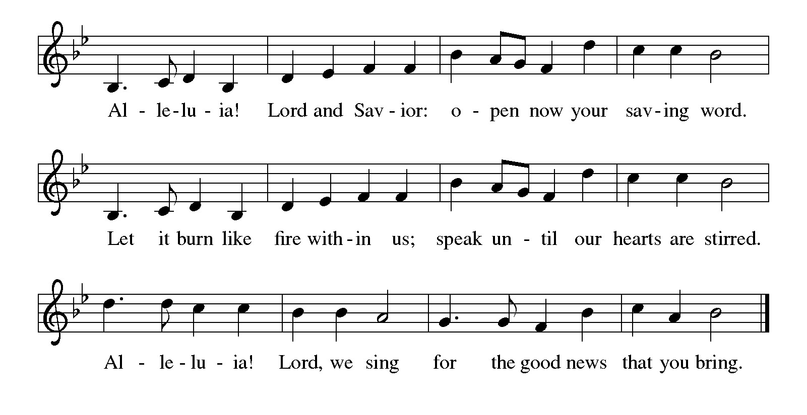
GOSPEL: The holy gospel according to Matthew 5:13-20
Glory to you, O Lord.
[Jesus said:] ¹³ “You are the salt of the earth, but if salt has lost its taste, how can its saltiness be restored? It is no longer good for anything but is thrown out and trampled under foot.
¹⁴ “You are the light of the world. A city built on a hill cannot be hid. ¹⁵ People do not light a lamp and put it under the bushel basket; rather, they put it on the lampstand, and it gives light to all in the house. ¹⁶ In the same way, let your light shine before others, so that they may see your good works and give glory to your Father in heaven.
¹⁷ “Do not think that I have come to abolish the Law or the Prophets; I have come not to abolish but to fulfill. ¹⁸ For truly I tell you, until heaven and earth pass away, not one letter, not one stroke of a letter, will pass from the law until all is accomplished. ¹⁹ Therefore, whoever breaks one of the least of these commandments and teaches others to do the same will be called least in the kingdom of heaven, but whoever does them and teaches them will be called great in the kingdom of heaven. ²⁰ For I tell you, unless your righteousness exceeds that of the scribes and Pharisees, you will never enter the kingdom of heaven.”
The gospel of the Lord. Praise to you, O Christ.

SERMON

HYMN OF THE DAY: WOV#752 Here I Am Lord

1 "I, the Lord of sea and sky, I have heard my people cry.
All who dwell in dark and sin my hand will save.
I, who made the stars of night, I will make their darkness bright.
Who will bear my light to them? Whom shall I send?"

Refrain: Here I am, Lord. Is it I, Lord? I have heard you calling in the night.
I will go, Lord, if you lead me. I will hold your people in my heart.

2 "I, the Lord of snow and rain, I have borne my people's pain.
I have wept for love of them. They turn away.
I will break their hearts of stone, give them hearts for love alone.
I will speak my word to them. Whom shall I send?" Refrain

3 "I, the Lord of wind and flame, I will tend the poor and lame.
I will set a feast for them. My hand will save.
Finest bread I will provide till their hearts be satisfied.
I will give my life to them. Whom shall I send?" Refrain
Text: Daniel L. Schutte, b. 1946. Text © 1981 OCP Publications, Inc., 5536 NE Hassalo, Portland, OR 97213. All rights reserved. Used by permission.
APOSTLES’ CREED
I believe in God, the Father almighty, creator of heaven and earth.
I believe in Jesus Christ, God’s only Son, our Lord, who was conceived by the Holy Spirit, born of the virgin Mary, suffered under Pontius Pilate, was crucified, died, and was buried; he descended into hell. On the third day he rose again; he ascended into heaven, he is seated at the right hand of the Father, and he will come to judge the living and the dead.
I believe in the Holy Spirit, the holy catholic church, the communion of saints, the forgiveness of sins, the resurrection of the body, and the life everlasting. Amen.

THE PRAYERS
As God’s beloved children united in Christ, let us pray for the church, the whole human community, and the well-being of the earth, our home.

A brief silence.

Your church does ministry in many and various ways. Keep the baptized true to the mind of Christ, that our works and witness bring hope to a troubled world. Merciful God,
receive our prayer.
Your marvelous creation cries out to you. Restore polluted air, soil, and water sources to wholeness. Guard honeybees, elephants, great whales and songbirds from harm, and renew the face of the earth. Merciful God,
receive our prayer.
Your people in every nation suffer injustice, poverty, and the threat of violence. Guide those in authority to govern with compassion, and bring peace to war zones. We pray for our enemies. Merciful God,
receive our prayer.
Your blessings are poured out for all in need. Help and heal any who experience trauma, discrimination, disease, hunger, abuse, or persecution. Comfort those who are sick or grieving especially those on our prayer list. Merciful God,
receive our prayer.
Your wisdom guides this congregation and its ministries. Sustain our ordained leaders, staff, lay leaders, and volunteers. Form us to be salt and light for the neighbors we serve, following the example of Christ. Merciful God,
receive our prayer.
Here other prayers may be offered.
Your saints rejoice at your heavenly banquet. We give thanks for their lives of faith, trusting that we also will be embraced by your eternal love. Merciful God,
receive our prayer.
Confident that the Holy Spirit receives our prayers and answers us, we commend all for whom we pray to God’s loving-kindness made known to us in Christ Jesus our Savior.
Amen.

PEACE
The peace of the Lord be with you always.
And also with you
OFFERTORY SENTENCE
With thankful hearts, we bring our offerings, trusting in God who provides for every need.

OFFERTORY HYMN: #564 Praise God, from Whom All Blessings Flow (inclusive language)
Praise God, from whom all blessings flow;
Praise God, all creatures here below;
Praise God, above, ye heav’nly host;
Creator, Christ, and Holy Ghost. Amen.

OFFERTORY PRAYER
God of majesty, no eye has seen, no ear has heard what you have prepared for those who love you, yet in this meal you reveal the wideness of your mercy. Use what we have gathered to feed us with the reign of God come near, Jesus Christ, our Savior and Lord.
Amen.

COMMUNION

THE GREAT THANKSGIVING
The Lord be with you.
And also with you.
Lift up your hearts.
We lift them to the Lord.
Let us give thanks to the Lord our God.
It is right to give our thanks and praise.

THE PROPER PREFACE: It is indeed right and salutary…

SANCTUS
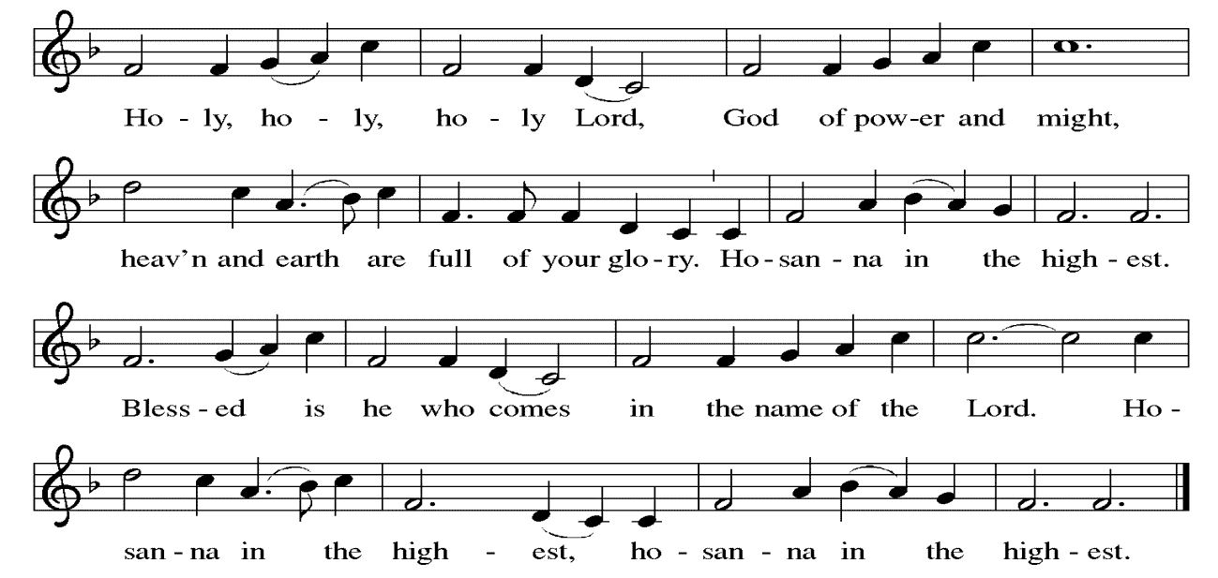

PRAYER OF INSTITUTION

LORD’S PRAYER
Gathered into one by the Holy Spirit, let us pray as Jesus taught us.

Our Father, who art in heaven, hallowed be thy name, thy kingdom come, thy will be done, on earth as it is in heaven. Give us this day our daily bread; and forgive us our trespasses, as we forgive those who trespass against us; and lead us not into temptation, but deliver us from evil. For thine is the kingdom, and the power, and the glory, forever and ever. Amen.

OR

Our Father in heaven, hallowed be your name, your kingdom come, your will be done, on earth as in heaven. Give us today our daily bread. Forgive us our sins as we forgive those who sin against us. Save us from the time of trial, and deliver us from evil. For the kingdom, the power, and the glory are yours now and forever. Amen

INVITATION TO COMMUNION
Here is the Lamb of God who takes away the sin of the world! Come to the table; taste and see.

COMMUNION ANTHEM
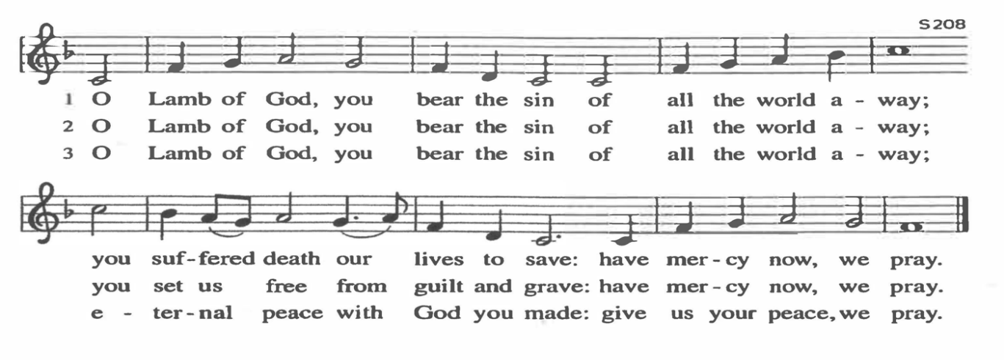
POST COMMUNION PRAYER
Radiant God, we have seen your glory in the face of Jesus Christ. In the sacrament of his body and blood you have drawn us to your heart. Send us from this table with delight, that our lives may reflect the beauty of your love, and bear witness to all we have seen and heard, through Jesus Christ, our Savior and Lord.
Amen.

BLESSING
May the triune God, who has put a new song in your mouth and tuned your heart for praise ☩ bless you now and forever.
Amen.

SENDING HYMN LBW#535 Holy God, We Praise Your Name
1 Holy God, we praise your name;
Lord of all, we bow before you.
All on earth your scepter claim,
all in heav'n above adore you.
Infinite your vast domain,
everlasting is your reign.
2 Hark! The glad celestial hymn
angel choirs above are raising;
cherubim and seraphim,
in unceasing chorus praising,
fill the heav'ns with sweet accord:
"Holy, holy, holy Lord!"
3 Lo, the apostolic train
join your sacred name to hallow;
prophets swell the glad refrain,
and the white-robed martyrs follow;
and from morn to set of sun
through the church the song goes on.

4 Holy Father, holy Son,
Holy Spirit, three we name you,
though in essence only one;
undivided God we claim you
and, adoring, bend the knee
while we own the mystery.

DISMISSAL
Go in peace. Do justice. Love mercy.
Thanks be to God.

POSTLUDE
PRAYER LIST
(Please call the office to add/or update the Prayer List)

Sue Patterson on hospice care, Ann Miller Taylor, Don and Barbara Wilson, Marty Cosgriff, Charlotte Berndt, God’s protection for David Powell, God’s guidance and wisdom for Cameron, healing for Helene Rabe, Fred W. Taylor, Madeline McEntyre, Scott Tyler, Jim Lynch, Shirley Lustig, Barbara who is in hospice, Michele Hansen, Lisa Weathers, Matthew Allison, Antonio Jamir and family, Joann and Tye Peyton, Linda Fairless, Shamari Johnson Moore, Christine Fairless, Suzy and John Henry, Gudrun Schamoni, God’s protection for Rhea, David Forsyth, Phil Arthur, Ruth Wolf with cancer, Peter Dow, Francis and Rueben, and Anne with cancer, protection for Audrey Frangiamore

ANNOUNCEMENTS

Annual Congregational Meeting Today February 8, 2026 after Worship: It is important to attend our congregational meeting where we review our ministry this past year and plan our way forward in 2026.

Fellowship Hour: We love spending time together after worship, please join us in Parish Hall and feel free to bring something yummy to share!

Council monthly meeting: The Council meets Wednesdays. The next meeting is February 18, 2026 at 7PM via Zoom. Congregation members are welcome at the meetings,

Next Dine and Connect, February 23, 2026: This is an interfaith and community run program to feed the houseless and food insecure in Alameda.

Immanuel Website: You can find our weekly worship bulletin, worship live streaming link, church calendar, events announcements and much more online. Please visit:

Donate to Immanuel Online: It is important that our offerings continue to support our ministry. You can tithe to Immanuel several different ways including PayPal via the church website, through the mail: 1910 Santa Clara Avenue, Alameda, CA 94501, or through the church mail slot located to the right of the metal gate on Santa Clara Ave. Thank you!

Pastor Availability & Contact Info: Rev. Crystal Larsen Stewart’s office hours have changed from Thursdays to Fridays. She can be reached by phone and email to schedule time for pastoral care and appointments. Cell: 510-693-1974. Email: pastor@immanuel-alameda.org

Church Office: Hours vary and are available by appointment. Please call the office at 510-523-0659 and leave a message for pastor or volunteers. We are in need of more volunteers for tasks like the Sunday bulletin, organizing and checking voicemail; please call if you can help.

Recycling: Pure Recycling is available by volunteer Walter McQuesten-510-521-1356. Collects: Plastic: CRV, empty, crushed, bagged, no lids (put lids in own recycle); Aluminum: empty, crushed/flattened and separated; Glass bottles: clean and boxed. It is good to recycle!
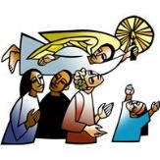
*Liturgy materials used from Sundays and Seasons & A Sanctified Art.

