IMMANUEL LUTHERAN CHURCH
Second Sunday after Epiphany, January 18, 2026
Martin Luther King Sunday
Worship in person or online Sunday at 10 AM
See our website for the link: www.immanuel-alameda.org
For those online wanting to participate in communion, please have bread & wine/or juice available.
Rev. Crystal Larsen Stewart · pastor@immanuel-alameda.org
Church: 1420 Lafayette Street Alameda, CA 94501; Office: 1910 Santa Clara Ave.
(510) 523-0659 · office@immanuel-alameda.org


THE GATHERING
The congregation’s spoken parts are in bold italic type.

PRELUDE

WORDS OF WELCOME AND ANNOUNCEMENTS

GATHERING HYMN: WOV #627 My Lord, What a Morning Text: African American Spiritual
Refrain: My Lord, what a morning;
my Lord, what a morning;
oh, my Lord, what a morning,
when the stars begin to fall.

1 You will hear the trumpet sound,
to wake the nations underground,
looking to my God's right hand,
when the stars begin to fall. Refrain

2 You will hear the sinner cry,
to wake the nations underground,
looking to my God's right hand,
when the stars begin to fall. Refrain

3 You will hear the Christian shout,
to wake the nations underground,
looking to my God's right hand,
when the stars begin to fall. Refrain

CONFESSION AND FORGIVENESS
All may make the sign of the cross, the sign that is marked at baptism, as the presiding minister begins.

Blessed be the holy Trinity, ☩ one God,
the Creator of heaven and earth,
the Word who spoke life into being,
the Wind stirring the waters.
Amen.
Let us turn in confession to the one who knows us completely.

Silence is kept for reflection.

Mighty God, lover of justice,
you call us to life in community,
but we have served our own interests
at the expense of our neighbors.
We have sown deceit where honesty was needed.
We say the right words, but our hearts are far from you.
Turn us to seek your face.
Knit us together and give us the mind of Christ,
that we may do justice, love mercy,
and walk humbly with you, our God.
Amen.

The former things have passed away,
and new things God now declares:
Like a spring of water that never fails,
God covers you in the righteousness of Christ,
and forgives your sin in ☩ Jesus’ name.
May the Spirit give you strength to live for others,
and bless you with the gift of peace.
Amen.

GREETING
The grace of our Lord Jesus Christ, the love of God, and the communion of the Holy Spirit be with you all.
And also with you.

CANTICLE OF PRAISE
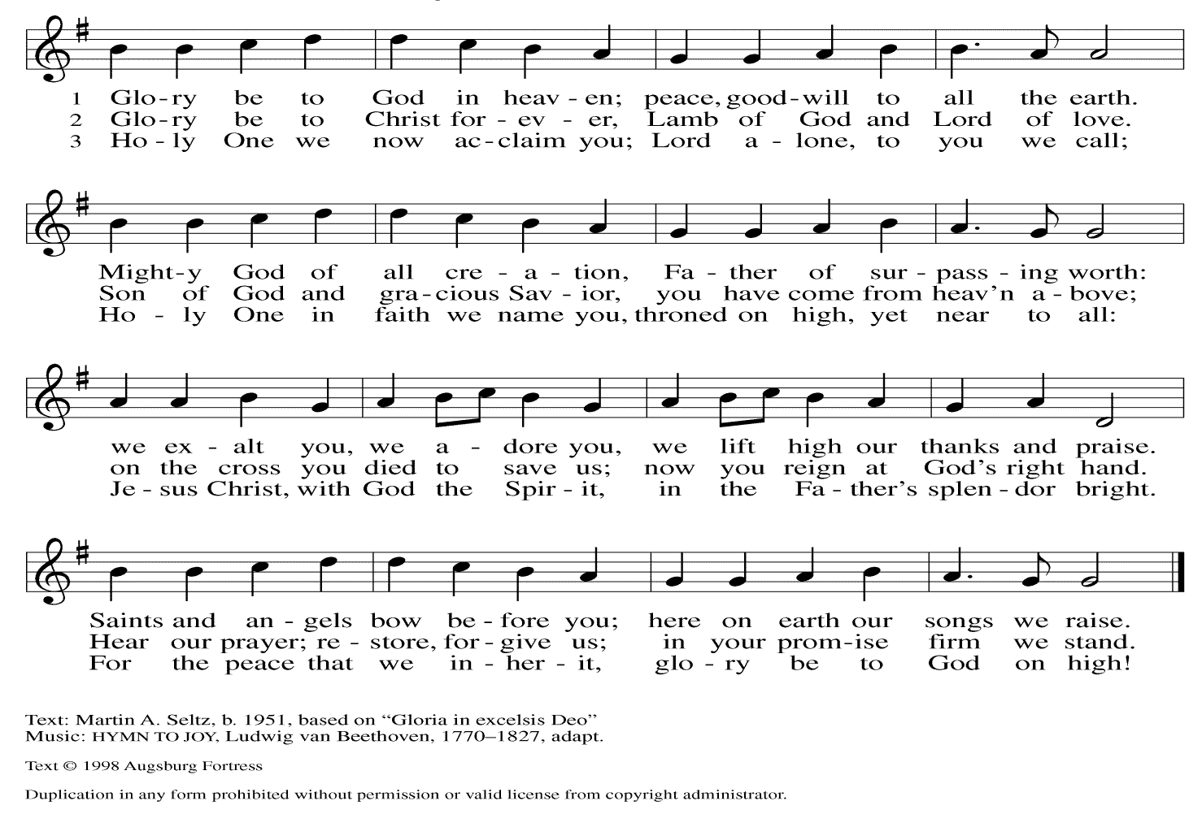

PRAYER OF THE DAY
Holy God, our strength and our redeemer, by your Spirit hold us forever, that through your grace we may worship you and faithfully serve you, follow you and joyfully find you, through Jesus Christ, our Savior and Lord.
Amen.

THE WORD

First Reading: Isaiah 49:1-7
Here the servant, identified as Israel, speaks for herself and describes her honored mission. Called before her birth like Jeremiah and John the Baptist, the servant is not only to restore Israel. The servant’s ultimate assignment is to bring news of God’s victory to the ends of the earth. God in faithfulness has chosen Israel for this task.
¹ Listen to me, O coastlands; pay attention, you peoples from far away! The Lord called me before I was born; while I was in my mother’s womb he named me.
² He made my mouth like a sharp sword; in the shadow of his hand he hid me; he made me a polished arrow; in his quiver he hid me away.
³ And he said to me, “You are my servant, Israel, in whom I will be glorified.”
⁴ But I said, “I have labored in vain; I have spent my strength for nothing and vanity; yet surely my cause is with the Lord and my reward with my God.”
⁵ And now the Lord says, who formed me in the womb to be his servant, to bring Jacob back to him, and that Israel might be gathered to him, for I am honored in the sight of the Lord, and my God has become my strength—
⁶ he says, “It is too light a thing that you should be my servant to raise up the tribes of Jacob and to restore the survivors of Israel; I will give you as a light to the nations, that my salvation may reach to the end of the earth.”
⁷ Thus says the Lord, the Redeemer of Israel and his Holy One, to one deeply despised, abhorred by the nations, the slave of rulers,
“Kings shall see and stand up; princes, and they shall prostrate themselves, because of the Lord, who is faithful, the Holy One of Israel, who has chosen you.”
Word of God. Word of life. Thanks be to God.

Psalm: Psalm 40:1-11 (read responsively)
¹ I waited patiently upon the Lord, who stooped to me and heard my cry.
² The Lord lifted me out of the desolate pit, out of the miry clay, and set my feet upon a high cliff, making my footing sure.
³ The Lord put a new song in my mouth, a song of praise to our God; many shall see, and stand in awe, and put their trust in the Lord.
⁴ Happy are they who trust in the Lord! They do not turn to enemies or to those who follow lies.
⁵ Great are the wonders you have done, O Lord my God! In your plans for us, none can be compared with you! Oh, that I could make them known and tell them! But they are more than can count.
⁶ Sacrifice and offering you do not desire; you have opened my ears: burnt-offering and sin-offering you have not required.
⁷ And so I said, “Here I am; I come. In the scroll of the book it is written of me:
⁸ ‘I love to do your will, O my God; your law is deep within me.’ ”
⁹ I proclaimed righteousness in the great assembly; I have not restrained my lips, O Lord, you know.
¹⁰ I have not hidden your righteousness in my heart; I have spoken of your faithfulness and your deliverance; I have not concealed your steadfast love and truth from the great assembly.
¹¹ You are the Lord; do not withhold your compassion from me; may your steadfast love and your truth continually keep me safe.

Second Reading: 1 Corinthians 1:1-9
Though God’s church in Corinth is a fractious congregation beset with many conflicts, Paul opens this letter by spotlighting the multiple ways God has enriched and sustained its life as part of the divine call into the fellowship of our Lord Jesus Christ.
¹ Paul, called to be an apostle of Christ Jesus by the will of God, and our brother Sosthenes,
² To the church of God that is in Corinth, to those who are sanctified in Christ Jesus, called to be saints, together with all those who in every place call on the name of our Lord Jesus Christ, both their Lord and ours:
³ Grace to you and peace from God our Father and the Lord Jesus Christ.
⁴ I give thanks to my God always for you because of the grace of God that has been given you in Christ Jesus, ⁵ for in every way you have been enriched in him, in speech and knowledge of every kind ⁶ just as the testimony of Christ has been strengthened among you ⁷ so that you are not lacking in any gift as you wait for the revealing of our Lord Jesus Christ. ⁸ He will also strengthen you to the end, so that you may be blameless on the day of our Lord Jesus Christ. ⁹ God is faithful, by whom you were called into the partnership of his Son, Jesus Christ our Lord.
Word of God. Word of life. Thanks be to God.

GOSPEL ACCLAMATION:
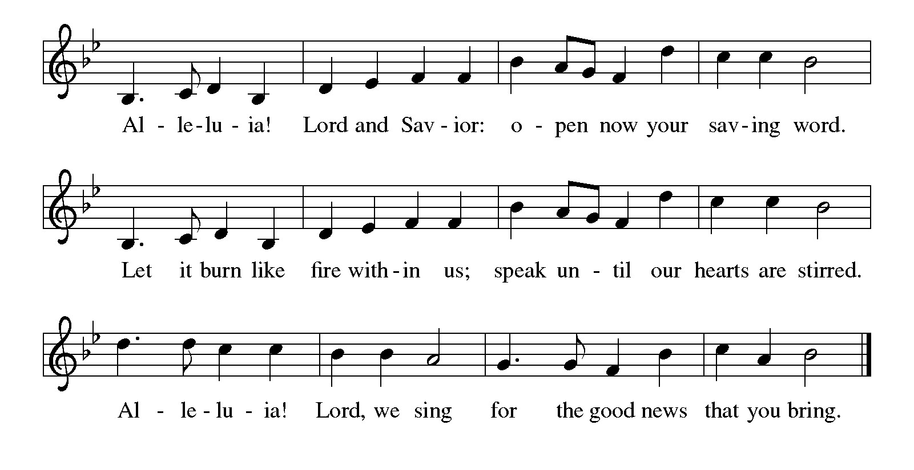
GOSPEL: The holy gospel according to John 1:29-42
Glory to you, O Lord.

¹³ Jesus came from Galilee to John at the Jordan, to be baptized by him. ¹⁴ John would have prevented him, saying, “I need to be baptized by you, and do you come to me?” ¹⁵ But Jesus answered him, “Let it be so now, for it is proper for us in this way to fulfill all righteousness.” Then he consented. ¹⁶ And when Jesus had been baptized, just as he came up from the water, suddenly the heavens were opened to him and he saw God’s Spirit descending like a dove and alighting on him. ¹⁷ And a voice from the heavens said, “This is my Son, the Beloved, with whom I am well pleased.”
The gospel of the Lord. Praise to you, O Christ.

SERMON

HYMN OF THE DAY: LBW#359 In Christ There Is No East or West Text: John Oxenham, 1852-1941

1 In Christ there is no east or west,
in him no south or north,
but one community of love
throughout the whole wide earth.

2 In Christ shall true hearts ev’rywhere
their high communion find;
his service is the golden cord
close binding humankind.
3 Join hands, disciples of the faith,
whate’er your race may be.
All children of the loving God
are surely kin to me.

4 In Christ now meet both east and west,
in him meet south and north;
all Christly souls are one in him
throughout the whole wide earth

APOSTLES’ CREED
I believe in God, the Father almighty, creator of heaven and earth.
I believe in Jesus Christ, God’s only Son, our Lord, who was conceived by the Holy Spirit, born of the virgin Mary, suffered under Pontius Pilate, was crucified, died, and was buried; he descended into hell. On the third day he rose again; he ascended into heaven, he is seated at the right hand of the Father, and he will come to judge the living and the dead.
I believe in the Holy Spirit, the holy catholic church, the communion of saints, the forgiveness of sins, the resurrection of the body, and the life everlasting. Amen.

THE PRAYERS
As God’s beloved children united in Christ, let us pray for the church, the whole human community, and the well-being of the earth, our home.

A brief silence.

Gracious God, gather the church into one great fellowship. Equip your people to work together for justice and peace, following the example of Martin Luther King Jr., renewer of society, whose birth we remember this week. Merciful God,
receive our prayer.
Creating God, sustain the web of life on this planet. Protect wild places, endangered species, and vulnerable habitats. Come to the aid of those affected by natural disasters. Merciful God,
receive our prayer.
Just God, you desire respect and equality for everyone. Raise up prophets who speak truth to the nations. Embolden leaders and those in authority to advocate for people in need. Merciful God,
receive our prayer.
Healing God, you lift up those who are bowed down by trouble, oppression, or illness especially those on our prayer list. Bring an end to social injustice and inequities of every kind, so that all people may have abundant life. Merciful God,
receive our prayer.
Abiding God, you are present with this congregation. Keep us mindful of our mission and guide our Dine and Connect and CRECE ministries in this community. Kindle in us a desire to help one another. Merciful God,
receive our prayer.
Here other prayers may be offered.
Faithful God, you promise to be with us always. We remember with gratitude the faithful departed who now rest in you. Strengthen us to the end, that we may see you face to face. Merciful God,
receive our prayer.
Confident that the Holy Spirit receives our prayers and answers us, we commend all for whom we pray to God’s loving-kindness made known to us in Christ Jesus our Savior.
Amen.

PEACE
The peace of the Lord be with you always.
And also with you
OFFERTORY SENTENCE
With thankful hearts, we bring our offerings, trusting in God who provides for every need.

OFFERTORY HYMN: #564 Praise God, from Whom All Blessings Flow (inclusive language)
Praise God, from whom all blessings flow;
Praise God, all creatures here below;
Praise God, above, ye heav’nly host;
Creator, Christ, and Holy Ghost. Amen.

OFFERTORY PRAYER
God of majesty, no eye has seen, no ear has heard what you have prepared for those who love you, yet in this meal you reveal the wideness of your mercy. Use what we have gathered to feed us with the reign of God come near, Jesus Christ, our Savior and Lord.
Amen.

COMMUNION

THE GREAT THANKSGIVING
The Lord be with you.
And also with you.
Lift up your hearts.
We lift them to the Lord.
Let us give thanks to the Lord our God.
It is right to give our thanks and praise.

THE PROPER PREFACE: It is indeed right and salutary…

SANCTUS
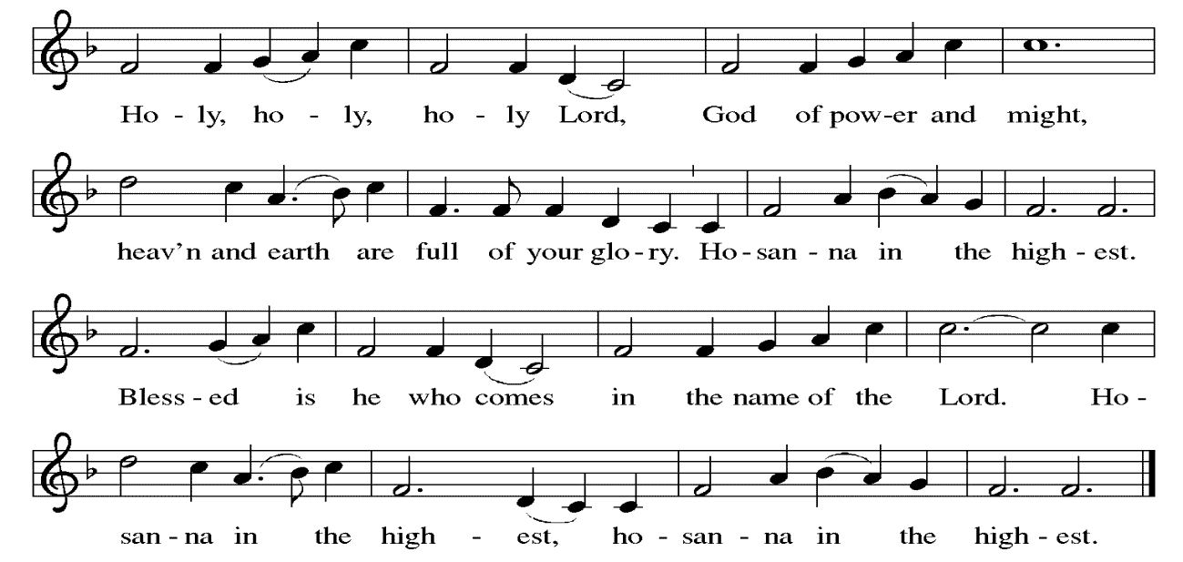

PRAYER OF INSTITUTION

LORD’S PRAYER
Gathered into one by the Holy Spirit, let us pray as Jesus taught us.

Our Father, who art in heaven, hallowed be thy name, thy kingdom come, thy will be done, on earth as it is in heaven. Give us this day our daily bread; and forgive us our trespasses, as we forgive those who trespass against us; and lead us not into temptation, but deliver us from evil.For thine is the kingdom, and the power, and the glory, forever and ever. Amen.

OR

Our Father in heaven, hallowed be your name, your kingdom come, your will be done, on earth as in heaven. Give us today our daily bread. Forgive us our sins as we forgive those who sin against us. Save us from the time of trial, and deliver us from evil. For th ekingdom, the power, and the glory are yours now and forever. Amen

INVITATION TO COMMUNION
Here is the Lamb of God who takes away the sin of the world! Come to the table; taste and see.

COMMUNION ANTHEM
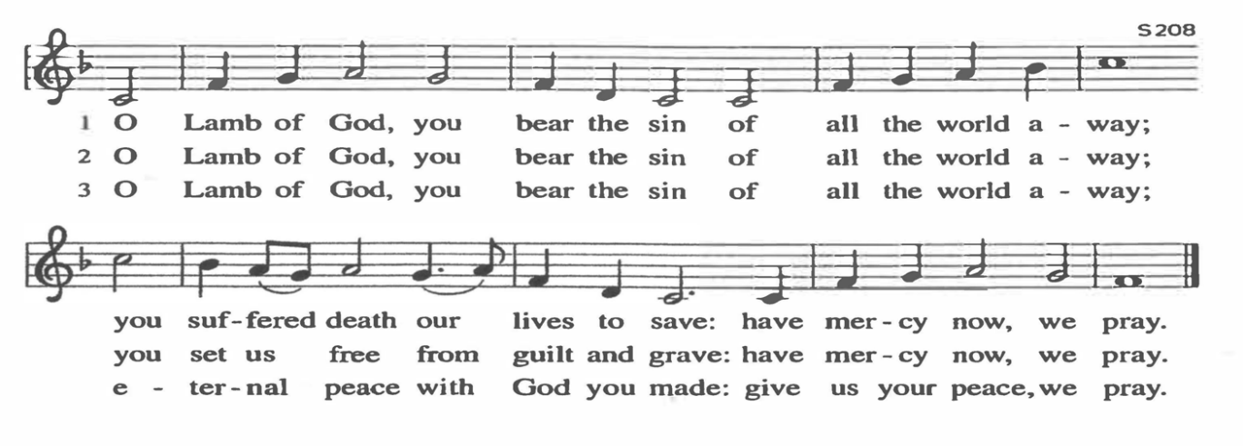
POST COMMUNION PRAYER
Radiant God, we have seen your glory in the face of Jesus Christ. In the sacrament of his body and blood you have drawn us to your heart. Send us from this table with delight, that our lives may reflect the beauty of your love, and bear witness to all we have seen and heard, through Jesus Christ, our Savior and Lord.
Amen.

BLESSING
May the triune God, who has put a new song in your mouth and tuned your heart for praise ☩ bless you now and forever.
Amen.

SENDING HYMNLBW#562 Lift Every Voice and Sing Text James W Johnson, 1871-1938.
1 Lift ev'ry voice and sing till earth and heaven ring,
ring with the harmonies of liberty.
Let our rejoicing rise high as the list'ning skies,
let it resound loud as the rolling sea.
Sing a song full of the faith that the dark past has taught us;
sing a song full of the hope that the present has brought us;
facing the rising sun of our new day begun,
let us march on till victory is won.

2 Stony the road we trod, bitter the chast'ning rod,
felt in the days when hope unborn had died;
yet with a steady beat, have not our weary feet
come to the place for which our parents sighed?
We have come over a way that with tears has been watered;
we have come, treading our path through the blood of the slaughtered,
out from the gloomy past, till now we stand at last
where the white gleam of our bright star is cast.

3 God of our weary years, God of our silent tears,
thou who hast brought us thus far on the way;
thou who hast by thy might led us into the light,
keep us forever in the path, we pray.
Lest our feet stray from the places, our God, where we met thee;
lest, our hearts drunk with the wine of the world, we forget thee;
shadowed beneath thy hand may we forever stand,
true to our God, true to our native land.

DISMISSAL
Go in peace. Do justice. Love mercy.
Thanks be to God.
POSTLUDE
PRAYER LIST
(Please call the office to add/or update the Prayer List)

Sue Patterson on hospice care, Ann Miller Taylor, Don and Barbara Wilson, Marty Cosgriff, Charlotte Berndt, God’s protection for David Powell, God’s guidance and wisdom for Cameron, healing for Helene Rabe, Fred W. Taylor, Madeline McEntyre, Scott Tyler, Jim Lynch, Shirley Lustig, Barbara who is in hospice, Michele Hansen, Lisa Weathers, Matthew Allison, Antonio Jamir and family, Joann and Tye Peyton, Linda Fairless, Shamari Johnson Moore, Christine Fairless, Suzy and John Henry, Gudrun Schamoni, God’s protection for Rhea, David Forsyth, Phil Arthur, Ruth Wolf with cancer, Peter Dow, Francis and Rueben, and Anne with cancer, for protection of Audrey Frangiamore

ANNOUNCEMENTS
Annual Congregational Meeting, February 8, 2026 after Worship: It is important to attend our congregational meeting where we review our ministry this past year and plan our way forward in 2026.

Fellowship Hour: We love spending time together after worship, please join us in Parish Hall and feel free to bring something yummy to share!

Council monthly meeting: The Council meets Wednesdays. The next meeting is January 21, 2026 at 7PM via Zoom. Congregation members are welcome at the meetings,

Next Dine and Connect, January 25, 2026. This is an interfaith and community run program to feed the houseless and food insecure in Alameda.

Immanuel Website: You can find our weekly worship bulletin, worship live streaming link, church calendar, events announcements and much more online. Please visit: www.immanuel-alameda.org

Donate to Immanuel Online: It is important that our offerings continue to support our ministry. You can tithe to Immanuel several different ways including PayPal via the church website, through the mail: 1910 Santa Clara Avenue, Alameda, CA 94501, or through the church mail slot located to the right of the metal gate on Santa Clara Ave. Thank you!

Pastor Availability & Contact Info: Rev. Crystal Larsen Stewart’s office hours have changed from Thursdays to Fridays. She can be reached by phone and email to schedule time for pastoral care and appointments. Cell: 510-693-1974. Email: pastor@immanuel-alameda.org

Church Office: Hours vary and are available by appointment. Please call the office at 510-523-0659 and leave a message for pastor or volunteers. We are in need of more volunteers for tasks like the Sunday bulletin, organizing and checking voicemail; please call if you can help.

Recycling: Pure Recycling is available by volunteer Walter McQuesten-510-521-1356. Collects: Plastic: CRV, empty, crushed, bagged, no lids (put lids in own recycle); Aluminum: empty, crushed/flattened and separated; Glass bottles: clean and boxed. It is good to recycle!

*Liturgy materials used from Sundays and Seasons & A Sanctified Art

