IMMANUEL LUTHERAN CHURCH
Twenty Second Sunday After Pentecost
November 9, 2025

Worship in person or online Sunday at 10 AM
See our website for the link: www.immanuel-alameda.org
For those online wanting to participate in communion, please have bread & wine/or juice available.

Rev. Crystal Larsen Stewart · pastor@immanuel-alameda.org
Church: 1420 Lafayette Street Alameda, CA 94501; Office: 1910 Santa Clara Ave.
(510) 523-0659 · office@immanuel-alameda.org

THE GATHERING
The congregation reads parts in bold type aloud together.
PRELUDE

WORDS OF WELCOME AND ANNOUNCEMENTS

GATHERING HYMN: WOV#780 What a Fellowship, What a Joy Divine

1 What a fellowship, what a joy divine, leaning on the everlasting arms;
what a blessedness, what a peace is mine, leaning on the everlasting arms.

Refrain; Leaning, leaning, safe and secure from all alarms;
leaning, leaning, leaning on the everlasting arms.

2 Oh, how sweet to walk in this pilgrim way, leaning on the everlasting arms;
oh, how bright the path grows from day to day, leaning on the everlasting arms. Refrain

3 What have I to dread, what have I to fear, leaning on the everlasting arms?
I have blessed peace with my Lord so near, leaning on the everlasting arms. Refrain
Text: Elisha A. Hoffman, 1839-1929

CONFESSION AND FORGIVENESS
All may make the sign of the cross, the sign that is marked at baptism, as the presiding minister begins.

We live fractured lives, and God seeks not to punish us for those fault and fault lines, but to reconcile and restore us. Trusting in God’s grace and mercy, let us make our confessions first in silent prayer, then together aloud.

Silence is kept for reflection.
Loving God, help us. When we have run away, when we have turned our backs on love, when we have sought immediate satisfaction and not long-term healing, help us.
Merciful God, forgive us. When we have been selfish, when we have been mean, when we have closed our ears to the cries of others, forgive us.
Powerful God, heal us. When we are so broken we cannot move, when we don’t know how to stem the bleeding of our wounds, when we are too ashamed to seek community, heal us.
Give us the courage, the strength, and the hope to accept your grace and hear your call in Christ.
Amen.

Friends in Christ, know this: the mercy of God is from everlasting to everlasting, and I remind you of this surpassing grace – in ☩Jesus Christ, we are forgiven.
Alleluia! Amen.

GREETING
The grace of our Lord Jesus Christ, the love of God, and the communion of the Holy Spirit with you all.
And also with you

CANTICLE OF PRAISE

Assisting Minister or Cantor:

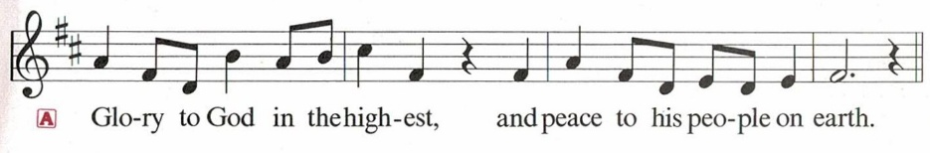

Congregation:
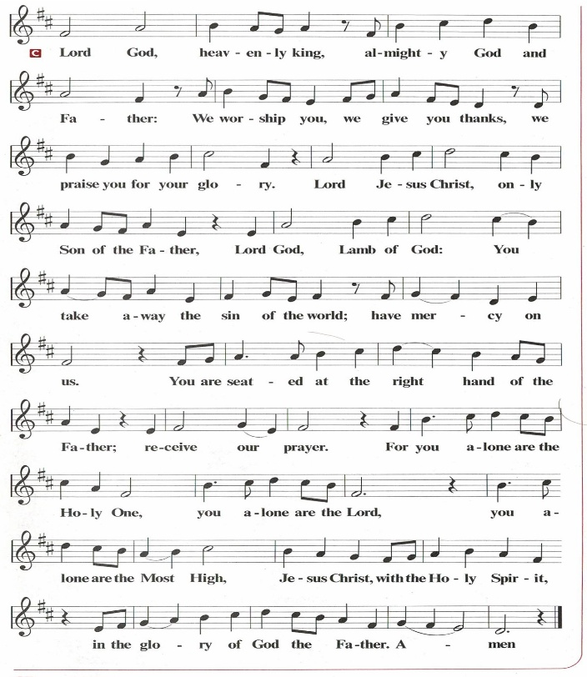

PRAYER OF THE DAY
O God, our eternal redeemer, by the presence of your Spirit you renew and direct our hearts. Keep always in our mind the end of all things and the day of judgment. Inspire us for a holy life here, and bring us to the joy of the resurrection, through Jesus Christ, our Savior and Lord.
Amen.

THE WORD

First Reading: Job 19:23-27a
Job suffers the loss of children, wealth, and health. Accused by his companions of wrongdoing, he knows himself to be innocent. Here, in the midst of his suffering, Job clings to the radical hope that his vindicator, his redeemer, lives; and that one day he himself will see God.
²³ “O that my words were written down!
O that they were inscribed in a book!
²⁴ O that with an iron pen and with lead
they were engraved on a rock forever!
²⁵ For I know that my vindicator lives
and that in the end he will stand upon the earth;
²⁶ and after my skin has been destroyed,
then in my flesh I shall see God,
^{27a} whom I shall see on my side,
and my eyes shall behold, and not another.”
Word of God. Word of life. Thanks be to God.

Psalm: Psalm 17:1-9
¹ Hear a just cause, O Lord; give heed to my cry; listen to my prayer, which does not come from lying lips.
² Let my vindication come forth from your presence; let your eyes be fixed on justice.
³ Examine my heart, visit me by night, melt me down; you will find no impurity in me.
⁴ I have not regarded what others do; at the word of your lips I have avoided the ways of the violent.
⁵ My footsteps hold fast to your well-worn path; and my feet do not slip.
⁶ I call upon you, O God, for you will answer me; incline your ear to me and hear my words.
⁷ Show me your marvelous lovingkindness, O Savior of those who take refuge at your right hand from those who rise against them.
⁸ Keep me as the apple of your eye; hide me under the shadow of your wings,
⁹ from the wicked who assault me, from my deadly enemies who surround me.

Second Reading: 2 Thessalonians 2:1-5, 13-17
This portion of the letter provides encouragement for the church at Thessalonica during a time of confusion and opposition, as some allowed their concern over Jesus’ imminent return to divert them from the central teachings of the gospel.
¹ As to the coming of our Lord Jesus Christ and our being gathered together to him, we beg you, brothers and sisters, ² not to be quickly shaken in mind or alarmed, either by spirit or by word or by letter, as though from us, to the effect that the day of the Lord is already here. ³ Let no one deceive you in any way, for that day will not come unless the rebellion comes first and the lawless one is revealed, the one destined for destruction. ⁴ He opposes and exalts himself above every so-called god or object of worship, so that he takes his seat in the temple of God, declaring himself to be God. ⁵ Do you not remember that I told you these things when I was still with you?
¹³ But we must always give thanks to God for you, brothers and sisters beloved by the Lord, because God chose you as the first fruits for salvation through sanctification by the Spirit and through belief in the truth. ¹⁴ For this purpose he called you through our gospel, so that you may obtain the glory of our Lord Jesus Christ. ¹⁵ So then, brothers and sisters, stand firm and hold fast to the traditions that you were taught by us, either by word of mouth or by our letter.
¹⁶ Now may our Lord Jesus Christ himself and God our Father, who loved us and through grace gave us eternal comfort and good hope, ¹⁷ comfort your hearts and strengthen them in every good work and word.
Word of God. Word of life. Thanks be to God.

GOSPEL ACCLAMATION

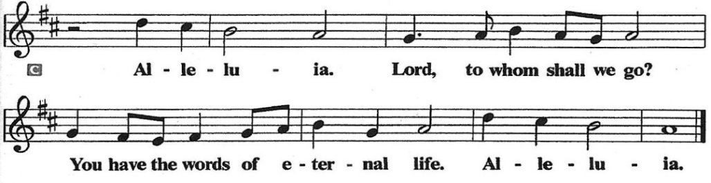

Gospel: Luke 20:27-38

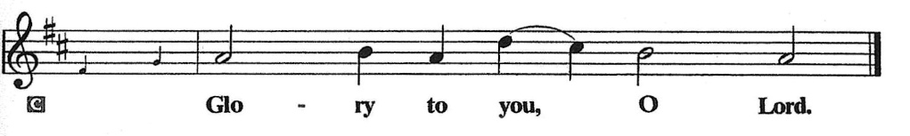
Some Sadducees, who do not believe in the resurrection of the dead, try to trap Jesus. They formulate the convoluted case of a serial widow who marries a succession of seven brothers. Jesus responds by teaching about God to whom all are alive and in whom all relationships are fulfilled.
²⁷ Some Sadducees, those who say there is no resurrection, came to [Jesus] ²⁸ and asked him a question: “Teacher, Moses wrote for us that if a man’s brother dies leaving a wife but no children, the man shall marry the widow and raise up children for his brother. ²⁹ Now there were seven brothers; the first married a woman and died childless; ³⁰ then the second ³¹ and the third married her, and so in the same way all seven died childless. ³² Finally the woman also died. ³³ In the resurrection, therefore, whose wife will the woman be? For the seven had married her.”
³⁴ Jesus said to them, “Those who belong to this age marry and are given in marriage, ³⁵ but those who are considered worthy of a place in that age and in the resurrection from the dead neither marry nor are given in marriage. ³⁶ Indeed, they cannot die anymore, because they are like angels and are children of God, being children of the resurrection. ³⁷ And the fact that the dead are raised Moses himself showed, in the story about the bush, where he speaks of the Lord as the God of Abraham, the God of Isaac, and the God of Jacob. ³⁸ Now he is God not of the dead but of the living, for to him all of them are alive.”
The Gospel of the Lord.

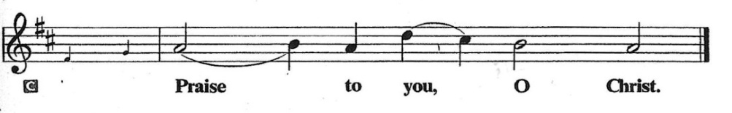

SERMON

HYMN OF THE DAY: WOV #699 Blessed Assurance Text: Fanny J. Crosby, 1820-1915
1 Blessed assurance, Jesus is mine! Oh, what a foretaste of glory divine!
Heir of salvation, purchase of God, born of his Spirit, washed in his blood.
Refrain: This is my story, this is my song, praising my Savior, all the day long:
this is my story, this is my song, praising my Savior all the day long.

2 Perfect submission, perfect delight, visions of rapture now burst on my sight;
angels descending bring from above echoes of mercy, whispers of love. Refrain

3 Perfect submission, all is at rest; I in my Savior am happy and blest,
watching and waiting, looking above, filled with his goodness, lost in his love. Refrain

APOSTLES’ CREED
I believe in God, the Father almighty, creator of heaven and earth.
I believe in Jesus Christ, God’s only Son, our Lord, who was conceived by the Holy Spirit, born of the virgin Mary, suffered under Pontius Pilate, was crucified, died, and was buried; he descended into hell. On the third day he rose again; he ascended into heaven, he is seated at the right hand of the Father, and he will come to judge the living and the dead.
I believe in the Holy Spirit, the holy catholic church, the communion of saints, the forgiveness of sins, the resurrection of the body, and the life everlasting. Amen.

Prayers of Intercession
Gathered with one voice, we offer our prayers for the church, the world, and all who are in need.
A brief silence.
God our Redeemer, bless your church universal and its leaders. Set all hearts on you from generation to generation in anticipation of Christ’s return. Hear us, O God.
Your mercy is great.
God of life, we give thanks for the fruits and grains of harvest, for rivers and streams, for all that is made of rock and iron. Renew the earth’s natural resources and the lands from which they come. Hear us, O God.
Your mercy is great.
God of justice, we give thanks for the service of our veterans and pray for those needing support for wounds of any kind. Strengthen those charged with the governance and protection of vulnerable populations. Bring an end to war throughout the world. Hear us, O God.
Your mercy is great.
God who leads us to belief and truth, we give thanks that you are always and already here. Nurture and support those who are unsteady in mind, unsafe in spirit, or unwell in body especially those on our prayer list.. Comfort those who suffer from trauma and exposure to traumatic events. Hear us, O God.
Your mercy is great.
God who gathers us together, we give thanks for our pastors and deacons, teachers and musicians, administrators, and building caretakers. May they find joy in leadership as we grow in faith together. Hear us, O God.
Your mercy is great.
Here other prayers may be offered.
God of the saints, we give thanks for all who have died in faith. Uplift us as we honor their memory and await your coming in glory. Hear us, O God.
Your mercy is great.
We offer these and all our prayers to you, O God, trusting in your grace and unyielding love; through Jesus Christ, our Lord.
Amen.

PEACE
The peace of the Lord be with you always.
And also with you
OFFERTORY SENTENCE
Accept our tithes and offerings as a gift of worship to you. Multiply what we give for the effective growth of your kingdom.

OFFERTORY HYMN
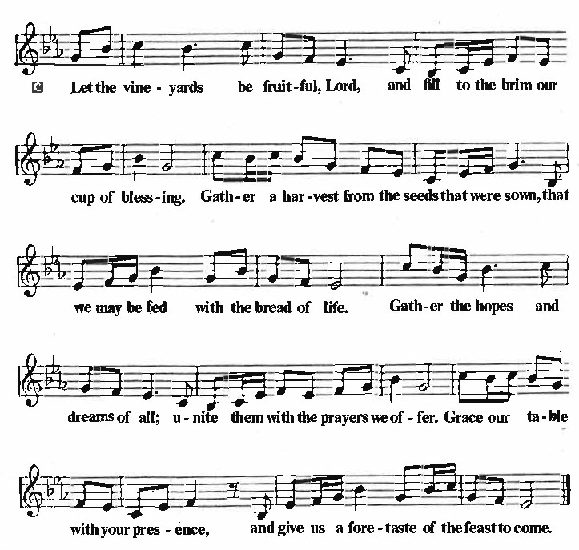
OFFERTORY PRAYER
Lord of the harvest, we return to you a portion of what you have given to us. Turn us to set our hope not on the uncertainty of riches, but on you, who richly provides for us. Multiply what we have gathered to bless all who are suffering and in need, through Jesus Christ our Lord.
Amen.

COMMUNION
THE GREAT THANKSGIVING
The Lord be with you.
And also with you.
Lift up your hearts.
We lift them to the Lord.
Let us give thanks to the Lord our God.
It is right to give our thanks and praise.
THE PROPER PREFACE: It is indeed right and salutary…

SANCTUS
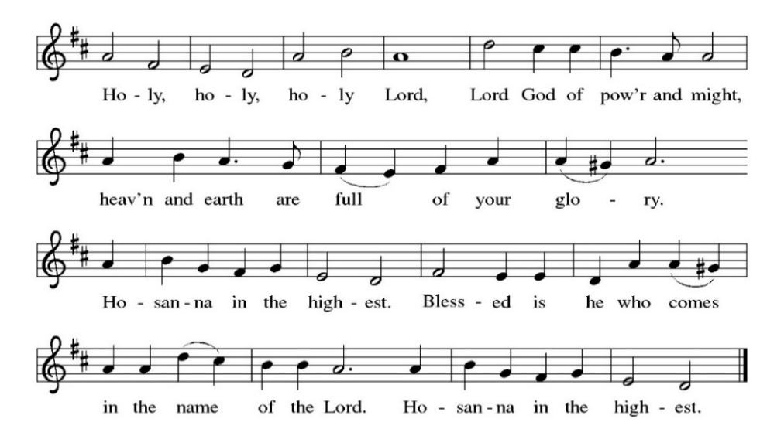
PRAYER OF INSTITUTION

LORD’S PRAYER
Gathered into one by the Holy Spirit, let us pray as Jesus taught us.

Our Father, who art in heaven, hallowed be thy name, thy kingdom come, thy will be done,
on earth as it is in heaven. Give us this day our daily bread; and forgive us our trespasses,
as we forgive those who trespass against us; and lead us not into temptation, but deliver us from evil. For thine is the kingdom, and the power, and the glory, forever and ever. Amen.

OR

Our Father in heaven, hallowed be your name, your kingdom come, your will be done,
on earth as in heaven. Give us today our daily bread. Forgive us our sins as we forgive those
who sin against us. Save us from the time of trial and deliver us from evil. For the kingdom, the power, and the glory are yours, now and forever. Amen.

INVITATION TO COMMUNION
Jesus welcomes sinners and eats with them. Come to this meal of mercy.

COMMUNION SONG
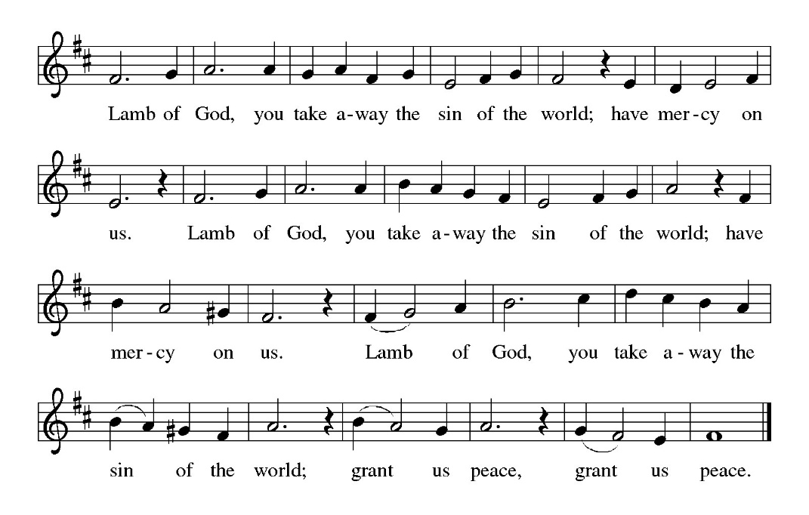
POST COMMUNION PRAYER
O God, through this meal you have strengthened us and appointed us to be your servants. Send us to do good and to share our possessions with all in need. We ask this in Jesus’ name.
Amen.

BLESSING
The God of righteousness, who gives justice to the oppressed, who gives food to the hungry, who sets the prisoners free, ☩ bless you now and forever.
Amen.

SENDING HYMN: LBW#315 Love Divine, All Love Excelling

1 Love divine, all loves excelling,
Joy of heav’n, to earth come down!
Fix in us thy humble dwelling,
all thy faithful mercies crown.
Jesus, thou art all compassion,
pure, unbounded love thou art;
visit us with thy salvation,
enter ev’ry trembling heart.

2 Breathe, oh, breathe thy loving Spirit
into ev’ry troubled breast;
let us all in thee inherit;
let us find thy promised rest.
Take away the love of sinning;
Alpha and Omega be;
end of faith, as its beginning,
set our hearts at liberty.

3 Come, Almighty, to deliver;
let us all thy life receive;
suddenly return, and never,
nevermore thy temples leave.
Thee we would be always blessing,
serve thee as thy hosts above,
pray, and praise thee without ceasing,
glory in thy perfect love.

4 Finish then thy new creation,
pure and spotless let us be;
let us see thy great salvation
perfectly restored in thee!
Changed from glory into glory,
till in heav’n we take our place,
till we cast our crowns before thee,
lost in wonder, love, and praise!

DISMISSAL
Go in peace. Do not lose heart.
Thanks be to God.

POSTLUDE

PRAYER LIST
(Please call the office to add/or update the Prayer List)

Sue Patterson on hospice care, Ann Miller Taylor, Don and Barbara Wilson, Marty Cosgriff, Charlotte Berndt, God’s protection for David Powell, God’s guidance and wisdom for Cameron, healing for Helene Rabe, Fred W. Taylor, Madeline McEntyre, Scott Tyler, Jim Lynch, Shirley Lustig, Barbara who is in hospice, Michele Hansen, Lisa Weathers, Matthew Allison, Antonio Jamir and family, Joann and Tye Peyton, Linda Fairless, Shamari Johnson Moore, Christine Fairless, Suzy and John Henry, Gudrun Schamoni, God’s protection for Rhea. David Forsyth, Phil Arthur, Ruth Wolf with cancer, Peter Dow, Francis and Rueben, Anne with cancer.

ANNOUNCEMENTS
Decorating the Sanctuary for Advent/Christmas: People are needed to help decorate the sanctuary after worship on November 23 to get ready for first Sunday of Advent on November 30.
Immanuel Lutheran Church Fall/Winter Come Celebrate with Us Events: Save the dates for the exciting events planned this fall and winter. See below for information and details.
Fellowship Hour: We love spending time together after worship, please join us in Parish Hall and feel free to bring something yummy to share!
Council monthly meeting: The Council meets Wednesdays. The next meeting is November 19, 2025 at 7PM via Zoom. Congregation members are welcome at the meetings,
Next Dine and Connect, November 24, 2025: This is an interfaith and community run program to feed the houseless and food insecure in Alameda.
Immanuel Website: You can find our weekly worship bulletin, worship live streaming link, church calendar, events announcements and much more online. Please visit: www.immanuel-alameda.org
Donate to Immanuel Online: It is important that our offerings continue to support our ministry. You can tithe to Immanuel several different ways including PayPal via the church website, through the mail: 1910 Santa Clara Avenue, Alameda, CA 94501, or through the church mail slot located to the right of the metal gate on Santa Clara Ave. Thank you!
Pastor Availability & Contact Info: Rev. Crystal Larsen Stewart’s office hours have changed from Thursdays to Fridays. She can be reached by phone and email to schedule time for pastoral care and appointments. Cell: 510-693-1974. Email: pastor@immanuel-alameda.org
Church Office: Hours vary and are available by appointment. Please call the office at 510-523-0659 and leave a message for pastor or volunteers. We are in need of more volunteers for tasks like the Sunday bulletin, organizing and checking voicemail; please call if you can help.
Recycling: Pure Recycling is available by volunteer Walter McQuesten-510-521-1356. Collects: Plastic: CRV, empty, crushed, bagged, no lids (put lids in own recycle); Aluminum: empty, crushed/flattened and separated; Glass bottles: clean and boxed. It is good to recycle!

*Liturgy materials used from Sundays and Seasons & Confession & Forgiveness Written by Beth Merrill Neel on her blog, ‘Hold Fast to What Is Good’. Used with permission.

