Decorating the Sanctuary for Advent/Christmas Today: Stay after worship to help decorate the sanctuary to get ready for first Sunday of Advent on November 30.

IMMANUEL LUTHERAN CHURCH
Christ the King Sunday
November 23, 2025

Worship in person or online Sunday at 10 AM
See our website for the link: www.immanuel-alameda.org
For those online wanting to participate in communion, please have bread & wine/or juice available.

Rev. Crystal Larsen Stewart · pastor@immanuel-alameda.org
Church: 1420 Lafayette Street Alameda, CA 94501; Office: 1910 Santa Clara Ave.
(510) 523-0659 · office@immanuel-alameda.org

THE GATHERING
The congregation reads parts in bold type aloud together.
PRELUDE

WORDS OF WELCOME AND ANNOUNCEMENTS

GATHERING HYMN: LBW#328 All Hail the Power of Jesus’ Name (vs.1-4)

1 All hail the pow’r of Jesus’ name!
Let angels prostrate fall;
bring forth the royal diadem
and crown him Lord of all.
Bring forth the royal diadem
and crown him Lord of all.

2 Crown him, you martyrs of our God,
who from his altar call;
extol the stem of Jesse’s rod
and crown him Lord of all.
Extol the stem of Jesse’s rod
and crown him Lord of all.
O seed of Israel’s chosen race
now ransomed from the fall,
hail him who saves you by his grace
and crown him Lord of all.
Hail him who saves you by his grace
and crown him Lord of all.

4 Hail him, you heirs of David’s line,
whom David Lord did call--
the God Incarnate, man divine--
and crown him Lord of all.
The God Incarnate, man divine--
and crown him Lord of all.

Text: Edward Perronet, 1726-1792, sts. 1-5; J. Rippon, A Selection of Hymns, 1787, sts. 6-7

CONFESSION AND FORGIVENESS
All may make the sign of the cross, the sign that is marked at baptism, as the presiding minister begins.

We live fractured lives, and God seeks not to punish us for those fault and fault lines, but to reconcile and restore us. Trusting in God’s grace and mercy, let us make our confessions first in silent prayer, then together aloud.

Silence is kept for reflection.
Loving God, help us. When we have run away, when we have turned our backs on love, when we have sought immediate satisfaction and not long-term healing, help us.
Merciful God, forgive us. When we have been selfish, when we have been mean, when we have closed our ears to the cries of others, forgive us.
Powerful God, heal us. When we are so broken we cannot move, when we don’t know how to stem the bleeding of our wounds, when we are too ashamed to seek community, heal us.
Give us the courage, the strength, and the hope to accept your grace and hear your call in Christ.
Amen.

Friends in Christ, know this: the mercy of God is from everlasting to everlasting, and I remind you of this surpassing grace – in ☩Jesus Christ, we are forgiven.
Alleluia! Amen.

GREETING
The grace of our Lord Jesus Christ, the love of God, and the communion of the Holy Spirit with you all.
And also with you

CANTICLE OF PRAISE

Assisting Minister or Cantor:

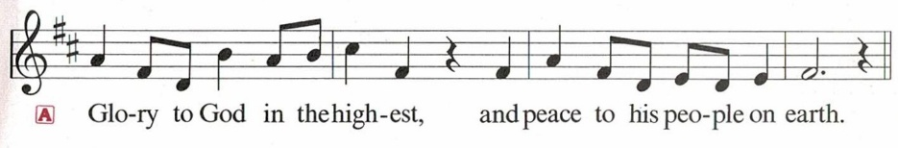
Congregation:
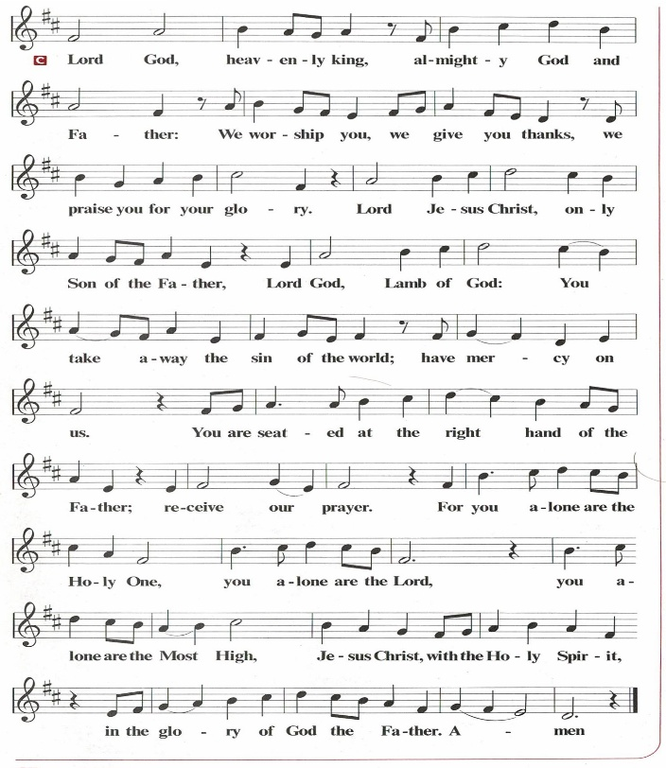

PRAYER OF THE DAY
O God, our true life, to serve you is freedom, and to know you is unending joy. We worship you, we glorify you, we give thanks to you for your great glory. Abide with us, reign in us, and make this world into a fit habitation for your divine majesty, through Jesus Christ, our Savior and Lord, who lives and reigns with you and the Holy Spirit, one God, now and forever.
Amen.

THE WORD

First Reading: Jeremiah 23:1-6
Today’s reading builds on the common, ancient Near Eastern metaphor of the king as shepherd. Judah’s unjust rulers have caused their people, their “flock,” to be scattered. Nevertheless, God will raise up a new and righteous shepherd who will rule a restored Judah.
¹ Woe to the shepherds who destroy and scatter the sheep of my pasture! says the Lord. ² Therefore thus says the Lord, the God of Israel, concerning the shepherds who shepherd my people: It is you who have scattered my flock and have driven them away, and you have not attended to them. So I will attend to you for your evil doings, says the Lord. ³ Then I myself will gather the remnant of my flock out of all the lands where I have driven them, and I will bring them back to their fold, and they shall be fruitful and multiply. ⁴ I will raise up shepherds over them who will shepherd them, and they shall no longer fear or be dismayed, nor shall any be missing, says the Lord.
⁵ The days are surely coming, says the Lord, when I will raise up for David a righteous Branch, and he shall reign as king and deal wisely and shall execute justice and righteousness in the land. ⁶ In his days Judah will be saved, and Israel will live in safety. And this is the name by which he will be called: “The Lord is our righteousness.”
Word of God. Word of life. Thanks be to God.

Psalm: Psalm 46
¹ God is our refuge and strength, a very present help in trouble.
² Therefore we will not fear, though the earth be moved, and though the mountains shake in the depths of the sea;
³ though its waters rage and foam, and though the mountains tremble with its tumult.
⁴ There is a river whose streams make glad the city of God, the holy habitation of the Most High.
⁵ God is in the midst of the city; it shall not be shaken; God shall help it at the break of day.
⁶ The nations rage, and the kingdoms shake; God speaks, and the earth melts away.
⁷ The Lord of hosts is with us; the God of Jacob is our stronghold.
⁸ Come now, regard the works of the Lord, what desolations God has brought upon the earth;
⁹ behold the one who makes war to cease in all the world; who breaks the bow, and shatters the spear, and burns the shields with fire.
¹⁰ “Be still, then, and know that I am God; I will be exalted among the nations; I will be exalted in the earth.”
¹¹ The Lord of hosts is with us; the God of Jacob is our stronghold.

Second Reading: Colossians 1:11-20
An early Christian hymn praises the mystery of the political, personal, and mystical Christ, the one who was present at creation and is eternally reigning with God.
¹¹ May you be made strong with all the strength that comes from his glorious power, so that you may have all endurance and patience, joyfully ¹² giving thanks to the Father, who has enabled you to share in the inheritance of the saints in the light. ¹³ He has rescued us from the power of darkness and transferred us into the kingdom of his beloved Son, ¹⁴ in whom we have redemption, the forgiveness of sins.
¹⁵ He is the image of the invisible God, the firstborn of all creation, ¹⁶ for in him all things in heaven and on earth were created, things visible and invisible, whether thrones or dominions or rulers or powers—all things have been created through him and for him. ¹⁷ He himself is before all things, and in him all things hold together. ¹⁸ He is the head of the body, the church; he is the beginning, the firstborn from the dead, so that he might come to have first place in everything. ¹⁹ For in him all the fullness of God was pleased to dwell, ²⁰ and through him God was pleased to reconcile to himself all things, whether on earth or in heaven, by making peace through the blood of his cross.
Word of God. Word of life. Thanks be to God.

GOSPEL ACCLAMATION

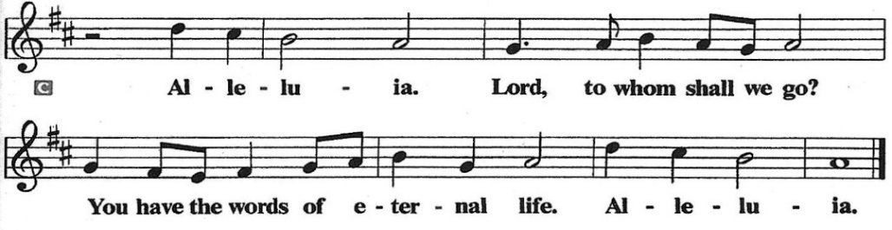

Gospel: Luke 23:33-43

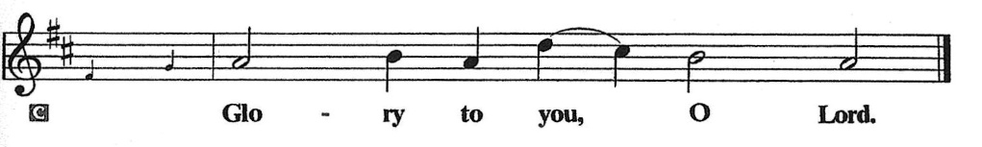
Amid scoffing and slander from those who sarcastically call him Messiah and king, Jesus reveals that to be Messiah and king is to give one’s life for others. Here he uses his power to welcome a despised sinner to paradise but puts his own death into God’s hands.
³³ When they came to the place that is called The Skull, they crucified Jesus there with the criminals, one on his right and one on his left. ³⁴ [[Then Jesus said, “Father, forgive them, for they do not know what they are doing.”]] And they cast lots to divide his clothing. ³⁵ And the people stood by watching, but the leaders scoffed at him, saying, “He saved others; let him save himself if he is the Messiah of God, his chosen one!” ³⁶ The soldiers also mocked him, coming up and offering him sour wine ³⁷ and saying, “If you are the King of the Jews, save yourself!” ³⁸ There was also an inscription over him, “This is the King of the Jews.”
³⁹ One of the criminals who were hanged there kept deriding him and saying, “Are you not the Messiah? Save yourself and us!” ⁴⁰ But the other rebuked him, saying, “Do you not fear God, since you are under the same sentence of condemnation? ⁴¹ And we indeed have been condemned justly, for we are getting what we deserve for our deeds, but this man has done nothing wrong.” ⁴² Then he said, “Jesus, remember me when you come in your kingdom.” ⁴³ He replied, “Truly I tell you, today you will be with me in paradise.”
The Gospel of the Lord.
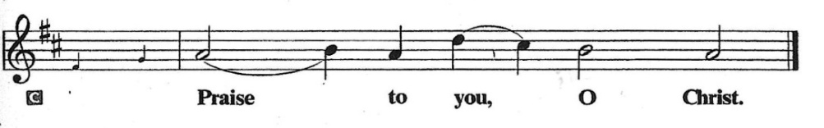

SERMON

HYMN OF THE DAY: LBW #518 Beautiful Savior

1 Beautiful Savior, King of creation, Son of God and Son of Man!
Truly I'd love thee, truly I'd serve thee, light of my soul, my joy, my crown.

2 Fair are the meadows, fair are the woodlands, robed in flow'rs of blooming spring;
Jesus is fairer, Jesus is purer, he makes our sorrowing spirit sing.
3 Fair is the sunshine, fair is the moonlight, bright the sparkling stars on high;
Jesus shines brighter, Jesus shines purer than all the angels in the sky.

4 Beautiful Savior, Lord of the nations, Son of God and Son of Man!
Glory and honor, praise, adoration, now and forevermore be thine!

Text: Gesangbuch, Münster, 1677; tr. Joseph A. Seiss, 1823-1904
APOSTLES’ CREED
I believe in God, the Father almighty, creator of heaven and earth.
I believe in Jesus Christ, God’s only Son, our Lord, who was conceived by the Holy Spirit, born of the virgin Mary, suffered under Pontius Pilate, was crucified, died, and was buried; he descended into hell. On the third day he rose again; he ascended into heaven, he is seated at the right hand of the Father, and he will come to judge the living and the dead.
I believe in the Holy Spirit, the holy catholic church, the communion of saints, the forgiveness of sins, the resurrection of the body, and the life everlasting. Amen.

Prayers of Intercession
Gathered with one voice, we offer our prayers for the church, the world, and all who are in need.
A brief silence.
We pray for the church in the world, its leaders, and its mission to share the good news of healing and restoration. Inspire us to embody the beloved community in ways that faithfully witness to the Holy Spirit. Hear us, O God.
Your mercy is great.
We pray for the trembling mountains and glad streams of creation. Preserve and renew your coastlines, deep seas, forests, and grasslands. Guide all who tend flocks or care for creatures of all kinds. Hear us, O God.
Your mercy is great.
We pray for leaders and advocates in government, civic life, and public safety. Support equity across the globe, and heal division with accountability and truth. Hear us, O God.
Your mercy is great.
We pray for any who are hungry, living in poverty or desperation, weary in body or spirit, or sick especially those on our prayer list. Comfort all in need of your tender care. Hear us, O God.
Your mercy is great.
We pray for this part of the body of Christ gathered around word and sacrament. Bring us into authentic community where all ages are valued and experience God’s faithfulness together. Hear us, O God.
Your mercy is great.
Here other prayers may be offered.
We give thanks for all who have died in faith. May we remember them faithfully until we are gathered with you in the paradise you promise. Hear us, O God.
Your mercy is great.
We offer these and all our prayers to you, O God, trusting in your grace and unyielding love; through Jesus Christ, our Lord.
Amen.

PEACE
The peace of the Lord be with you always.
And also with you

OFFERTORY SENTENCE
Accept our tithes and offerings as a gift of worship to you. Multiply what we give for the effective growth of your kingdom.

OFFERTORY HYMN
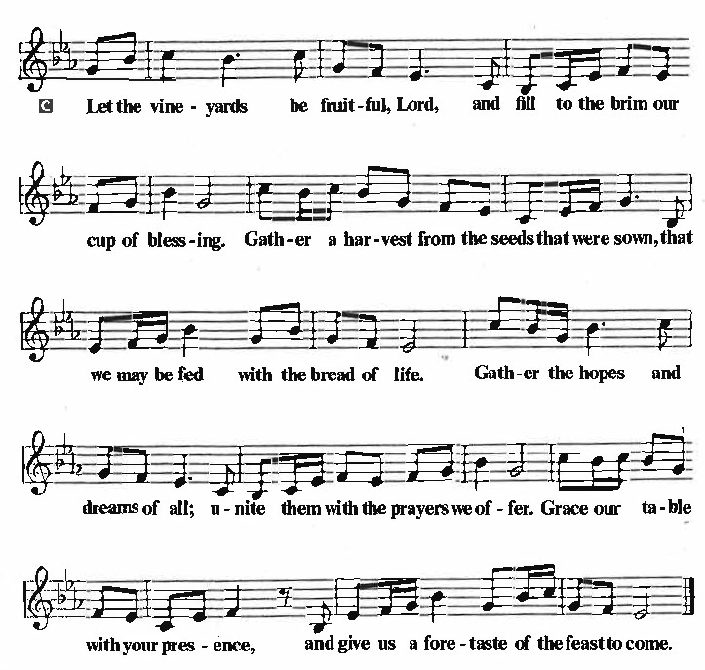
OFFERTORY PRAYER
Lord of the harvest, we return to you a portion of what you have given to us. Turn us to set our hope not on the uncertainty of riches, but on you, who richly provides for us. Multiply what we have gathered to bless all who are suffering and in need, through Jesus Christ our Lord.
Amen.

COMMUNION
THE GREAT THANKSGIVING
The Lord be with you.
And also with you.
Lift up your hearts.
We lift them to the Lord.
Let us give thanks to the Lord our God.
It is right to give our thanks and praise.
THE PROPER PREFACE: It is indeed right and salutary…

SANCTUS
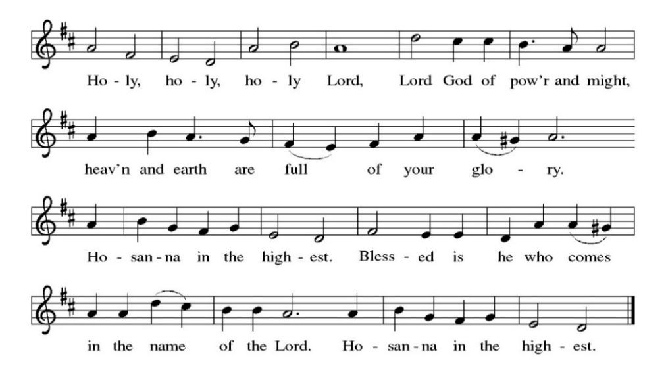
PRAYER OF INSTITUTION
LORD’S PRAYER
Gathered into one by the Holy Spirit, let us pray as Jesus taught us.

Our Father, who art in heaven, hallowed be thy name, thy kingdom come, thy will be done,
on earth as it is in heaven. Give us this day our daily bread; and forgive us our trespasses,
as we forgive those who trespass against us; and lead us not into temptation, but deliver us from evil. For thine is the kingdom, and the power, and the glory, forever and ever. Amen.

OR

Our Father in heaven, hallowed be your name, your kingdom come, your will be done,
on earth as in heaven. Give us today our daily bread. Forgive us our sins as we forgive those
who sin against us. Save us from the time of trial and deliver us from evil. For the kingdom, the power, and the glory are yours, now and forever. Amen.

INVITATION TO COMMUNION
Jesus welcomes sinners and eats with them. Come to this meal of mercy.

COMMUNION SONG
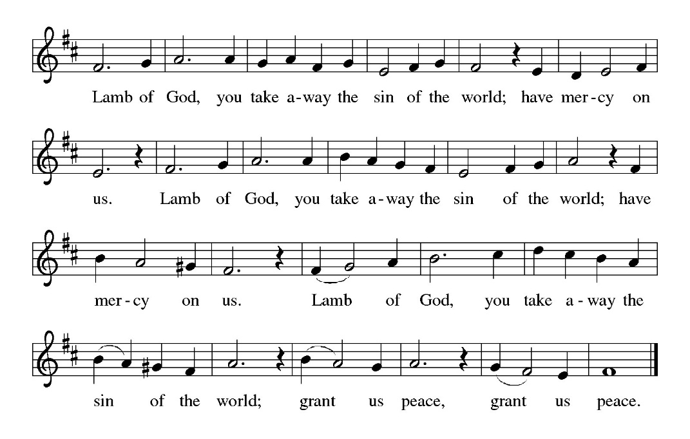
POST COMMUNION PRAYER
O God, through this meal you have strengthened us and appointed us to be your servants. Send us to do good and to share our possessions with all in need. We ask this in Jesus’ name.
Amen.

BLESSING
The God of righteousness, who gives justice to the oppressed, who gives food to the hungry, who sets the prisoners free, ☩ bless you now and forever.
Amen.

SENDING HYMN: LBW#170 Crown Him with Many Crowns (vs. 1-4)
1 Crown him with many crowns, the Lamb upon his throne;
hark, how the heav’nly anthem drowns all music but its own.
Awake, my soul, and sing of him who died for thee,
and hail him as thy matchless king through all eternity.
2 Crown him the virgin’s Son, the God incarnate born,
whose arm those crimson trophies won which now his brow adorn;
fruit of the mystic rose, yet of that rose the stem,
the root whence mercy ever flows, the babe of Bethlehem.

3 Crown him the Lord of love-- behold his hands and side,
rich wounds, yet visible above, in beauty glorified.
No angels in the sky can fully bear that sight,
but downward bend their burning eyes at mysteries so bright.

4 Crown him the Lord of life, who triumphed o’er the grave
and rose victorious in the strife for those he came to save.
His glories now we sing, who died and rose on high,
who died, eternal life to bring, and lives that death may die.
Text: Matthew Bridges, 1800-1894; Godfrey Thring, 1823-1903

DISMISSAL

Go in peace. Do not lose heart.
Thanks be to God.

POSTLUDE

PRAYER LIST
(Please call the office to add/or update the Prayer List)

Sue Patterson on hospice care, Ann Miller Taylor, Don and Barbara Wilson, Marty Cosgriff, Charlotte Berndt, God’s protection for David Powell, God’s guidance and wisdom for Cameron, healing for Helene Rabe, Fred W. Taylor, Madeline McEntyre, Scott Tyler, Jim Lynch, Shirley Lustig, Barbara who is in hospice, Michele Hansen, Lisa Weathers, Matthew Allison, Antonio Jamir and family, Joann and Tye Peyton, Linda Fairless, Shamari Johnson Moore, Christine Fairless, Suzy and John Henry, Gudrun Schamoni, God’s protection for Rhea. David Forsyth, Phil Arthur, Ruth Wolf with cancer, Peter Dow, Francis and Rueben, Anne with cancer.

ANNOUNCEMENTS
CRECE Toy Drive:
Immanuel Lutheran Church Fall/Winter Come Celebrate with Us Events: Save the dates for the exciting events planned this fall and winter. See below for information and details.
Fellowship Hour: We love spending time together after worship, please join us in Parish Hall and feel free to bring something yummy to share!
Council monthly meeting: The Council meets Wednesdays. The next meeting is November 19, 2025 at 7PM via Zoom. Congregation members are welcome at the meetings,
Next Dine and Connect, November 24, 2025: This is an interfaith and community run program to feed the houseless and food insecure in Alameda.
Immanuel Website: You can find our weekly worship bulletin, worship live streaming link, church calendar, events announcements and much more online. Please visit: www.immanuel-alameda.org
Donate to Immanuel Online: It is important that our offerings continue to support our ministry. You can tithe to Immanuel several different ways including PayPal via the church website, through the mail: 1910 Santa Clara Avenue, Alameda, CA 94501, or through the church mail slot located to the right of the metal gate on Santa Clara Ave. Thank you!
Pastor Availability & Contact Info: Rev. Crystal Larsen Stewart’s office hours have changed from Thursdays to Fridays. She can be reached by phone and email to schedule time for pastoral care and appointments. Cell: 510-693-1974. Email: pastor@immanuel-alameda.org
Church Office: Hours vary and are available by appointment. Please call the office at 510-523-0659 and leave a message for pastor or volunteers. We are in need of more volunteers for tasks like the Sunday bulletin, organizing and checking voicemail; please call if you can help.
Recycling: Pure Recycling is available by volunteer Walter McQuesten-510-521-1356. Collects: Plastic: CRV, empty, crushed, bagged, no lids (put lids in own recycle); Aluminum: empty, crushed/flattened and separated; Glass bottles: clean and boxed. It is good to recycle!

*Liturgy materials used from Sundays and Seasons & Confession & Forgiveness Written by Beth Merrill Neel on her blog, ‘Hold Fast to What Is Good’. Used with permission.

