IMMANUEL LUTHERAN CHURCH
18th Sunday after Pentecost
October 12, 2025

Worship in person or online Sunday at 10 AM
See our website for the link: www.immanuel-alameda.org
If you’re joining online and would like to participate in communion, please have bread & wine/or juice available.

Rev. Crystal Larsen Stewart · pastor@immanuel-alameda.org
Church: 1420 Lafayette Street Alameda, CA 94501; Office: 1910 Santa Clara Ave.
(510) 523-0659 · office@immanuel-alameda.org



THE GATHERING
The congregation’s parts are in bold type.
PRELUDE

WORDS OF WELCOME AND ANNOUNCEMENTS

GATHERING HYMN: LBW #543 Praise to the Lord, the Almighty

1 Praise to the Lord, the Almighty, the King of creation! O my soul, praise him, for he is your health and salvation! Let all who hear now to his temple draw near, joining in glad adoration!

2 Praise to the Lord, who o'er all things is wondrously reigning and, as on wings of an eagle, uplifting, sustaining. Have you not seen all that is needful has been sent by his gracious ordaining?

3 Praise to the Lord, who will prosper your work and defend you; surely his goodness and mercy shall daily attend you. Ponder anew what the Almighty can do if with his love he befriend you.

4 Praise to the Lord! Oh, let all that is in me adore him! All that has life and breath, come now with praises before him! Let the amen sound from his people again. Gladly forever adore him!

Text: Joachim Neander, 1650-1680; tr. Catherine Winkworth, 1827-1878, alt.

CONFESSION AND FORGIVENESS

All may make the sign of the cross, the sign that is marked at baptism, as the presiding minister begins.

We live fractured lives, and God seeks not to punish us for those fault and fault lines, but to reconcile and restore us. Trusting in God’s grace and mercy, let us then make our confession together, first in silent prayer.

Silence is kept for reflection.
Loving God, help us. When we have run away, when we have turned our backs on love, when we have sought immediate satisfaction and not long-term healing, help us.
Merciful God, forgive us. When we have been selfish, when we have been mean, when we have closed our ears to the cries of others, forgive us.
Powerful God, heal us. When we are so broken we cannot move, when we don’t know how to stem the bleeding of our wounds, when we are too ashamed to seek community, heal us.
Give us the courage, the strength, and the hope to accept your grace and hear your call in Christ.
Amen.

Friends in Christ, know this: the mercy of God is from everlasting to everlasting, and I
remind you of this surpassing grace – in ☩Jesus Christ, we are forgiven.
Alleluia! Amen.

GREETING
The grace of our Lord Jesus Christ, the love of God, and the communion of the Holy Spirit with you all.
And also with you

CANTICLE OF PRAISE

Assisting Minister or Cantor:

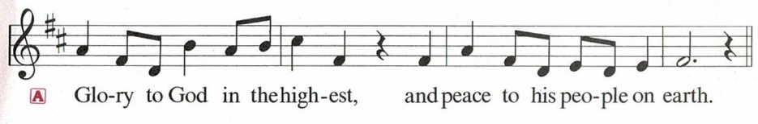

Congregation:
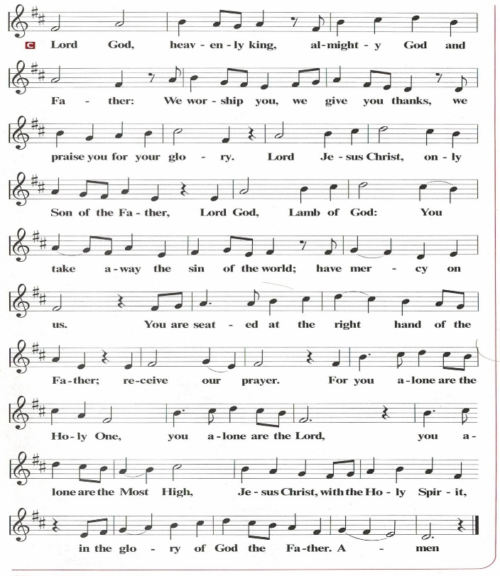

PRAYER OF THE DAY
Almighty and most merciful God, your bountiful goodness fills all creation. Keep us safe from all that may hurt us, that, whole and well in body and spirit, we may with grateful hearts accomplish all that you would have us do, through Jesus Christ, our Savior and Lord.
Amen.

THE WORD

First Reading: 2 Kings 5:1-3, 7-15
Naaman, a Syrian general, suffers from leprosy. In this passage Elisha miraculously cures his illness, but only after Naaman realizes, with the help of his servants, that he also needs healing for his pride. This foreign general then acknowledges the sovereignty of the God of Israel.
¹ Naaman, commander of the army of the king of Aram, was a great man and in high favor with his master because by him the Lord had given victory to Aram. The man, though a mighty warrior, suffered from a skin disease. ² Now the Arameans on one of their raids had taken a young girl captive from the land of Israel, and she served Naaman’s wife. ³ She said to her mistress, “If only my lord were with the prophet who is in Samaria! He would cure him of his skin disease.”
⁷ When the king of Israel read the letter, he tore his clothes and said, “Am I God, to give death or life, that this man sends word to me to cure a man of his skin disease? Just look and see how he is trying to pick a quarrel with me.”
⁸ But when Elisha the man of God heard that the king of Israel had torn his clothes, he sent a message to the king, “Why have you torn your clothes? Let him come to me, that he may learn that there is a prophet in Israel.” ⁹ So Naaman came with his horses and chariots and halted at the entrance of Elisha’s house. ¹⁰ Elisha sent a messenger to him, saying, “Go, wash in the Jordan seven times, and your flesh shall be restored, and you shall be clean.” ¹¹ But Naaman became angry and went away, saying, “I thought that for me he would surely come out and stand and call on the name of the Lord his God and would wave his hand over the spot and cure the skin disease! ¹² Are not Abana and Pharpar, the rivers of Damascus, better than all the waters of Israel? Could I not wash in them and be clean?” He turned and went away in a rage. ¹³ But his servants approached and said to him, “Father, if the prophet had commanded you to do something difficult, would you not have done it? How much more, when all he said to you was, ‘Wash, and be clean’?” ¹⁴ So he went down and immersed himself seven times in the Jordan, according to the word of the man of God; his flesh was restored like the flesh of a young boy, and he was clean.
^{15a, b, c} Then he returned to the man of God, he and all his company; he came and stood before him and said, “Now I know that there is no God in all the earth except in Israel.”
Word of God. Word of life. Thanks be to God.

Psalm: Psalm 111
¹ Hallelujah! I will give thanks to the Lord with my whole heart,
in the assembly of the upright, in the congregation.
² Great are your works, O Lord,
pondered by all who delight in them.
³ Majesty and splendor mark your deeds,
and your righteousness endures forever.
⁴ You cause your wonders to be remembered;
you are gracious and full of compassion.
⁵ You give food to those who fear you,
remembering forever your covenant.
⁶ You have shown your people the power of your works
in giving them the lands of the nations.
⁷ The works of your hands are faithfulness and justice;
all of your precepts are sure.
⁸ They stand fast forever and ever,
because they are done in truth and equity.
⁹ You sent redemption to your people and commanded your covenant forever;
holy and awesome is your name.
¹⁰ The fear of the Lord is the beginning of wisdom;
all who practice this have a good understanding. God’s praise endures forever.

Second Reading: 2 Timothy 2:8-15
Though Paul is chained as a prisoner, the word of God is never shackled or confined. Timothy is encouraged to proclaim that word of freedom in an honest and upright life as well as in his teaching and preaching.
⁸ Remember Jesus Christ, raised from the dead, a descendant of David—that is my gospel, ⁹ for which I suffer hardship, even to the point of being chained like a criminal. But the word of God is not chained. ¹⁰ Therefore I endure everything for the sake of the elect, so that they may also obtain the salvation that is in Christ Jesus, with eternal glory. ¹¹ The saying is sure:
If we have died with him, we will also live with him;
¹² if we endure, we will also reign with him;
if we deny him, he will also deny us;
¹³ if we are faithless, he remains faithful—
he cannot deny himself.
¹⁴ Remind them of this, and warn them before the Lord that they are to avoid wrangling over words, which does no good but only ruins those who are listening. ¹⁵ Do your best to present yourself to God as one approved by him, a worker who has no need to be ashamed, rightly explaining the word of truth.
Word of God. Word of life. Thanks be to God.

GOSPEL ACCLAMATION
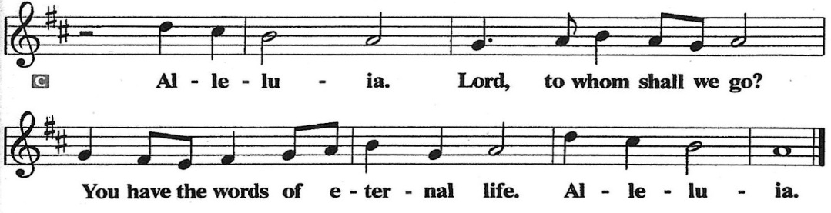

Gospel: Luke 17:11-19
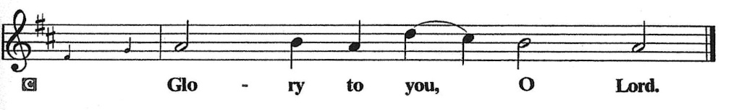

11 On the way to Jerusalem Jesus was going through the region between Samaria and Galilee. 12 As he entered a village, ten men with a skin disease approached him. Keeping their distance, 13 they called out, saying, “Jesus, Master, have mercy on us!” 14 When he saw them, he said to them, “Go and show yourselves to the priests.” And as they went, they were made clean. 15 Then one of them, when he saw that he was healed, turned back, praising God with a loud voice. 16 He prostrated himself at Jesus’s feet and thanked him. And he was a Samaritan. 17 Then Jesus asked, “Were not ten made clean? So where are the other nine? 18 Did none of them return to give glory to God except this foreigner?” 19 Then he said to him, “Get up and go on your way; your faith has made you well.”
The Gospel of the Lord.

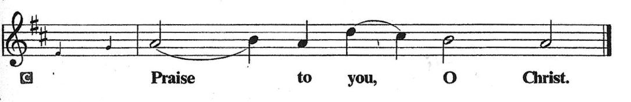

SERMON

HYMN OF THE DAY: LBW #534 Now Thank We All Our God

1 Now thank we all our God
with hearts and hands and voices,
who wondrous things has done,
in whom his world rejoices;
who, from our mothers’ arms,
has blest us on our way
with countless gifts of love,
and still is ours today.

2 Oh, may this bounteous God
through all our life be near us,
with ever joyful hearts
and blessed peace to cheer us,
and keep us in his grace,
and guide us when perplexed,
and free us from all harm
in this world and the next.

3 All praise and thanks to God
the Father now be given,
the Son, and him who reigns
with them in highest heaven,
the one eternal God,
whom earth and heav’n adore;
for thus it was, is now,
and shall be evermore.
Text: Martin Rinkhart, 1586-1649; tr. Catherine Winkworth, 1829-1878

APOSTLES’ CREED
I believe in God, the Father almighty, creator of heaven and earth.
I believe in Jesus Christ, God’s only Son, our Lord, who was conceived by the Holy Spirit, born of the virgin Mary, suffered under Pontius Pilate, was crucified, died, and was buried; he descended into hell. On the third day he rose again; he ascended into heaven, he is seated at the right hand of the Father, and he will come to judge the living and the dead.
I believe in the Holy Spirit, the holy catholic church, the communion of saints, the forgiveness of sins, the resurrection of the body, and the life everlasting. Amen.

The Prayers
Renewed in God’s everlasting grace, let us pray for the church, the world, and all creation.
A brief silence.

Gracious God, you lead your people to faith. Remind the church that your word flows into the world. By your Spirit, teach the church to share the word of God for the sake of the world. God of grace,
receive our prayer.
Creating God, you provided cleansing and healing waters for Naaman. Water the earth’s lands in parched places. Restore clean water to all communities, and guide the work of all who advocate for safe and abundant water supplies. God of grace,
receive our prayer.
Righteous One, you bring justice and wholeness throughout the world, and your righteousness endures forever. By your spirit, guide leaders of all nations and lands to right relationship with you and with one another. God of grace,
receive our prayer.
Merciful God, you know the needs of your people. Show mercy to those suffering in the world. Comfort those in need of your healing (especially). God of grace,
receive our prayer.
Life-giving God, you free us by your word. Help us, by your Spirit, to be transformed to live your word of freedom honestly and uprightly in our teaching, preaching, and serving. God of grace,
receive our prayer.
Here other intercessions may be offered.
Holy God, thank you for the witness of those who have died in faith (especially). Guide us to trust in the baptismal promise of resurrection in Christ. God of grace,
receive our prayer.
We offer our prayers, O God, trusting in your everlasting grace and mercy, through Jesus Christ our Lord.
Amen.

PEACE
The peace of the Lord be with you always.
And also with you

OFFERTORY SENTENCE
Accept our tithes and offerings as a gift of worship to you. Multiply what we give for the effective growth of your kingdom.

OFFERTORY HYMN
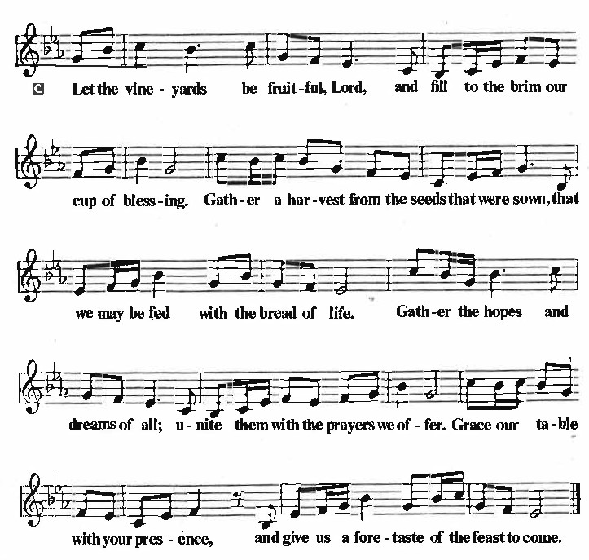

OFFERTORY PRAYER
Lord of the harvest, we return to you a portion of what you have given to us. Turn us to set our hope not on the uncertainty of riches, but on you, who richly provides for us. Multiply what we have gathered to bless all who are suffering and in need, through Jesus Christ our Lord.
Amen.

COMMUNION
THE GREAT THANKSGIVING
The Lord be with you.
And also with you.
Lift up your hearts.
We lift them to the Lord.
Let us give thanks to the Lord our God.
It is right to give our thanks and praise.
THE PROPER PREFACE: It is indeed right and salutary…

SANCTUS
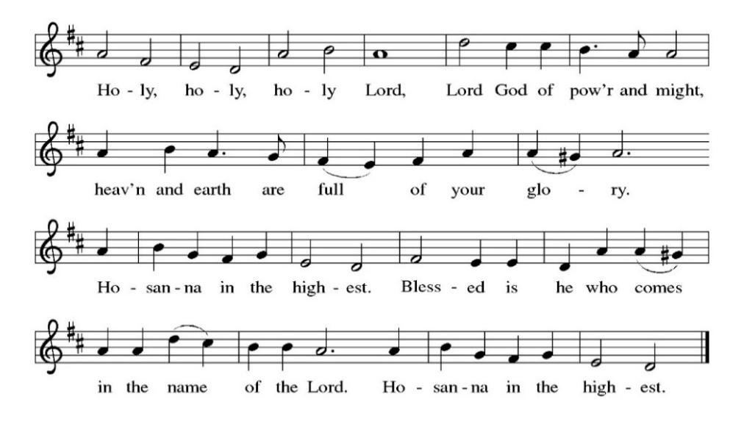
PRAYER OF INSTITUTION

LORD’S PRAYER
Gathered into one by the Holy Spirit, let us pray as Jesus taught us.

Our Father, who art in heaven, hallowed be thy name, thy kingdom come, thy will be done,
on earth as it is in heaven. Give us this day our daily bread; and forgive us our trespasses,
as we forgive those who trespass against us; and lead us not into temptation, but deliver us from evil. For thine is the kingdom, and the power, and the glory, forever and ever. Amen.

OR

Our Father in heaven, hallowed be your name, your kingdom come, your will be done,
on earth as in heaven. Give us today our daily bread. Forgive us our sins as we forgive those
who sin against us. Save us from the time of trial and deliver us from evil. For the kingdom, the power, and the glory are yours, now and forever. Amen.

INVITATION TO COMMUNION
Jesus welcomes sinners and eats with them. Come to this meal of mercy.

COMMUNION SONG
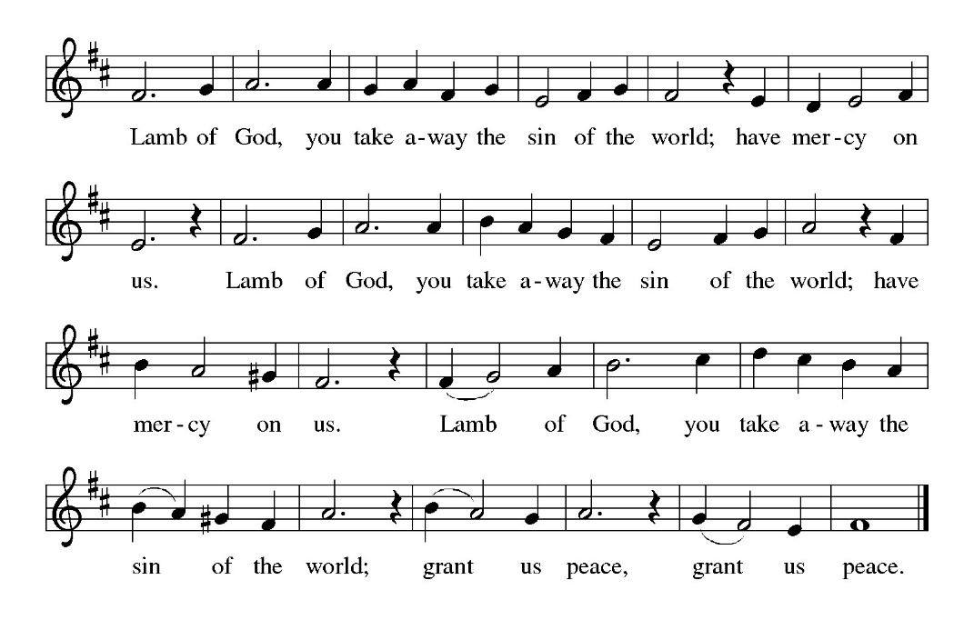

POST COMMUNION PRAYER
O God, through this meal you have strengthened us and appointed us to be your servants. Send us to do good and to share our possessions with all in need. We ask this in Jesus’ name.
Amen.

BLESSING
The God of righteousness, who gives justice to the oppressed, who gives food to the hungry, who sets the prisoners free, ☩ bless you now and forever.
Amen.

SENDING HYMN: WOV #721 Go, My Children, with My Blessing

1 “Go, my children, with my blessing, never alone. Waking, sleeping, I am with you, you are my own. In my love’s baptismal river, I have made you mine forever. Go, my children, with my blessing, you are my own.

2“Go, my children, sins forgiven, at peace and pure. Here you learned how much I love you, what I can cure. Here you heard my dear Son’s story, here you touched him, saw his glory.
Go, my children, sins forgiven, at peace and pure.

3“Go, my children, fed and nourished, closer to me. Grow in love and love by serving, joyful and free. Here my Spirit’s power filled you, here his tender comfort stilled you. Go, my children, fed and nourished, joyful and free.

4 “I the Lord will bless and keep you, and give you peace. I the Lord will smile upon you, and give you peace. I the Lord will be your Father,
Savior, Comforter and Brother. Go, my children, I will keep you, and give you peace.”

Text: Jaroslav J. Vajda, b. 1919
© 1983 Jaroslav J. Vajda

DISMISSAL
Go in peace. Do not lose heart.
Thanks be to God.

POSTLUDE

PRAYER LIST
(Please call the office to add/or update the Prayer List)

Ann Miller Taylor, Don and Barbara Wilson, Marty Cosgriff, Charlotte Berndt, God’s protection for David Powell, God’s guidance and wisdom for Cameron, healing for Helene Rabe, Fred W. Taylor, Madeline McEntyre, Scott Tyler, Jim Lynch, Shirley Lustig, Barbara who is in hospice, Michele Hansen, Lisa Weathers, Matthew Allison, Antonio Jamir and family, Joann and Tye Peyton, Linda Fairless, Shamari Johnson Moore, Christine Fairless, Suzy and John Henry, Gudrun Schamoni, God’s protection for Rhea. David Forsyth, Phil Arthur, Ruth Wolf with cancer, Peter Dow, Francis and Rueben.

ANNOUNCEMENTS
Immanuel Lutheran Church Fall/Winter Come Celebrate with Us Events: Save the dates for the exciting events planned this fall and winter. See below for information and details.
Trinity Lutheran Church invites Immanuel to their 3rd annual Oktoberfest, Saturday, October 4th at 4:30 PM, $25 per person. RSVP by September 30th to 510-522-5220.
Fellowship Hour: We love spending time together after worship, please join us in Parish Hall and feel free to bring something yummy to share!
Council monthly meeting: The Council meets Wednesdays. The next meeting is October 15, 2025 at 7PM via Zoom. Congregation members are welcome at the meetings,
Next Dine and Connect, September 29, 2025: This is an interfaith and community run program to feed the houseless and food insecure in Alameda.
Immanuel Website: You can find our weekly worship bulletin, worship live streaming link, church calendar, events announcements and much more online. Please visit: www.immanuel-alameda.org
Donate to Immanuel Online: It is important that our offerings continue to support our ministry. You can tithe to Immanuel several different ways including PayPal via the church website, through the mail: 1910 Santa Clara Avenue, Alameda, CA 94501, or through the church mail slot located to the right of the metal gate on Santa Clara Ave. Thank you!
Pastor Availability & Contact Info: Rev. Crystal Larsen Stewart holds office hours on Thursdays. She can be reached by phone and email to schedule time for pastoral care and appointments. Please note, beginning Friday, October 31, Pastors office day will change to Fridays.
Cell: 510-693-1974. Email: pastor@immanuel-alameda.org
Church Office: Hours vary and are available by appointment. Please call the office at 510-523-0659 and leave a message for pastor or volunteers. We are in need of more volunteers for tasks like the Sunday bulletin, organizing and checking voicemail; please call if you can help.
Recycling: Pure Recycling is available by volunteer Walter McQuesten-510-521-1356. Collects: Plastic: CRV, empty, crushed, bagged, no lids (put lids in own recycle); Aluminum: empty, crushed/flattened and separated; Glass bottles: clean and boxed. It is good to recycle!

*Liturgy materials used from Sundays and Seasons & Confession & Forgiveness Written by Beth Merrill Neel on her blog, ‘Hold Fast to What Is Good’. Used with permission.

